ST ALBANS STEINER KINDERGARTEN HANDBOOK

If a translation of this is required, please ask a member of staff.

Welcome to the Kindergarten, we hope that you enjoy your time with us. This little booklet hopes to show how we work in partnership with parents and carers and that together we can make your child’s time at kindergarten a positive and valuable experience.
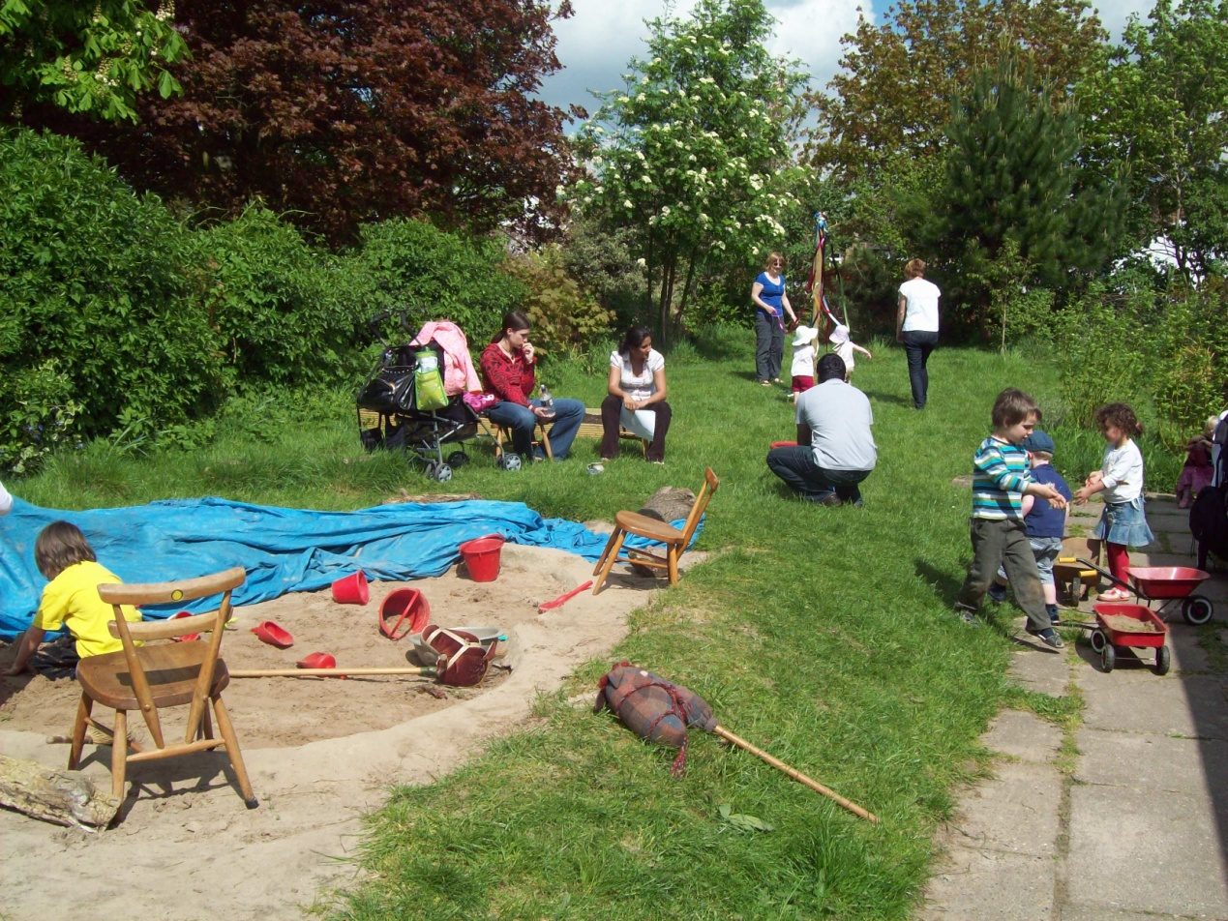
The aim of the kindergarten is to provide a gentle first step towards independence for the child. We provide a family like structure, and a warm, friendly, nurturing environment for all children. The kindergarten is open to every child and family from all sections of the community; we believe strongly that we have a social responsibility make the kindergarten available to everyone regardless of religious, social, ethnic and cultural group, special needs or financial situation. We promote equal opportunities and anti- discriminatory practice that ensures that every child is included and not at a disadvantage. It is our aim to ensure that every child is treated as an individual with individual needs.
The kindergarten supports the families and carers of the children. Staff, parents and carers all work together to provide a warm and caring family atmosphere, so that there is a shared experience, and common ideals.
Underlining all that we do is an understanding of Rudolf Steiner’s/Waldorf philosophy on early childhood education, which is based on gently guiding children through their education using their head, heart and hands to engage with and understand the world in a natural and holistic way.
Our aim is to help the child to build a strong base for social and emotional competence, literacy, and numeracy, by creating a warm and secure learning environment where the qualities of childhood are nurtured and respected.
Children of all ages are welcome:
- From birth- three years of age
Friday morning Parent/Carer and Child Group.
10am - 12pm

- Age 2 to 6 years
Monday – Thursday during term time.
9.00am - 12.30pm & up til 3.00pm
Early starts available from 8.30am

Our Approach

At Kindergarten we create an environment where a child will widen their physical, social and educational development, providing a firm foundation for further life skills.
We reflect the natural world around us as well as the seasons. The toys and materials used within the Kindergarten’s daily routine are all made from natural materials. The festivals celebrated within Kindergarten are all related to the natural seasonal cycle, incorporating festivals from cultures of all of our children. Please let us know if you would like to share a celebration or festival with us.
The Kindergarten day works with a strong rhythm, thus making the child feel safe, secure and nurtured within its boundaries, giving them the freedom to play and learn.

We have a library of books available in the Kindergarten on subjects such as child health and development, Rudolf Steiner, festivals, crafts etc. Please do ask if you are interested.

How we are regulated?

Kindergarten is answerable to Ofsted and received a ‘Good’ judgement in our last inspection in 2022.
We are also affiliated with Waldorf UK, the national Steiner Waldorf education body.

We receive funding from Herts County for children from the term after their third birthday to the term after their fifth birthday and are also registered for funding for 2 year olds.

Curriculum
We follow the E.Y.F.S (Early Years Foundation Stage) curriculum framework, but what sets the Steiner Early Years Curriculum apart is that it is exempt from some areas of the numeracy and literacy guidelines of the EYFS.
We support children to gain skills in language and mathematics through play-based learning. Children are not expected to sit down and learn to write letters and numbers at such an early age but instead learn the art of language through free play, interaction with peers and adults, learning songs and rhymes. Seasonal stories are told, often with a puppet show. Children gain a representational understanding of maths by playing counting games, real life experiences e.g. setting the table for the number of children, observing and discussing shapes within their play, craft & baking activities and in the sharing of books and stories. View the exemptions here: https://img1.wsimg.com/blobby/go/c9fcb3d0-edcc-4b37-862f-1df46880b2ea/downloads/1%20SWSF%20EXEMPTIONS%20%20MODIFICATIONS%20TO%20EYFSAugust.pdf?ver=1761928461539

There is no exemption from the safeguarding and welfare requirements.

Daily Routine

Every morning we have a good morning ring which all parents and carers are welcome to join. After the ring please leave promptly so staff and children can make a full use of the morning.
Each day the children will do some baking or food preparation, which enables them to eat a healthy vegetarian lunch: bread rolls, home made soup, vegetables, cheese, fruit. We will ensure that our meals cater for children with food allergies.
The children have time to engage in “open-ended” play. During this session the craft table is set out, where seasonal activities are offered. Tidy away time arrives with a song.
Now we sit down and sing and play finger games which help with fine motor skills, circle time which has seasonal games which help their co-ordination and large motor skills. This is followed by a shared lunch together as a group before going into the garden. The morning finishes with a seasonal or topical story.

Parent and Child Group

We meet on Fridays at 10am until 12pm. This is a gentle introduction to the Kindergarten and its structure and philosophies. We enjoy open-ended play, indoors and out, and a shared snack which the children can help to prepare. We encourage parents to start their child in this group.

Record keeping and Parents’ meetings

We monitor and keep confidential written records on your child’s progress. These records are available to parents on request. We are also available to discuss your child’s progress by prior arrangement. Parent consultation sessions are held twice a year.

Festivals

We hope to enjoy your family’s company in celebrating our seasonal and end of term festivals which are an important part of the Kindergarten year. These are very special occasions and provide opportunities for families to feel part of our community. You may also wish to bring festivals particular to your culture or religion for all the children to experience, if so please discuss any ideas with Zanna.

Home Toys

The children soon accept that all Kindergarten toys are to share. Apart from comforters, please discourage your child from bringing their own toys since this often causes distress either when the toy becomes lost or other children wish to play with the toy. We have a visitor’s basket by the door for the toys to rest in upon arrival if necessary.

Clothing

Please bring clothing appropriate to the weather. We always try to go in the garden so coats and hats for the cold and summer hats for the sun. Please apply sunscreen onto your child’s skin during the hot summer months. Wellies are essential when it is wet because the grass gets very slippery and there are many puddles.
The Kindergarten provides slippers for every child. Please help your child to put them on when they arrive.
We like children to be happy in what they wear but we discourage pictures and images on clothing such as monsters, superheroes, skeletons etc.

Attendance

Please ring if you are unable to attend.
Kindergarten’s telephone number: 07712104510
Zanna’s telephone number: 07970 117251

Sickness

Please do not bring your child if he/she feels unwell. Allow 48 hours to pass after a high temperature, diarrhoea or vomiting has abated before coming back to Kindergarten. If in any doubt, please talk to a member of staff.
If your child is unwell in Kindergarten they will be kept in a quiet place with a member of staff until parents can collect them. Please ensure that you are contactable by phone.
Please check your child’s head regularly for head lice and keep staff informed.

Pick-up & Drop off

Please be prompt in both bringing and picking up your child from Kindergarten as this helps your child learn to manage their transitions.

If someone else is doing the pick-up – please ensure you have arranged this with the Staff beforehand – see uncollected child policy.

Kindergarten staff may refuse to hand over a child if they feel that the adult is not in fit condition to be responsible, for instance smells strongly of alcohol, is staggering or speech is slurred. In this instance the other parent or contact person will be contacted.

Complaints

Our Kindergarten believes that children and parents are entitled to expect courtesy and prompt, careful attention to their needs and wishes.

Please see our complaints procedure in the list of Policies.

