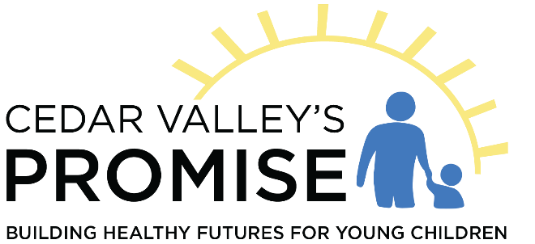

Currently, the Board meets on the second Thursday of each month at 3:30pm. Please fill out the application if you would like to be considered for a position on the Board.

Name:
Address:
City, State, and Zip:
County:
Preferred Phone:
Preferred Email:

Current Employer (if applicable):
Are you elected to a public office through a public election: Yes/No

Do you work for an organization that provides a service to or for Cedar Valley’s Promise?
Do you have a spouse that works for an organization that receives funds from or provides a service to Cedar Valley’s Promise?

Are you a parent or grandparent of a child 0-5 years of age?

Which of the following areas could you represent as a Board Member?
Business
Human Services
Faith
Education
Health
Consumer

The Board must be gender balanced. Are you male or female?

