**CEDAR VALLEY’S PROMISE**

**COMMUNITY PLAN**

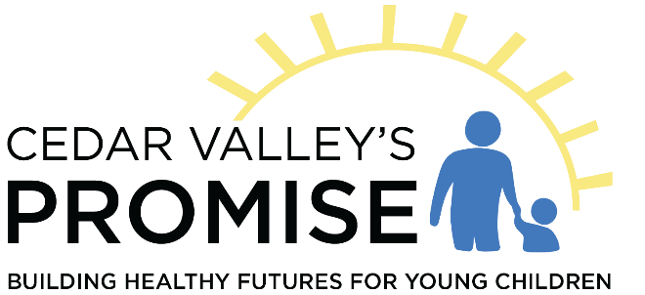

**Name of ECI Area: Cedar Valley’s Promise**

**Board Chairperson: Lew Everling Executive Director: Brenda Loop**

**E-mail: lew@leweverling.com Address: 4231 Cedar Ridge**

**Hazel Green, WI 53811**

**Phone: 608-568-3062**

[**cedarvalleyspromise@gmail.com**](mailto:cedarvalleyspromise@gmail.com)

[**www.cedarvalleyspromise.net**](http://www.cedarvalleyspromise.net)

**Approved by Cedar Valley’s Promise Policy Board:  September 12, 2024**

**_____________________________**

**Lew Everling, Board ChairTABLE OF CONTENTS**

**Section I: General Information Page(s)**

Identification of the Early Childhood Iowa Area3

Early Childhood Iowa Area’s Vision and Mission 3

Use of the Community Plan 4

**Section II: Community Needs Assessment**

Area Demographics and Geographic Composition 4

Development Process for the Community Needs Assessment 7

Summary of Needs Assessment Results 23

Collaborative and Networking Opportunities 23

Priorities of the ECI Area Board 24

**Section III: Fiscal Assessment and Use of Funding Sources**

Process used to Gather Information 25

Collaborative Funding Identified 25

Early Childhood Iowa Area Fiscal Assessment Results Matrix 25

**Section IV: Use of Funds**

ECI Area Board’s Process for Awarding Funds 26

**Section V: Strategies, Indicators, and Desired Results**

Strategies of the ECI Area Board 29

Indicators for Tracking Progress 30

Process for Tracking Strategies, Indicators, and Desired Results 32

**Section I: General Information**

**Identification of the Early Childhood Iowa Area**

Cedar Valley’s Promise (CVP) is the Early Childhood Iowa area located in Black Hawk County approximately mid-way between Des Moines and the northeast corner of the state. CVP is one of 35 ECI areas across Iowa representing all 99 counties.

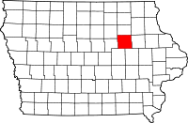

Agencies providing services to families with children, prenatal through age 5, living in the Black Hawk County area are eligible to apply for Early Childhood Iowa funds. Cedar Valley’s Promise Board has policies in regard to:

* Families in the area but requesting to receive services outside of area
* Families living outside the area but requesting services within Black Hawk County

Please refer to Policy 1.6 Area Boundaries/Services Out of Area Policy located in our Policies and Procedures Manual on our website listed above.

**Vision/Mission Statement**

Our vision and mission were developed by community leaders at the time Cedar Valley’s Promise was founded in 1997. Through the review process, the vision and mission statements are determined to be true and/or updated.

**Vision**

Each child in the Cedar Valley will achieve his/her maximum potential living in our safe, healthy, and supportive community.

**Mission**

Parents, families, and communities must be united for the love of our children. They will be informed and wholly involved in nurturing all young children to ensure access to resources needed for optimal development.

**Use of the Community Plan**

Cedar Valley’s Promise (CVP) Early Childhood Iowa Area Board of Directors is dedicated to improving Black Hawk County’s early childhood care, health, and education system to provide opportunities for all families to help their children be healthy and reach their full potential. The Community Plan is intended as a blueprint for the design and implementation of programs and services to meet the needs of area families and children. Sharing the Community Plan with the community and providers and awarding funding based on the plan is the most effective way to communicate those needs. The Board reviews its annual report performance data and outcomes of provider agencies using the Community Plan as a guide.

As a state-funded initiative, Cedar Valley’s Promise adheres to the Open Records and Meetings Laws. All documents and files are available for viewing or distribution to the public. As with all documents, the public may request a copy of the Community Plan by contacting the ECI Area Director. It may be downloaded from the CVP website or to request a paper copy, please contact the Executive Director. Since COVID-19, the CVP Board has met virtually allowing easy access for the public to participate.

The Cedar Valley Early Childhood Advisory Coalition meets every other month. These community partners, along with the CVP Executive Director, utilize the CVP Community Plan to assist in developing plans within their coalitions to meet the needs of our children, families, and community. Needs/gaps are identified throughout the year, and each respective plan is evaluated regularly.

**Section II: Community Needs Assessment**

**Area Demographics and Geographic Composition**

Black Hawk County is a [county](http://en.wikipedia.org/wiki/County_(United_States)) located in the northeastern part of the [U.S. state](http://en.wikipedia.org/wiki/U.S._state) of [Iowa](http://en.wikipedia.org/wiki/Iowa). Black Hawk County’s 2020 population at 131,144 is a slight increase from the 2010 Census data of 131,090. Black Hawk County has the fifth largest population of counties in the state. Most of the county's population resides in the Waterloo-Cedar Falls urbanized area. [Waterloo](http://en.wikipedia.org/wiki/Waterloo,_Iowa), the [county seat](http://en.wikipedia.org/wiki/County_seat), is located approximately 65 miles (105 km) east of I-35 at the intersection of U.S. Highways 20, 63 and 218. The city of [Cedar Falls](http://en.wikipedia.org/wiki/Cedar_Falls,_Iowa) is located approximately eight miles west of Waterloo.

Black Hawk County consists of the following by population (Waterloo 67,314, Cedar Falls 40,713, Evansdale 4,561, Hudson 2,546, LaPorte City 2,274, Elk Run Heights 1,069, Washburn 870, Dunkerton 842, Gilbertville 794, and Raymond 759. There are thirteen school districts that operate wholly or partially in Black Hawk County.

The CVP Plan is utilized throughout the year in all aspects of the Board’s planning and evaluation of services. At each board meeting, the Board reviews financial reports, bank statements, and credit card statements. Quarterly, the Board reviews contractor performance reports to determine if contractor performance measures are being met.

**Black Hawk County, Iowa**

|  |  |  |  |
| --- | --- | --- | --- |
| Quick Facts | Black Hawk County | Iowa | Black Hawk |
| Population | 131,144 (2022) | 3,109,369 (2022) | 131,090 (2010) |
| Persons Under 5 Years | 8,021/6.1% (2022) | 189,797/6.0% (2022) | 7,827 (2000) |
| Persons Under 18 Years | 28,327/21.6% (2022) | 712,046/22.9% (2022) | 27,924 (2009) |
| Persons 65 and Over | 23,606/18% (2022) | 547,249/17.6% (2022) | 17,899 (2000) |
| White alone | 97,965/74.7% (2022) | 2,627,417/84.5% (2022) | 100,945 (2006) |
| Black Alone | 12,983/9.9% (2022) | 127,484/4.1% (2022) | 10,146 (2006) |
| American Indian/Alaska Native Alone | 393/0.3% (2022) | 12,437/0.4% (2022) | 228 (2000) |
| Asian Alone | 3,279/2.5% (2022) | 74,625/2.4% (2022) | 1254 (2000) |
| Native Hawaiian/Other Pacific Islander | 787/0.6% (2022) | 6,219/0.2% (2022) | 56 (2000) |
| Two or More Races | 6,819/5.2% (2022) | 174,125/5.6% (2022) | 1911 (2000) |
| Language Other than English Spoken | 9.6% (2022) | 8.9% (2022) | 6.6% (2000) |
| Bachelor’s Degree or Higher | 32.2% (2022) | 32.3% (2022) | 23% (2000) |
| Veteran/Active Duty | 5.5% (2022) | 6.4% (2022 | 13% (2000) |
| Housing Units | 58,559 (2022) | 1,412,789 (2022) | 51,759 (2000) |
| Housing Occupancy | 93% (2022) | 92.5% (2022) | 95.9% (2000) |
| Homeownership Rate | 65.2% (2022) | 72.0% (2022) | 66% (2000) |
| Median Gross Rent | $941 (2022) | $891 (2022) | $472 (2000) |
| Median Household Income | $60,529 (2022) | $69,588 (2022) | $40,502 (2005) |
| Persons Below Poverty Level | 17.6% (2022) | 11.0% (2022) | 15% (2005) |
| Persons Under 18 in Poverty | 24.5% (2022) | 12.2% (2022) |  |
| Child Abuse Rate per 1000 0-5 years | 23 (2022) | 22 (2022) | 39 (2009) |
| Domestic Abuse per 100,000 | 236 (2022) | 186 (2022) | 268 (2016) |
| Quick Facts | Black Hawk County | Iowa | Black Hawk |
| Mothers on WIC/Medicaid at Birth | 61% (2022) | 46% (2022) | 57% (2007) |
| Children under 6 All Parents in Workforce | 77% (2022) | 76% (2022) | 71% (2011) |
| Percentage of Unemployed Persons | 2.9% (2022) | 2.7% (2022) | 3.8% (2008) |
| Percentage of Mothers over age 19 with no  High School Diploma/GED | 10.8% (2022) | 9.3% (2022) | 11.6% (2007) |
| Percentage of Kindergartners Meeting  Fall Literacy Requirements | 66% (2022) | 67% (2022) | 57% (2015) |
| Percentage of Children Immunized by 2 | 75% (2022) | 71% (2022) | 84% (2000) |
| Teen Birth Rate % born to mom <20 | 4.5% (2022) | 3.8% (2022) | 9.3% (2007) |
| Percentage of Children Born to Mothers  With Inadequate Prenatal Care | 9.5% (2022) | 7.9% (2022) | 8.7% (2007) |
| Percentage of Children Born with Tobacco  Exposure | 11.6% (2022) | 9.1% (2022) | 29% (2007) |
| Percentage of Children Born Pre-Term or  Low Birth Weight | 13.6% (2022) | 11.6% (2022) | 11.9% (2007) |
| Percentage of Children Born with 3 or  More Birth Risks* | 26% (2022) | 18% (2022) | 33% (2007) |
| Percentage of Children 0-5 with Medicaid  Who Receive Dental Services | 37% (2022) | 43% (2022) | 40% (2010) |
| Child Care Slots Registered/Licensed | 6,840 (2023) | 158,964 (2023) | 5,507 (2007) |
| Four Year Graduation Rate | 90.4% (2023) | 87.5% (2023) | 78% (2000) |
| Waterloo CSD Not Reading Proficiently  Grade 3 | 46% (23-24 Year) |  |  |
| Cedar Falls CSD Chronically Absent  18 Days or More Per School Year | 14% (23-24 Year) |  |  |
| Waterloo CSD Chronically Absent  18 Days or More Per School Year | 23.7% (23-24 Year) |  |  |

*Birth risks include: poverty at birth, pre-term or low birth weight, single mom, teen mom, mother without high school education, inadequate prenatal care, tobacco exposure.

**Development Process for the Community Needs Assessment**

Cedar Valley’s Promise staff utilized a combination of data available about Black Hawk County, a survey of agencies/providers, and a survey of parents of children 0-5 years for the community needs assessment. Surveys were sent to members of the Early Childhood Coalition (69) as well as members of the Black Hawk Interagency (131) with the request to share with staff and families served electronically. In addition, the acting CPPC/DECAT Coordinator shared through his networks. At the August, 2024, Early Childhood Coalition meeting, group members worked in small groups to identify strengths and weaknesses in a variety of areas.

The following secondary data sources were identified, reviewed, and considered during the development of the Community Needs Assessment.

1. Community Needs Survey for Agencies-Programs-Staff
2. Family Survey with Children Ages 0-5
3. Iowa’s Integrated Data System for Decision Making (I2D2)
4. SuccessLink Data System
5. US Census Bureau
6. Early Childhood Coalition Strengths/Weaknesses Worksheet
7. Iowa Department of Education
8. Iowa Department of Health and Human Services

**Family Survey Results**

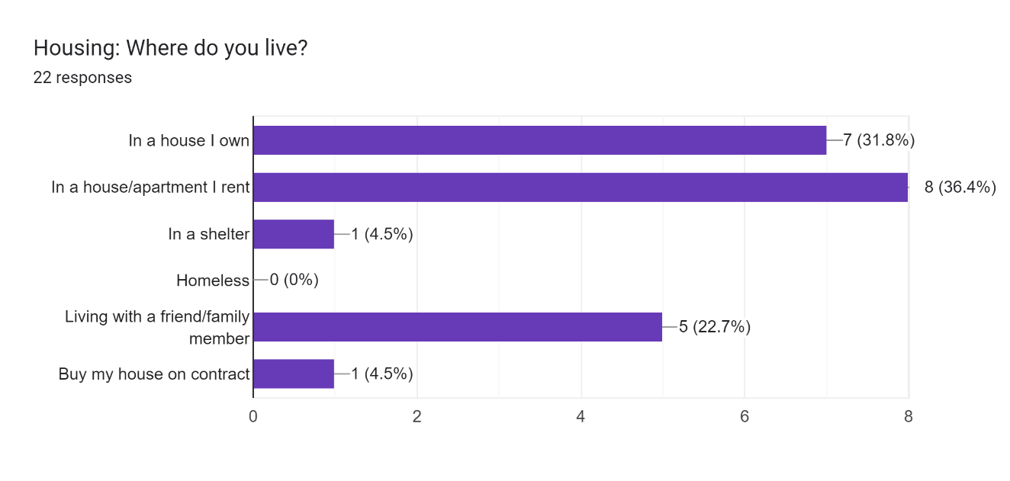

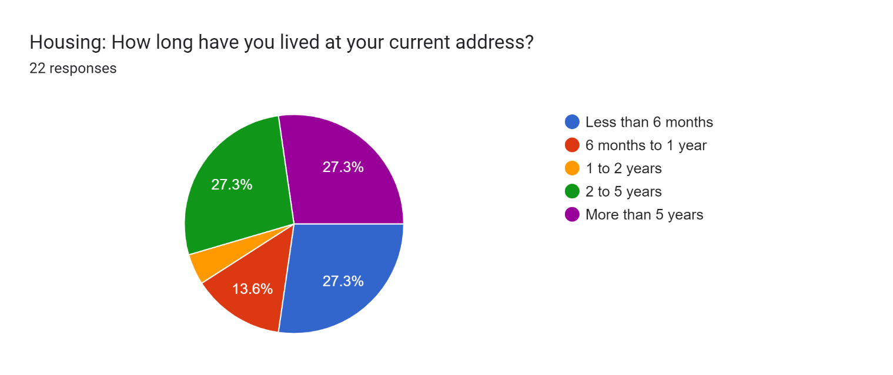

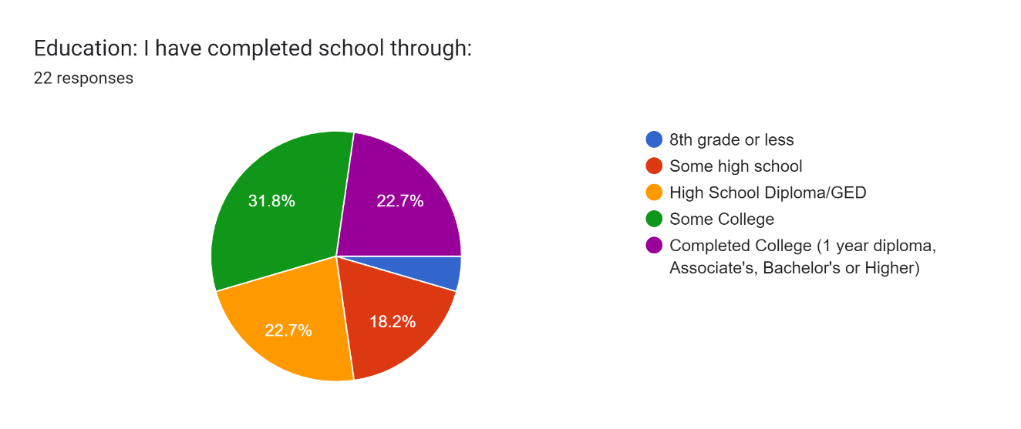

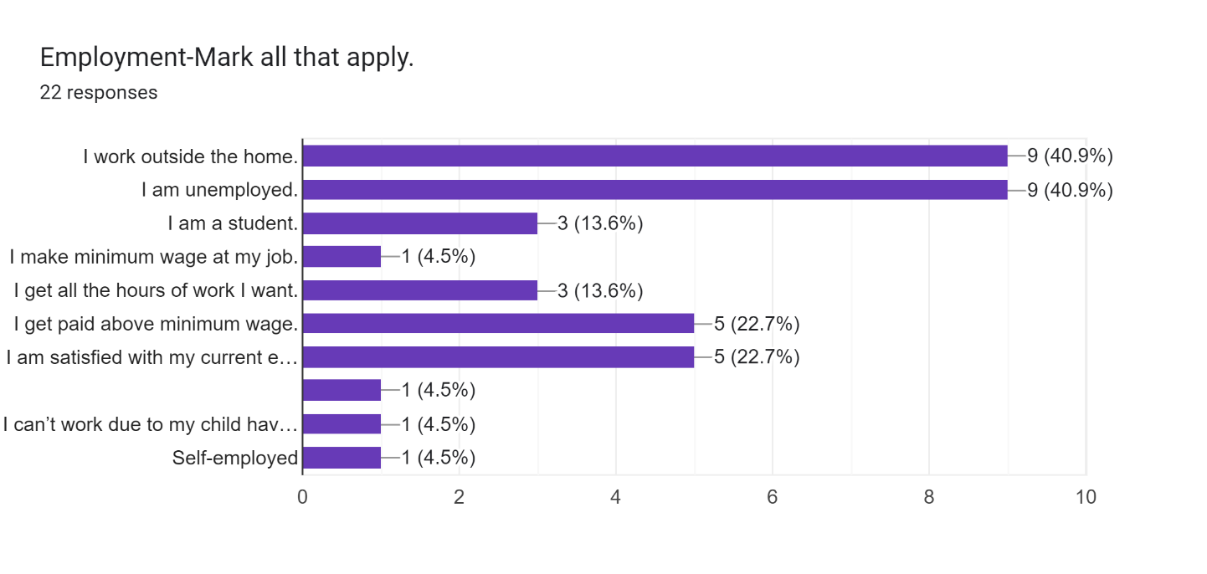

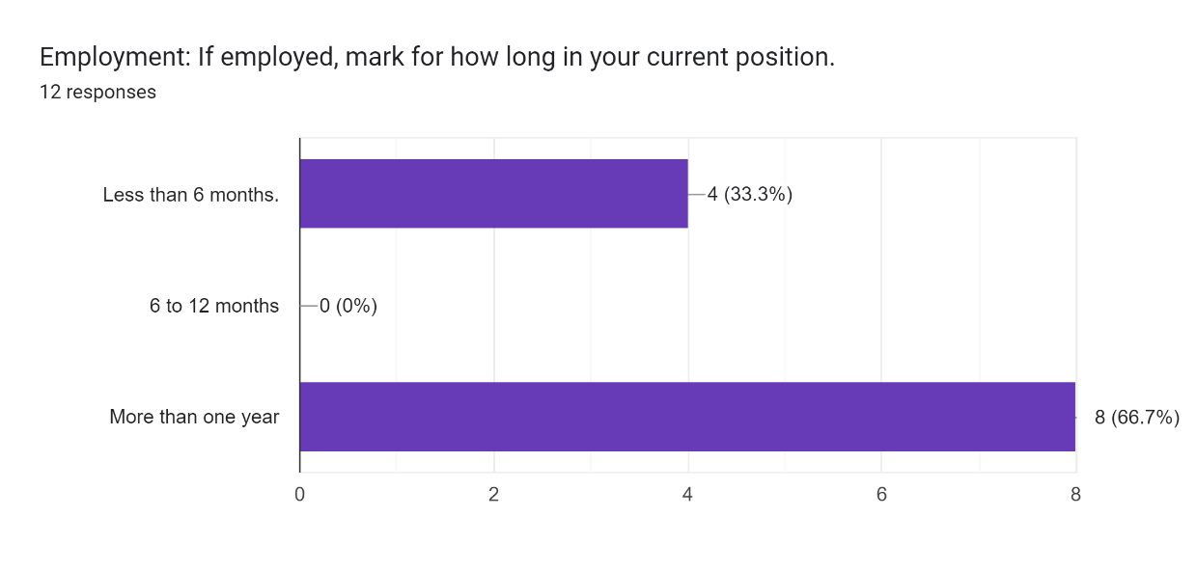

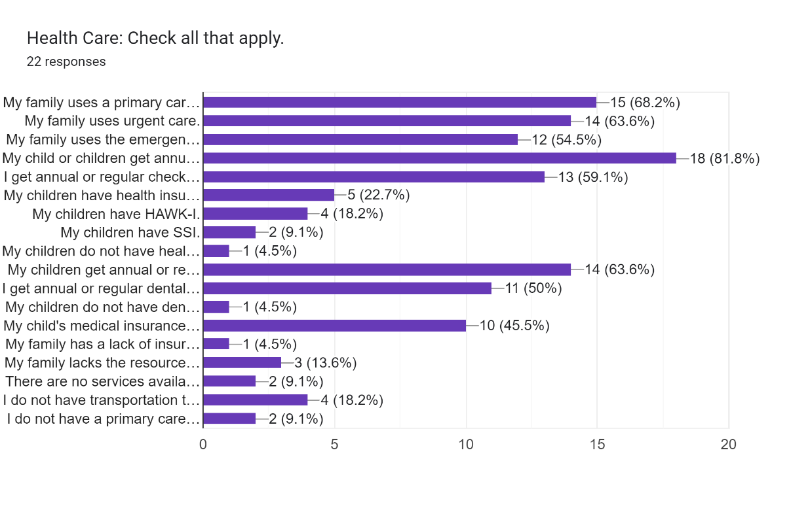

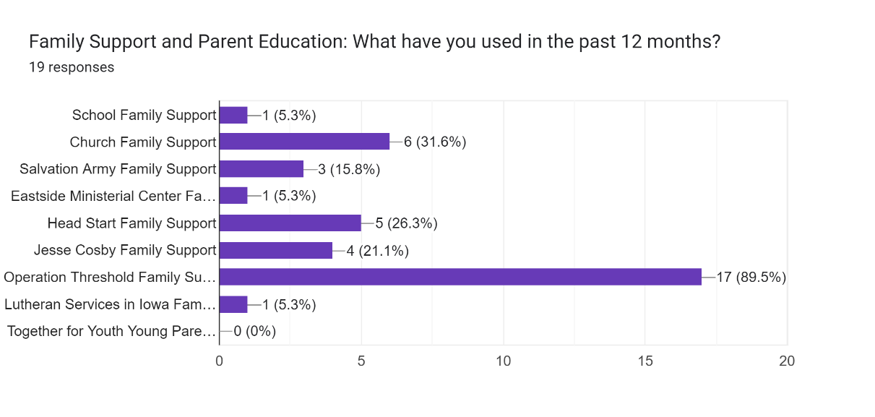

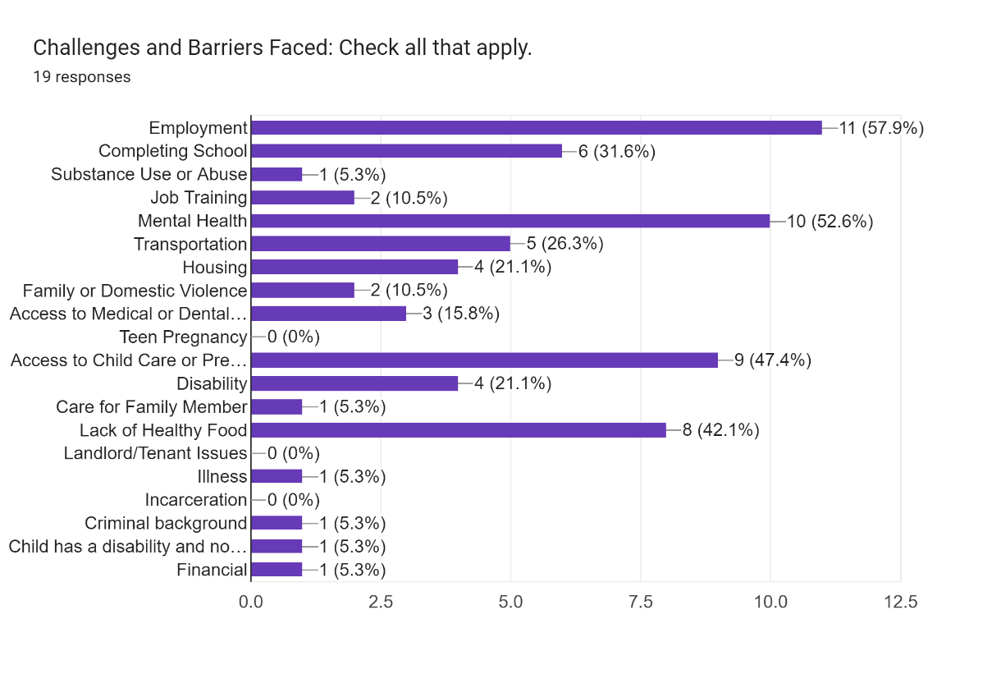

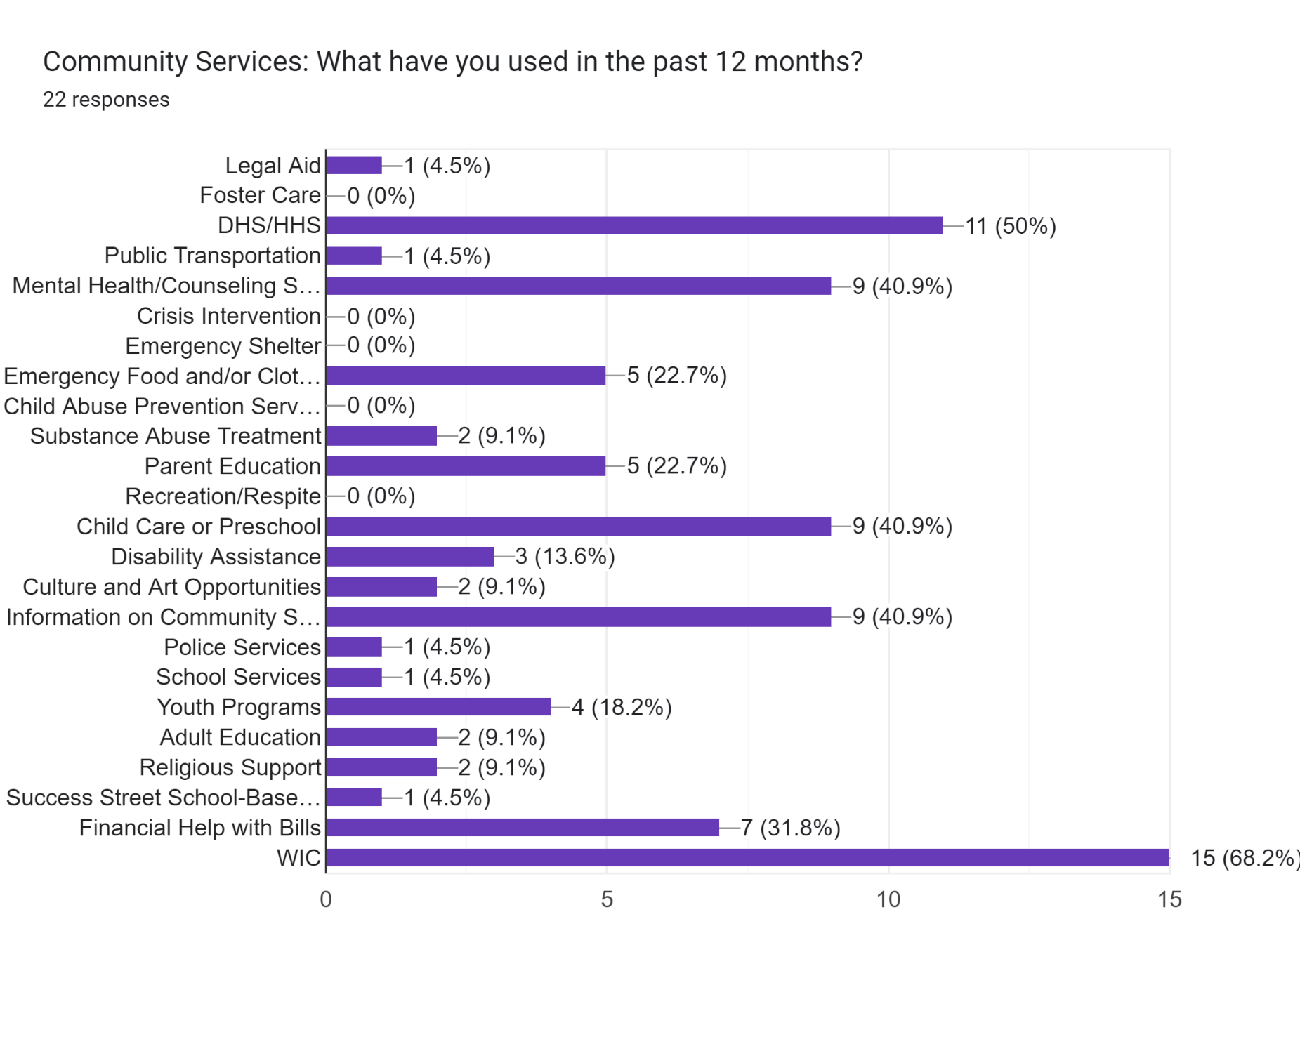

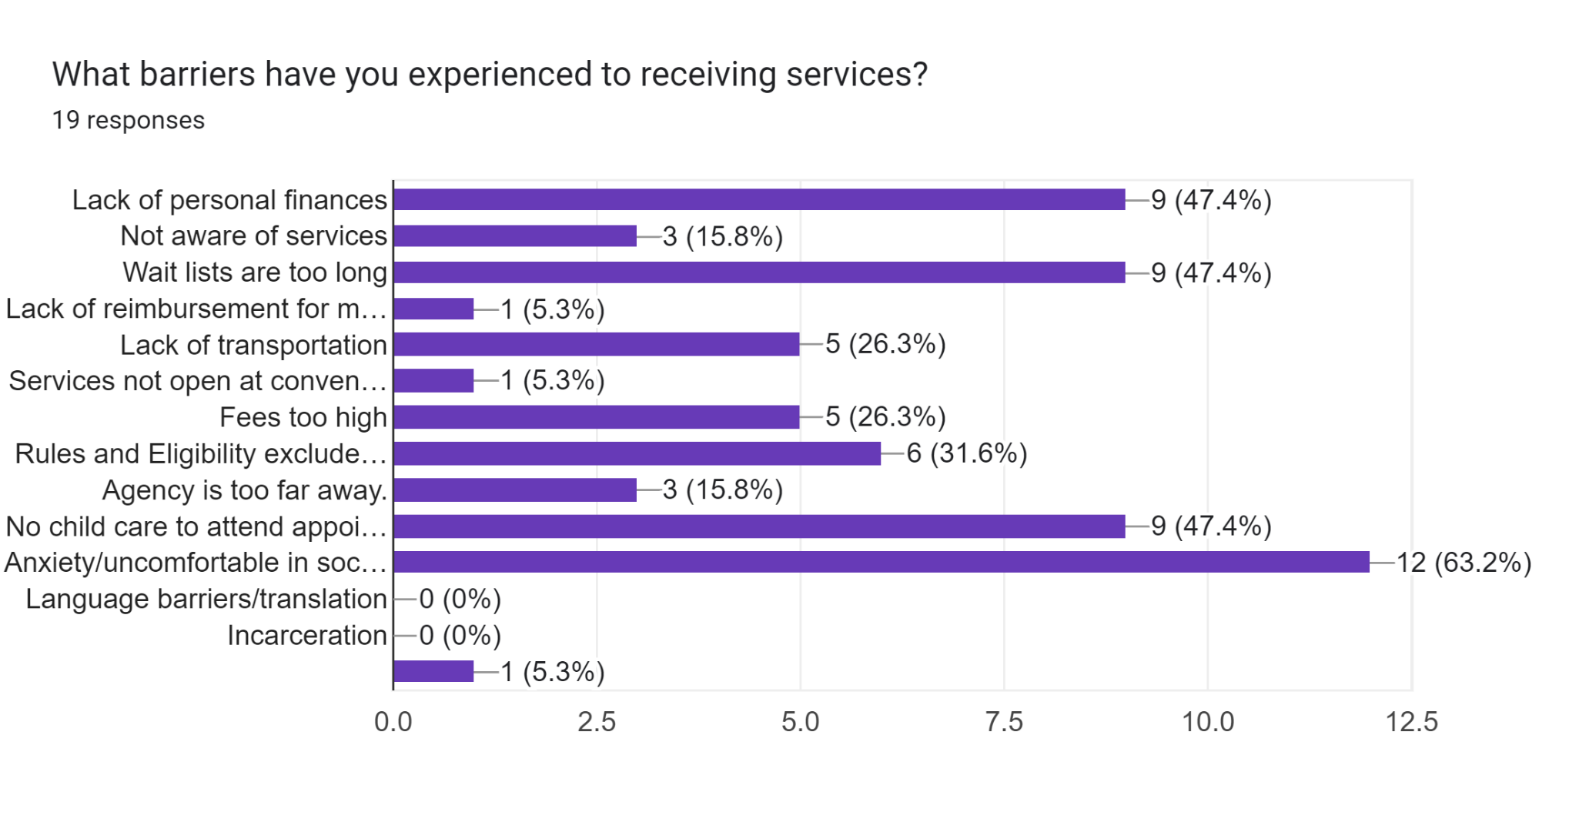

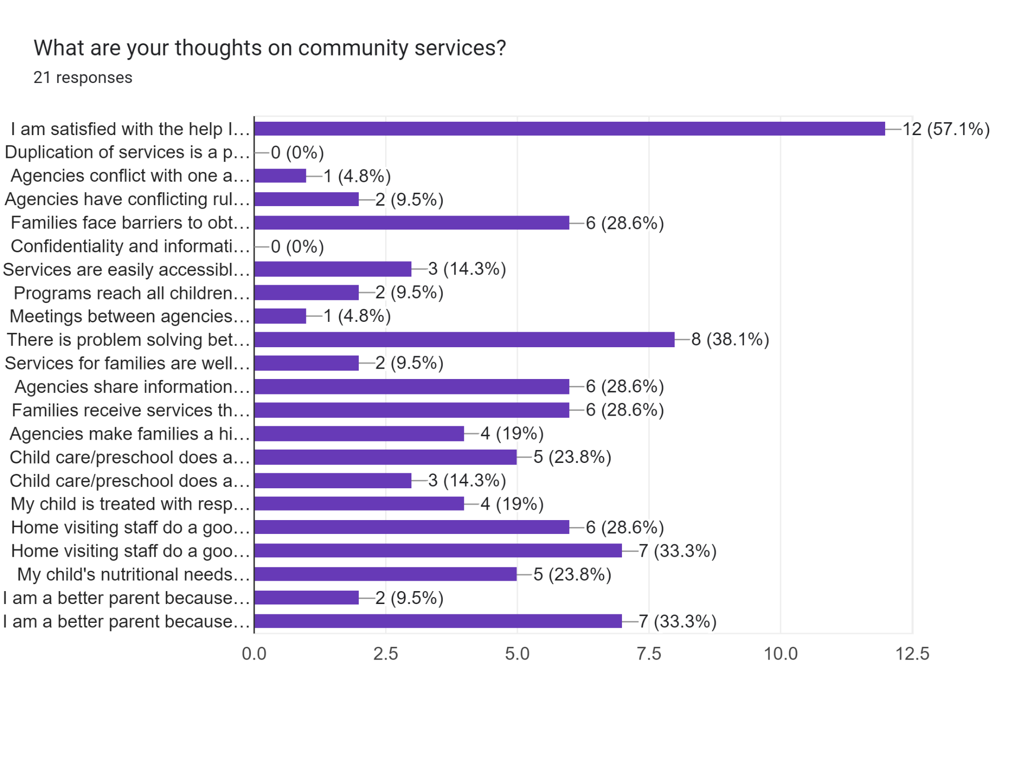

**Community Service Providers Results**

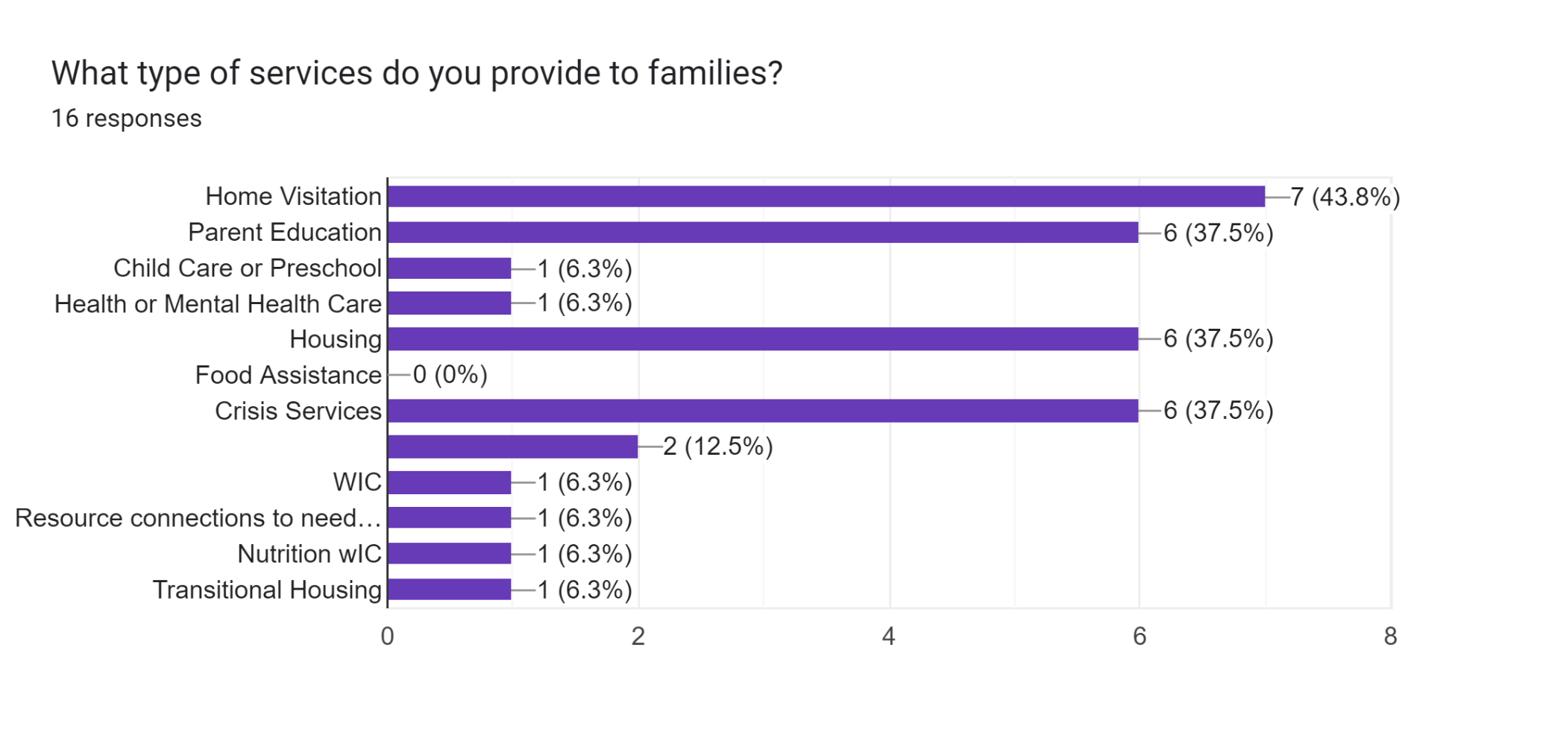

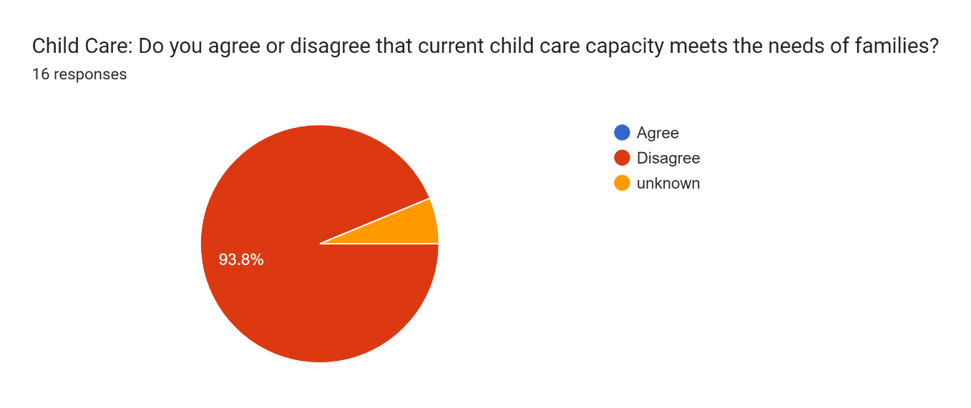

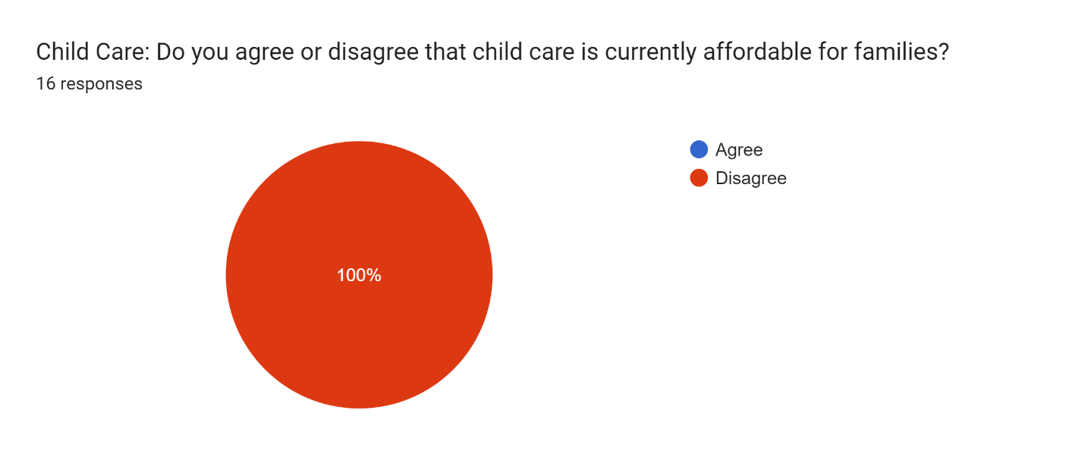

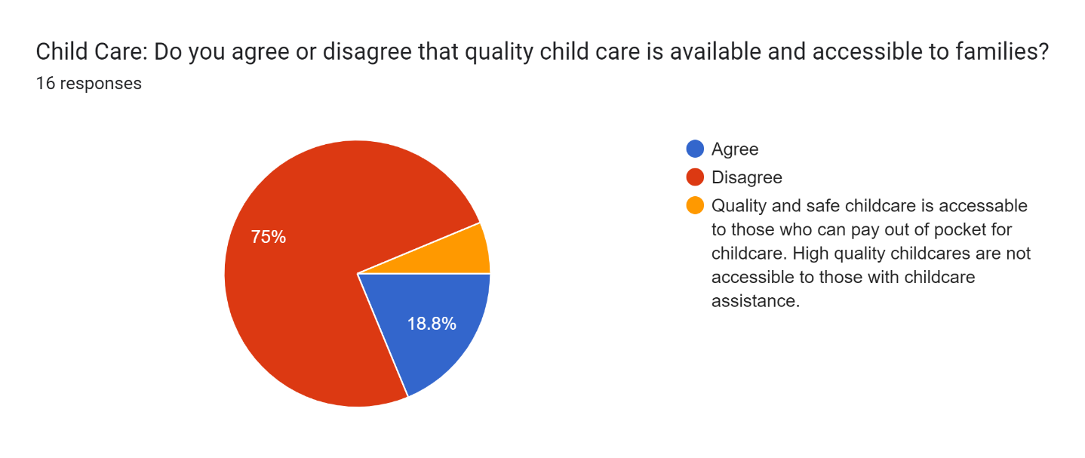

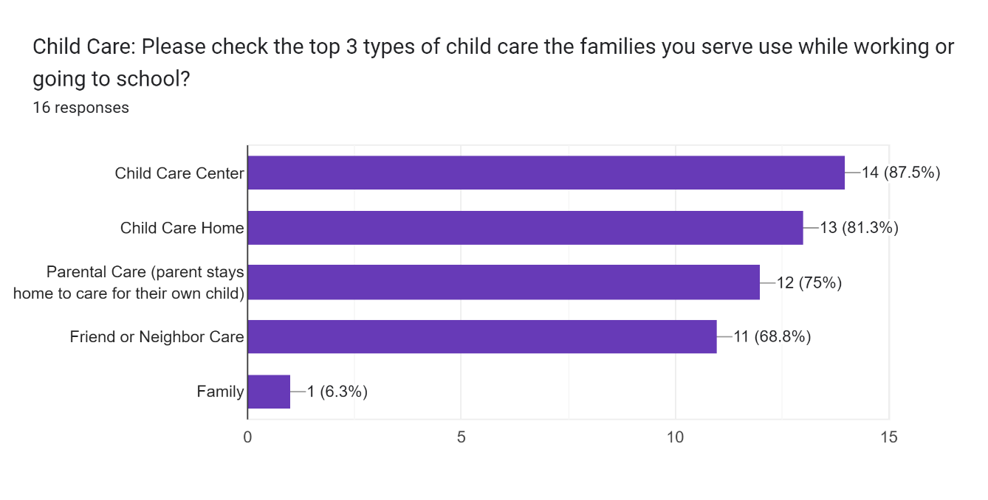

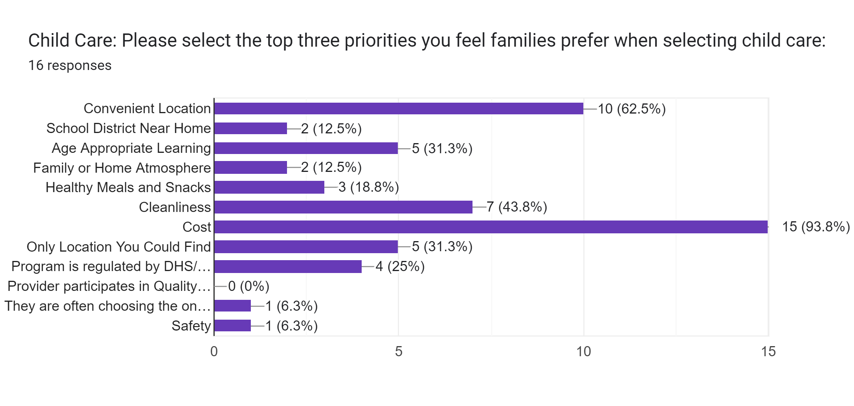

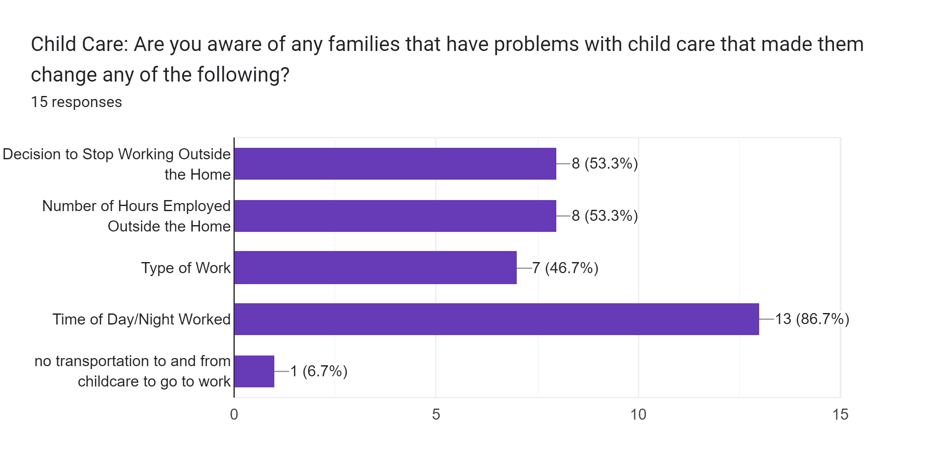

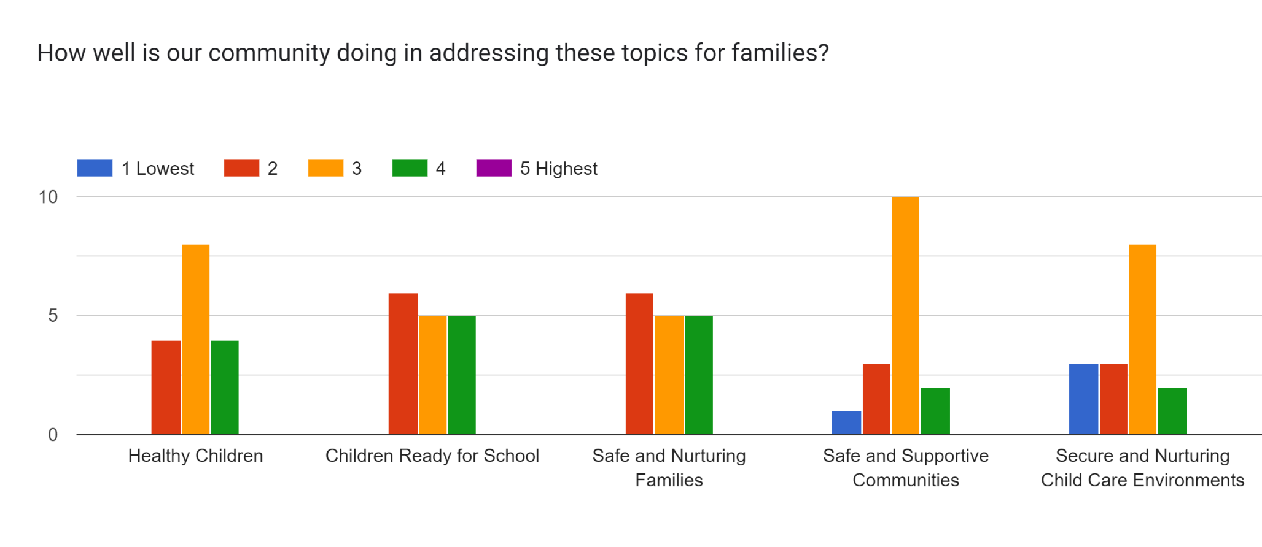

The small group in-person work of the Early Childhood Coalition led to this summary of strengths and weaknesses in our community.

Strengths

1. **Home Visitation and Parental Support**:
   * Strong home visitation programs with collaboration for parents.
   * Extensive prenatal classes, accessible resources, and parenting fairs.
   * Supportive coalitions and Medicaid coverage through age one.
2. **Collaborative Community Efforts**:
   * Strong cross-collaboration among different areas and organizations.
   * Good community collaboration, particularly in child care resources and referrals.
3. **Quality Programming**:
   * Quality educational programming including district pre-K options.
   * Coaching and technical assistance available, though there's a need for more business engagement and workforce support.
4. **Housing and Basic Needs**:
   * Section 8 and income-based housing options.
   * Support from local organizations like Habitat for Humanity and churches.
5. **Support for Families and Children**:
   * Programming for ages 3-5, with AEA handling some of these services.
   * In-home services, vision exams, and support for local child care programs.
6. **Food and Nutrition Resources**:
   * Community gardening, farmers markets, and SNAP benefits.
   * Programs to address food costs, summer meals for kids, and access to fresh food through clinics.
   * Support from organizations like YWCA and Farm to ECE.
7. **Health and Wellness Services**:
   * Multiple options for health services, including i-Smile and People's Clinic.
   * Support from the Black Hawk County Health Department and Hawk-I insurance.
8. **Cultural and Community Engagement**:
   * Recognition of the need for cultural components in training and community services.
   * A strong collaboration network involving CCR&R and other local entities.

These strengths reflect a well-connected community with a range of services supporting health, education, and basic needs, while also identifying areas where further engagement and support are needed.

Weaknesses

1. **Transportation and Accessibility:**
   * Significant challenges with transportation, particularly for accessing healthcare and behavioral health services.
   * Accessibility issues in rural areas, especially for prenatal care, birth control, and mental health services.
   * Technology access issues, limiting participation in online resources or programs.
2. **Cost and Insurance:**
   * High costs associated with healthcare, housing, and food, along with limited insurance coverage.
   * Difficulty in finding providers that accept Medicaid/HAWK-I, especially for dental and mental health services.
   * Inadequate rental assistance and insufficient funding for low-income housing.
3. **Cultural and Language Barriers:**
   * Cultural differences and language barriers impacting the effectiveness of healthcare, prenatal care, and community services.
   * A lack of culturally specific parenting classes and mental health services for multicultural and diverse families.
   * Insufficient interpretation services for non-English speakers.
4. **Mental Health and High-Risk Populations:**
   * Limited mental health services, especially for high-risk populations like those with high-risk pregnancies and those in rural areas.
   * Long waiting periods for mental health services and a general stigma associated with seeking mental health care.
   * A need for more mental health providers and awareness of mental health needs in the job market.
5. **Housing and Shelter:**
   * Limited availability of shelters and affordable housing, particularly in rural areas.
   * Long waitlists for housing assistance, with rental assistance often insufficient to secure safe housing.
   * Issues with the quality of housing, including the presence of slum lords and substandard living conditions.
6. **Education and Childcare:**
   * Lack of early childhood centers, staff shortages, and long waiting lists.
   * Inadequate services for children with special needs and the impact of preschool only programs taking away business from other types of child care settings.
   * Cuts to AEA funding affecting educational programming for children.
7. **Food and Nutrition:**
   * Limited access to healthy food, especially for certain communities like Pacific Islanders.
   * Challenges with food banks, including a lack of healthy options and decreased donations.
   * Issues with the summer food program for kids and access to food for families with special dietary needs.
8. **Awareness and Outreach:**
   * A need for better outreach and community messaging, especially around prenatal resources and program availability.
   * Lack of awareness of available resources, particularly in rural areas and among expecting mothers.
   * Community organizations not well-informed about prenatal resources, leading to gaps in service delivery.
9. **Healthcare Services:**
   * Shortages of healthcare providers, especially for high-risk pregnancies, pediatric dental care, and rural areas.
   * Issues with accessing birth control and inconsistent standards of care due to language and cultural barriers.
   * High infant mortality rates among African Americans and restrictive abortion laws creating further challenges for prenatal care.

This summary highlights significant gaps in access, awareness, and service delivery across multiple sectors, with particular emphasis on transportation, cost, cultural barriers, and mental health services. These weaknesses indicate areas where targeted interventions could improve overall community support and health outcomes.

**Summary of Needs Assessment Results**

Community needs remain very similar to those in past community plans. There still exists in our community a barrier to accessing quality, affordable child care. One item in the Community Survey that stands out is 100% of respondents feel that child care is not affordable for families. In fact, the top priority identified by community partners for families is affordability followed by convenient location and cleanliness. Adding to the challenge of child care in a convenient location is that almost 30% of families report living at their current address for less than 6 months. Access to child care also greatly affects parents’ ability to work outside the home. More than forty percent of families responding to our survey report that they are unemployed. The most common challenges identified by families is employment followed closely by access to mental health services and access to child care or preschool services. Most common barriers identified by families were anxiety or being uncomfortable in social settings, followed by lack of personal finances, wait lists too long, or no child care available to attend appointments. On the positive side, the two most identified feelings about community services identified by parents are that they are satisfied with the help they are receiving and that there is problem solving between agencies to fill gaps in services. The barriers identified in Black Hawk County are not dissimilar to those in other areas of the state. The quality of life in the Cedar Valley is affected by high occupancy rates in housing and a growing median monthly rent.

**Collaboration and Networking Opportunities**

The Executive Director of Cedar Valley’s Promise convenes partners locally every other month via the Early Childhood Coalition and monthly with the Black Hawk Interagency. The Early Childhood Coalition is made up of currently funded ECI programs as well as other community partners serving families with children ages 0-5 years. The Black Hawk Interagency is a much broader scope of service providers including those serving school-aged children, child care, housing and shelter organizations, juvenile court services, domestic abuse/sexual assault organizations, foster care and immigrant services, job/education support services, managed care organizations, and mental health service providers. In addition, the Executive Director attends the local CPPC meetings and is a member of Metro Funders made up of grant making organizations in the area. Recently, she joined the Northeast Iowa Child Abuse Prevention Alliance and is the chair of Cedar Valley Readers, the local Campaign for Grade Level Reading site. At the state level, the Executive Director is a member of both Iowa AEYC Executive and Governing Boards and a member of the ECI Steering Committee. She is also on the Professional Development Committee of the Association of Early Childhood Iowa Area Boards and Advocates and with that role regularly attends those board meetings and is a member of the Results Accountability Workgroup. She is also a member of a 3-person team that approves or denies exceptions to Family Support Exam waiver requests and is a member of the Oral Health Iowa coalition.

Early care environments are supported in Black Hawk County with a Child Care Nurse Consultant employed by the Black Hawk County Health Department and supported by Healthy Child Care Iowa.

**Priorities of the Early Childhood Iowa Area Board**

**CVP Community-wide Indicators:** The CVP Board reviews data through planning and monitoring activities. We have selected the following indicators as a snapshot of progress made toward the result areas (indicated below).

A – Children Ready to Succeed in School

B – Healthy Children

C – Secure and Nurturing Families

D – Safe and Supportive Communities

E – Secure and Nurturing Child Care Environments

|  |  |
| --- | --- |
| Priority | Rationale for Identification or Deletion of Priority |
| Children will have access to quality early education | Programs will be encouraged to participate in activities to increase quality including attending training, participating in coaching, participating in T.E.A.C.H./WAGE$ and participating in IQ4K or national accreditations |
| Number of early learning environments participating in a quality initiative | Early learning environments with high quality staff decrease mistreatment of children in care settings and increase a child’s school readiness skills. |
| Third Grade Reading Proficiencies | Research has shown that third grade reading proficiencies are a strong indicator of future academic success and have a direct correlation to graduation rates and dropout risks. |
| High School Graduation Rate | This is a widely accepted and relevant indicator for measuring progress with our community’s youth and future success. |
| Child Care Cost and Capacity | The availability of affordable and quality childcare has been identified as a stressor for working parents, and the majority of households in the service area have all parents in the workplace. |
| Number of confirmed or founded child abuse reports and type of abuse. | There are many underlying factors that contribute to child abuse and neglect. Examples include poverty, lack of parenting skills, mental health issues, substance abuse, etc. |
| Immunizations | The immunization rate is a good indicator that children are adhering to their physician-recommended well-child visit schedule. |

**Section III: Fiscal Assessment**

**Process Used to Gather Information/Collaborative Funding Identified**

During the 2024 Community Plan process, Cedar Valley’s Promise staff conducted outreach to social service agencies in the community. The following chart details the fiscal resources reported to Cedar Valley’s Promise Early Childhood Iowa Area by the responding agencies. In addition, annually in the end of year report, funded agencies share what other funds were used to support the work done with ECI dollars. In some cases, there is more funding from other sources than there is from ECI showcasing great collaborations.

**Early Childhood Iowa Area Fiscal Assessment Results Matrix**

**Early Care and Education**

|  |  |  |  |
| --- | --- | --- | --- |
| Organization | Ages Served | Services Provided | Source of Funds |
| Head Start | 3-5 years | Preschool | Federal |
| Early Head Start | 0-3 years | Center Based | Federal, ECI |
| Statewide Voluntary Preschool | 4-5 years | Preschool | State |
| Shared Visions | 4-5 years | Preschool | State |
| CCR&R | 0-12 years | Child Care Referrals & Training & Consultation | State, ECI |
| Iowa AEYC T.E.A.C.H. and WAGE$ | 18 years+ | Education Support and Wage Supplements | State |

**Family Support**

|  |  |  |  |
| --- | --- | --- | --- |
| Organization | Ages Served | Services Provided | Source of Funds |
| Early Head Start | 0-5 years | Home Visitation | Federal, ECI |
| Lutheran Services | 0-5 years | Home Visiting | Federal, State, Local, ECI |
| Operation Threshold Nest | 0-5 years | Group Parent Education | State, Local, ECI |
| Operation Threshold FADSS | 0-5 years | Group Parent Education | State |
| Operation Threshold PAT | 0-5 years | Home Visitation | State |
| Young Parents Together | 0-19 years | Group Parent Education | State, Local, ECI |

**Health & Well-Being**

|  |  |  |  |
| --- | --- | --- | --- |
| Organization | Ages Served | Services Provided | Source of Funds |
| Operation Threshold WIC | 0-5 years | Nutrition | Federal |
| 1st Five | 0-5 years | Screenings & Referrals | State |
| i-Smile | 0-21 years | Screenings, Fluoride, and Sealants | State |
| Hawk-i | 0-18 years | Medical & Dental Insurance | Federal, State |
| Medicaid | All Ages |  | Federal, State |

**Section IV: Use of Funds**

**2024 Process for Awarding Funds**

Cedar Valley’s Promise Board of Directors annually evaluates two options to determine the appropriate funding process as outlined in Policy 3.1. A condensed application and budget may be required for currently funded programs and/or a complete Request for Proposal (RFP) may be released to the public. All applications including currently funded programs must be submitted on the “CVP Proposal Format” located on the website [www.cedarvalleyspromise.net](http://www.cedarvalleyspromise.net) and emailed to current contractors. Applications are typically accepted annually during February, March, and April, and all funds are allocated for the upcoming fiscal year for services to begin on July 1.

The Board of Directors only awards funding to programs and services that are designed to address the priorities that the Board has identified in the Community Plan. Items to consider when determining funding requests for proposals will be current community priorities, performance of current contractors, levels of funding compared to previous year(s), and Early Childhood Iowa service types. The CVP Proposal Format located on the website is designed to lead the proposing agency or individual to clearly explain how the proposed program and/or service will contribute to the Board’s priorities as outlined in the Community Plan. It also addresses data collection and reporting performance measurements.

The Proposal Review Committee is the evaluation committee. The Proposal Review Committee reviews all applications, completes a rubric independently and then compile the results from rubric and make funding recommendations to the full board. The completed funding recommendation and analysis is shared at the next regularly scheduled meeting. The proposal guidelines and Policy 3.10 address the right to appeal. Both documents can be located on the website at www.cedarvalleyspromise.net.

Cedar Valley’s Promise Board uses priorities identified when funding decisions are being made and/or gaps in services have been identified. The Board observes collective data results of the indicators and encourages feedback from the community when reviewing priorities each year. If needed, the Board amends strategies to meet the identified priorities and any new local needs/gaps that may arise.

The Board evaluates the performance of programs funded by requiring quarterly progress and year-end reports from each program. The Board also reviews the Annual Report submitted through Iowa Grants. These reports allow the board to review the results of funded programs to ensure they are meeting the state required and locally contracted outcomes. Quarterly Reports and the Annual Report can be reviewed by visiting Cedar Valley’s Promise website at www.cedarvalleyspromise.net. The Executive Director annually conducts contract monitoring with each contractor and reviews success of program outcomes, program successes and challenges, fiscal records, insurance coverage, financial audit, attendance at Early Childhood Coalition meetings, and quarterly reports/DAISEY data. Contract monitoring the last few years have all occurred virtually allowing any or all board members to attend, listen to contractor information, and ask questions. Results from the monitoring of programs are communicated to the CVP Board. Corrective actions are created by the Director and Board if needed.

The Board annually evaluates their roles, responsibilities, and operations by completing a self-evaluation of their functions. It is the practice of the Board to invite and welcome community feedback at all board meetings and review planning meeting minutes and presentations from community collaborators. The Community Plan is approved by the Cedar Valley’s Promise Board prior to it being submitted to the State Early Childhood Iowa office.

FY25 Rubric

|  |  |  |  |  |
| --- | --- | --- | --- | --- |
| Name of Program | Type of Service | Outside Funding to Support Program | Meeting Current Contract Requirements | Measurable Results |
| Applicant 1 | Service Type |  |  |  |
| Applicant 2 | Service Type |  |  |  |
| Applicant 3 | Service Type |  |  |  |
| Applicant 4 | Service Type |  |  |  |
| Applicant 5 | Service Type |  |  |  |
| Applicant 6 | Service Type |  |  |  |
|  |  | 1-No outside funding | 1-Not meeting more than 1 contract requirement | 1-Applicant shows little results. Return on investment is poor. |
|  |  | 3-In-Kind Funding Only | 3-Not meeting 1 contract requirement | 3-Demonstrated history of measurable results. Return on investment demonstrated. |
| Name of Reviewer: |  | 5-Outside Funding | 5-Meeting All Contract Requirements | 5-Demonstrated history of measurable results. Return on investment strongly demonstrated. |

**Section V: Strategies, Indicators, and Desired Results**

**Strategies of the Early Childhood Iowa Area Board**

Cedar Valley’s Promise undertakes a number of strategies in order to effectively understand strengths and challenges in the community as well as to inform the public about the work being done to support children and families in Black Hawk County. The staff and board:

* Annually review by-laws and policies and pro
* Regularly update website
* Undergoes an annual audit
* Conducts contract monitoring annually
* Contractors present annually to the board
* Board evaluates the staff and itself annually
* Conflict of interest statements completed annually
* Recruitment of new/returning board members as needed
* Reviews quarterly reports from contractors 4 times per year
* Reviews financials at each board meeting
* Convenes the Early Childhood Coalition every other month
* Convenes the Black Hawk Interagency monthly
* Annual reports and annual fiscal reports are posted on the website.

In the past 4 years, the board has had more active engagement due to virtual meetings and has never not had a quorum. The board continues to prioritize early childhood funding to support the work of CCR&R in increasing the number and quality of child care programming in the county. We struggle as the rest of the state does with people leaving the field of child care due to low wages and lack of benefits. With more funding and/or community partnerships, we see this area as an opportunity for improvement. It’s better for the entire community to have a well-compensated and educated workforce in early childhood. School ready and quality funds have been targeted over the last 4 years to home visitation, group parent education, child care nurse consultant, preschool scholarships and coordinated intake. We are proud that all funded family support programs use evidence-based models. We struggle in filling all available family support program slots and are dedicating time and community collaborations to this effort currently. Coordinated intake has had decreasing success with families enrolling in referred services. Work on this service continues hand in hand with filling family support program slots. Family support programming also struggles with turnover and adequate compensation just like child care. Investments in the early years are paid back many times over with less services needed as children grow. Preschool scholarships have been an area of success. Many more programs are participating now than in the past. We have allowed programs more time to achieve an IQ4K rating, but anticipate requiring participation again in the future. We also have a waiting list of approved families so additional funding would be beneficial in the future.

**Indicators for Tracking Progress**

|  |  |  |  |  |  |  |  |  |
| --- | --- | --- | --- | --- | --- | --- | --- | --- |
| **EARLY CHILDHOOD IOWA AREA INDICATORS** | | | | | | | | |
| **Cedar Valley’s Promise Area Indicators** | Identify the State Results Linked to the Indicator by A, B, C, D, E | ***Identify***  ***Source of data for each Indicator*** | **Baseline Data**  **(date & numerical value)** | **Subsequent Year’s Data**  **(Trend Line)**  **Identify Year** | | | **Goal**  **(numerical value & projected timeline)** | **Progress Update**  **(Brief Analysis of data)** |
| Number of early learning environments participating in the quality rating system | A, B, D, E | Child Care Resource & Referral | 2011  37/285  13% | 2014  38/241  16% | 2020  76/236  32% | 2023  9/202  4% | Annual upward trend in regulated providers participating in QRS | We experienced a steady increase in QRS participation which has dropped significantly with the rollout of the new IQ4K system. We except participation to increase but it will be some time before we achieve the previous levels. |
| Child Care Capacity  Registered &  Licensed | A, B, C, D, E | Child Care Resource & Referral | 2011  5745 | 2014  5268 | 2020  7049 | 2023  6662 | Annual upward trend in # of safe childcare spaces available for our 0-12-year-olds | A marked decrease in spaces has occurred between the beginning of the pandemic and now. Fewer people are interested in opening child care programs. |
| Percent of families with all parents working and children under age 6 | A, B, C, D, E | State Library of Iowa | 2011  71% | 2014  72% | 2020  77% | 2023  74% | Consistency in families with parents working outside the home | Iowa ranks near the top consistently with all parents in the home working. Iowa’s employers depend on parents working. |
| Percent of median income for one infant in child care in registered and licensed care | A, B, C, D, E | Child Care Resource & Referral | 2011  12% home  15% center | 2014  12% home  15% center | 2020  11% home  15% center | 2023  11% home  14% center | Annual downward trend or less than the state average | The trend for the average income/child care costs has remained steady. However, Black Hawk County has a large percentage of families below the poverty level and costs shown are for one child when many families have multiple children. Child care is considered affordable when families pay no more than 7% of their income on child care. |
| Third Grade reading proficiencies | A, B | Iowa Dept of Education/iaschoolperformance.gov | 2006  75.3% | 2014  74.5% | 2017  70.4% | 2023  68.2% | Annual upward trend or above the state average | Summer slide and attendance have been determined to be detrimental to this goal. Early access to books and daily reading are essential to meeting this goal. |
| High school graduation rate | A, B, D | Iowa Kids Count/SuccessLink/Iowa Dept of Education | 2000  78% | 2014  84.3% | 2021  92.8% | 2023  90.4% | Annual upward trend or above the state average | Graduation rates are much higher than when our work began but there is a marked difference across school districts within the county. |
| Immunization rate | A, B, D | BH Health Department/I2D2 |  | 2000  84% | 2014  93.8% | 2022  75% | Annual upward trend or above the state average | There continues to be an upward trend in Black Hawk County. |
| Incidence of Child Abuse per 1000 for children 0-5 | A, B, C, D, E | I2D2 | 2009  39 | 2014  22 | 2020  27 | 2022  23 | Annual upward trend less than the state average | Black Hawk consistently has higher rates than the state average. |
| # and % of confirmed or founded child abuse reports that are age 0-5 | A, B, C, D, E | Department of Health & Human Services | 2000  610  NA% | 2014  222  53.1% | 2020  266  53.5% | 2023  192  56.1% | Annual downward trend less than the state average | The trend over time is decreasing numbers of child abuse cases, however, the percentage of 0-5 compared to all cases remains fairly consistent. |

**Process for Tracking Strategies, Indicators, and Desired Results**

The board reviews progress or lack thereof on indicators as well as performance of currently funded contractors at least 4 times per year including the annual report and the Executive Summary which details all the required state performance measures for each service type funded.