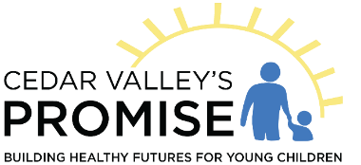
Thank you for inquiring about the Preschool Scholarship program. I am including the application as well as the information sheet about the program. I have also included a list of preschools that are enrolled in the program and accept children receiving scholarships as space allows.
You must meet income guidelines and attend an approved preschool to receive a scholarship. Scholarships are limited based on funding available and applications are processed in the order received, first come, first served. A waiting list will be maintained. The maximum amount awarded will be $300 per month, per child, but will not exceed the total tuition charged if less than $300.
Families at 100% of federal poverty or below qualify for head start and must attend head start if there is space available. If head start is full and cannot enroll additional children, you may qualify for a preschool scholarship if funding is available.
If you think you qualify for a preschool scholarship, please return the application with the income verification required via email to cedarvalleyspromise@gmail.com or by mail to Cedar Valley’s Promise, 4231 Cedar Ridge Circle, Hazel Green WI 53811.
If you have any questions, please contact me at 608-568-3062 or at the email address above.

Sincerely,

Brenda Loop
Executive Director

