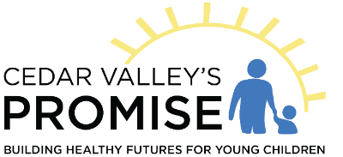
Preschool Scholarship Program 7/1/2022 – 6/30/2023

Cedar Valley’s Promise is pleased to offer funding for eligible children to have a preschool experience prior to entering kindergarten. Children must live and attend a preschool in Black Hawk County and meet income qualifications. You may choose the program you’d like your child to attend from a list of eligible programs.
Children must be at least 3 or 4 years old by September 15 of the program year. Priority is given to 4-year-olds, but 3-year-old children as of 9/15 may apply and if funding allows, 3-year-olds can be supported with a scholarship as well. A child who is age 5 prior to September 15, 2022, is not eligible unless there are extenuating circumstances that prevent the child from entering kindergarten.
Income eligibility can be determined over the phone by calling Brenda Loop at 608-568-3062. Families will need to know their gross annual income before calling. Income limits are designated in late February typically.
An application can be mailed or emailed directly to families or the preschool program. Families return the application with proof of income (current tax form or one month’s worth of recent consecutive pay stubs.)
After the application and supporting documentation is received, Brenda Loop will determine if the family qualifies. However, before scholarships can be awarded, Cedar Valley’s Promise funding must be approved which will be approximately July 1.
All preschools charging a tuition or fee to families are invited to participate but programs must be licensed by DHS. A list of approved programs will be provided to families as well as posted on our website at cedarvalleyspromise.net
A family may choose to send their children to one preschool up to 5 days a week. A preschool may be in a licensed center, but preschool is not child care, so a participating center must offer a preschool program.
This funding is available on a year-to-year basis, family must apply each year. Income guidelines change slightly each year also based on the federal poverty level.
Funding is available for up to $300 per month per eligible child. Funding cannot be used for registration fees, field trip fees, or supply fees, etc.
Families who qualify for head start must attend head start unless they are full.

