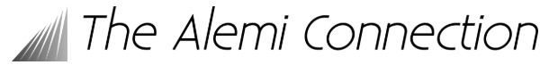

**Program Alemi-meeting Sunday 6 July**

**Venue: Vakwerkhuis. Location: Professor Snijdersstraat 2, Delft, the Netherlands**

**9:00 Welcome – Maria Santofimia, Erik Offerman and Hatem Zurob**

9:15 Michel Perez or PhD-student - Austenite to ferrite/bainite transformation

9:45 Marion Bregeault - Bainite nucleation, growth and overall kinetics

10:15 Zongbiao Dai - Deciphering bainite and martensite formation through mechanistic modelling and machine learning

**10:45 Break**

11:15 Philippe Maugis - Kinetics of martensite ageing

11:45 Antoine Kieffer - Austenite to acicular ferrite transformation

**12:15 Lunch break**

13:30 Wenzheng Zhang – Shear-Coupled Interface Migration—Theory, Simulation and  Experiments

14:00 Yongjie Zhang - Interface mobility

14:30 Kanon Sato - Interface mobility, solute drag effect

**15:00 Closure – Hatem Zurob, Maria Santofimia & Erik Offerman**

----------

15:15 Transfer to reception location of PTM2025 (10 minutes walking)

16:00 Reception PTM2025 at ‘Loetje’, Korte Geer 1A, Delft

More information about the Alemi-meeting location: <https://vakwerkhuis.com/contact/?lang=en>