To: Unit Owners

From: Dan Sheridan, President

Date: November 12, 2024

Re: Summit Broadband Fiber Optic Installation

On November 6, 2024, a representative from Summit Broadband held an information session for owners to discuss the next phase of the installation of the new fiber optic internet and TV service. A box for the new services has been installed in the closet of the second bedroom of each unit. To power the next phase of the upgrade, an electrical outlet and wiring will need to be installed in each unit near the broadband box installed in the second bedroom closet. The Board is presently seeking bids for the electrical work. **There may be a need to assess owners for the electrical work necessary for their unit.** This will be determined when the Board reviews its budget.

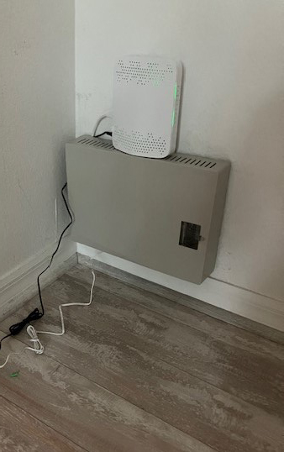 Summit Broadband box in second bedroom closet with temporary electrical connection pending outlet installation

Attached is a copy of the slideshow presented by the Summit Broadband representative.

Each Unit Owner should contact Summit Broadband Customer Care at **(877) 678-6648** to schedule your standard, no-charge installation of the new contract covered equipment. The standard, no-charge equipment installation will be available until **November 13, 2025**.

**A Unit Owner and/or their authorized representative must be present in the unit at the time of installation to show ID and provide signature**. Summit Broadband is not authorized to move any furniture or customer owned equipment. Residents are to make the necessary access to own equipment connections (back of TV, power outlets, etc.) upon installer arrival. If TV’s are installed on the wall or within a cabinet, it is the Unit Owners responsibility to remove the TV so the technician can readily access it.

While Summit will allow owners a full year to schedule the install, Summit would naturally like to get the process done as soon as possible. Please contact Summit to schedule your installation as soon as you will be in your unit or will have a responsible representative there.

Summit reports that Owners who have Samsung TV’s or ROKU may have difficulty interacting with the Summit app software. If the Samsung is the main TV connected to the box, this should work. But if the Samsung TV or ROKU stick are in another room, there may be difficulty getting cable channels. Summit reports that secondary TV’s should be smart TV’s or you can use an Amazon Firestick.

Any questions should be directed to Summit at the number provided above.