To: Unit Owners

From: Dan Sheridan, President

Date: August, 2020

Re: Information Update

1. **Fire System Upgrade Will Require Some Repainting** - As part of the renovations to our buildings, work was required inside each unit in order to bring us up to code for our smoke detection/fire alarm system. This work will require each owner to touch up/repaint the affected areas. Below are some photos showing the areas needing repainting in one unit.

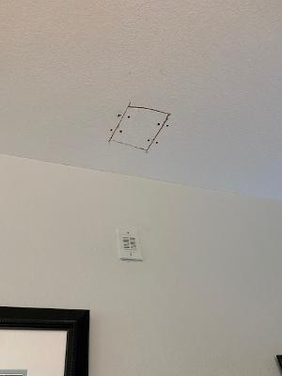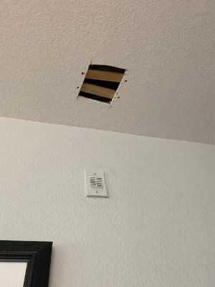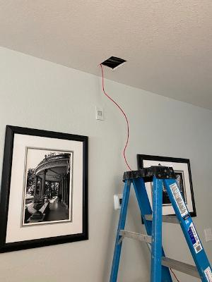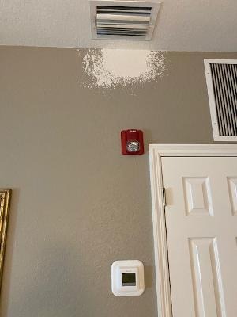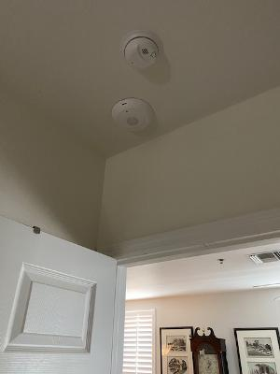

2. **Interior Renovations/Modifications** - For those in the rental pool or interested in joining, John Allard has indicated that an inventory will be taken for each unit with recommendations for upgrades, if needed, for the owners to consider. John indicated that he is working on getting quotes from local contractors with the possibility of some quantity discounts if a number of owners are interested. John has provided some suggestions for those interested in remodeling consistent with the Lark hotel theme:

*The best choice will be to go with neutral like:*

*Solid White Quartz Counters*

*White Shaker Cabinets with brushed chrome drawer pulls and knobs*

*Stainless Appliances*

*Subway tile backsplash.*

*LVT floors instead of tile.*

*Carry the white quartz into the bathrooms and recommend simple white subway tile for the shower enclosure (no cute details).*

*2 or 3"  carrera marble hex for the bathroom floors.*

*Walls should be white.*

*When we go further down the road with Larks FF&E they would want the hard surfaces to be neutral and have the FF&E and art stand out and create the design direction.*

 3. **Certificates of Completion for any Permitted Work** – Reminder to anyone having work done in your unit necessitating the pulling of a permit, make sure your contractor provides you with a copy of a **Certificate of Completion** from the City showing that the permit was properly closed out. Failure to do so could lead to unwelcome surprises and costs when you go to have future work done or sell the property. For additional information, please consult the city’s online guide to permitting and inspections: <https://www.cityofmarcoisland.com/building/page/guide-permitting-and-inspections>

4. **Elevators** – The elevator in Tarpon has passed all inspections and is operational. The renovation of the cab should begin on or about August 24 and should take several days for the walls and lights. We are trying to schedule for tile replacement to complete the elevator overhaul in Tarpon.

In Dolphin, the work is scheduled to begin August 31st and should take around 3 weeks. Once the mechanical work is completed, the renovation of the cab should commence. The elevator in Dolphin is predicted to be back in service by October 1.

Again, having the elevator out is a major inconvenience for those on the premises, but necessary for the extensive work being conducted. Please bear with us.

5. **Doors and Locks** – While the Board and Resort Management have arranged and paid for all of the work to date on our buildings, John and Max Allard are overseeing the doors and locks for the rental pool as the locks need to be compatible with the OMI/Lark system. The city has approved the locks and the doors are in. John and Max are awaiting the locks which they expect to be delivered within 6 weeks. Guardian Hurricane Protection will be installing the doors and locks (the same contractor who did such great work on the windows and sliders).

If you should have any questions, please do not hesitate to contact me or one of our other Board members. I hope you enjoy the remainder of your summer!