To: Unit Owners

From: Dan Sheridan, President

Date: June 12, 2024

Re: Board Meeting Update

I hope this letter finds you well.

Our most recent Board of Directors’ meeting was held today. Our next meeting is scheduled for September 18, 2024 at 10 a.m. EST. Please check our website to stay informed [www.oldemarcohoa.com](http://www.oldemarcohoa.com)

The Board is proud of how well-kept our buildings and grounds are. In an effort the keep things looking their best, the Board of Directors wants to remind owners of several issues.

Parking

Owners may not store vehicles in the Dolphin or Tarpon garage when they are not staying at their unit. As we know, we share parking with the shops and restaurants in the Olde Marco Inn and shops complex. This leads to very congested garages.

There has been a Jaguar parked in the Tarpon garage for an extended period of time. We have already confirmed it does not belong to any Tenant or employee of the properties’ retail operations.  We are making arrangements to have it towed from our garage. If you own this vehicle or know who does, please contact me at (413) 575-9664 or [dsheridanq@aol.com](mailto:dsheridanq@aol.com)

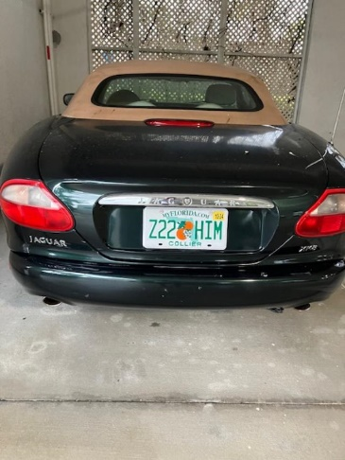

Owner/Realtor Locks & Lock Boxes

Owners (and their agents) cannot affix items to areas of common property without the express approval of the Board of Directors. There are presently a number of locks/lock boxes affixed to common areas such as the railing on Tarpon level 2. All locks and items affixed to common areas will be removed and discarded by Condo Association unless owner removes it prior to June 30. Thereafter, locks and other items affixed to common property without proper authorization will be removed without prior notice.

Bicycles

Owners may use the bicycle racks in the garage for their bicycles. However, if bicycles fall into disrepair or look unsightly (e.g. rusting, flat tires, etc.), they will be removed and discarded without further notice.

SIRS

In 2022, Florida enacted a law requiring condominiums having 3 or more stories to conduct a structural integrity reserve study (SIRS) to include the following:

* Requires condominium associations and cooperative associations to complete a structural integrity reserve study every 10 years for each building in an association that is three stories or higher in height.
* Requires associations existing on or before July 1, 2022, that are controlled by non-developer unit owners to have a structural integrity reserve study completed by December 31, 2024.
* Defines “structural integrity reserve study” as a study of the reserve funds required for future major repairs and replacement of the common elements based on a visual inspection of the common elements.
* Requires the study to include a visual inspection, state the estimated remaining useful life, and the estimated replacement cost of the roof, load bearing walls or other primary structural members, floor, foundation, fireproofing and fire protection systems, plumbing, and any item with a deferred maintenance or replacement cost that exceeds $10,000.
* Requires the visual inspection to be performed by a person licensed as an engineer or an architect. However, any qualified person or entity may perform the other components of a structural integrity reserve study.
* Provides that it is a breach of a board member or officer’s fiduciary duty if an association fails to complete a structural integrity reserve study.

Today, the Board selected the UES Milestone Inspections, LLC to conduct the required SIRS. Once we receive the report, we will update you.

Summit Broadband

The Board voted to enter an 8 year contract with Summit Broadband (our current provider and the largest provider of cable/internet services on Marco) to make the move from cable to fiber optic. Broadband providers want significant contract periods to justify running the fiber optic lines to all units. We were able to negotiate the contract from the proposed 10 year period to 8 years. It will take some time (estimated January, 2025), to get the fiber optic installed. During the install, Summit will be given access to each unit to allow for the installation. Below is a chart comparing the current services next to the services under the new contract.

Each unit will receive one set-top box. As long as the other TV’s in your unit are SMART TV’s, you will be able to stream channels from those as well. The cost for this service is part of your Condo Association assessments (dues). If you want premium services (Cinemax, ShowTime, The Movie Channel, etc.) or extra equipment (i.e. additional remotes), you may contract with Summit directly.

|  |  |  |  |
| --- | --- | --- | --- |
| **Current Agreement** | **Details** | **New Agreement** | **Details** |
| Price on January 1, 2025 | $79.05 | Price on January 1, 2025 | $74.99 |
| Annual Increase | 5% | Annual Increase | 4% |
| Internet Speed | 30 Mbps /  6 Mbps | Internet Speed | 2,000 Mbps /  2,000 Mbps |
| Wireless Router Included | No | Wireless Router Included | Yes |
| Wireless Extender Included | No | Wireless Extender Included | Yes |
| Streaming Set-top Box | No | Streaming Set-top Box | Yes |
| Whole-home DVR | No | Whole-home DVR | Yes |
| 3-day Rewind TV | No | 3-day Rewind TV | Yes |
| Voice Activated Remote | No | Voice Activated Remote | Yes |
| Netflix Built In | No | Netflix Built In | Yes |
| HBO | No | HBO | Yes |

Trying to Reason with Hurricane Season

If you happen to be on Marco, the rains have already told you that Hurricane season is upon us. Hurricane Information from the city of Marco Island at: <https://cityofmarcoisland.com/police/page/hurricane-information>

If you should have any questions or concerns or have any suggestions for making our property look its best, please do not hesitate to contact me at (413) 575-9664 or [dsheridanq@aol.com](mailto:dsheridanq@aol.com)