To: Unit Owners

From: Dan Sheridan, President

Date: September 25, 2024

Re: Board Meeting Update

I hope this letter finds you well.

Our most recent Board of Directors’ meeting was held on September 18, 2024. Our next meeting is scheduled for November 13, 2024 at 10 a.m. EST. Please check our website to stay informed [www.oldemarcohoa.com](http://www.oldemarcohoa.com)

In my June, 2024 letter to owners, I addressed the issue of parking. I am repeating the message below because we continue to have a vehicle stored in the garage of the Tarpon Building.

**Important reminders covered in our Condominium Documents:**

1. **Parking**

Owners may not store vehicles in either garage or on adjacent property when they are not staying at their unit. As we know, we share parking with the shops, the restaurants, and the Olde Marco Inn. This leads to very congested garages.

There has been a Jaguar (Florida Tags Z22 HIM) parked in the Tarpon garage for an extended period of time. If you own this vehicle or know who does, please contact me at (413) 575-9664 or [dsheridanq@aol.com](mailto:dsheridanq@aol.com) **This vehicle will be towed and stored at the owner’s expense if it is not immediately moved!**

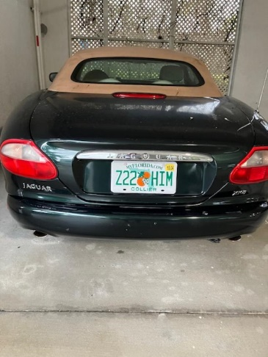

1. **Access to Units**

In accordance with Florida Law, Section 718.111(5)(a) of the Florida Condominium Act, as well as item 13 in our Bylaws, owners are required to provide access (key or entry code) to Resort Management (our property manager) so they can enter their units and their utility closet when necessary. This was also noted in my June, 2024 letter to owners. Failure to do so may result in damage to the owner's doors and/or locks and owner liability for any damage incurred due to the delayed access in the event of an emergency.

1. **Owners Renting Outside the Olde Marco Inn (OMI) Rental Pool**

Owners who are not participating in the OMI rental pool must inform their guests that they do not have access to OMI staff, nor OMI supplies or services (towels, linens, etc).

Also, per 18.1 of our Condominium Declaration, owners cannot list their units max occupancy at more than 6 persons (including children) and must have beds for each of those 6 persons. If there is only sufficient bed space for 4, then four is the maximum that can be advertised.

1. **Owners’ contact Information**

All owners must keep their contact information (phone & address) current with Resort Management. You may also want to provide your email as well so that we have multiple ways to reach you in the event of an emergency or an important message.

1. **Addition, Alterations, or Improvements**

This is a reminder that per 10.1 of our Condominium Declaration, any modifications or renovations to your unit require Board pre-approvalin addition toany city, county or state licensing/ permits. See ***form*** on website to request Board approval.

**Other Property Updates:**

1. **Automatic Water Shutoff and Leak Detector**

Given the time, aggravation and expense of water leaks, the Board is trying to budget for the installation of an automatic water shutoff and leak detector in each unit. We a presently looking at the system by *Moen Flo Smart Water Monitor and Automatic Shutoff* with sensors for the bathrooms, kitchen and utility closet. This system would require the installation of an electrical outlet in each owners closet (if there is not already one there).

We also remind owners that their hot water heater must be replaced within 10 years from the date of manufacture per the Condominium Documents. Owners anticipating replacement may to explore tankless electric water heaters which are reported to be more energy efficient (only heats water as it is used, not constantly heating and storing) and to have a longer useful life than conventional water heaters.

1. **Fiber Optic Installation**

The Board is awaiting information from Summit Broadband regarding the installation of fiber optic for TV/internet. The project is projected to be completed by January 2025.

1. **Annual Smoke Alarm Sprinkler Inspection**

On September 12, 2024, the annual smoke alarm/sprinkler inspection was conducted in all units.

If you should have any questions or concerns or have any suggestions for making our property look its best, please do not hesitate to contact me at (413) 575-9664 or [dsheridanq@aol.com](mailto:dsheridanq@aol.com)