Midsummer House
5 Deacon Place
Caterham
Surrey
CR3 5FN

RE: Happy Paws Caterham Update 2025

Welcome to 2025

Grooming Days (Carol Anne’s clients)

13/14/15/16 January 2025
10/11/12/13 February 2025
10/11/12/13 March 2025
14/15/16/17 April 2025
12/13/14/15 May 2025
9/10/11/12 June 2025
14/15/16/17 July 2025
11/12/13/14 August 2025
8/9/10/11 September 2025
13/14/15/16 October 2025
10/11/12/13 November 2025
8/9/10/11/12 December 2025

Puppy Groom £30
Full Groom £45
Cocker Spaniel Groom £40
Big Cockerpoos £50
(Bank transfer as agreed with Carol Anne)

Additional Grooming (Megan’s clients)
Bath, Brush Blow dry £15 small/medium dog. £20 large dog
Teeth (Plaque removal) £40

Please note our prices are changing from 20th Feb 2025 for walks.

Dog Walking: at Paw Park
Monday to Friday £16.00 per dog for up to 1 hour

Day Care:
£30 – per dog up to 8 hours (Mon – Thurs)
£25 – up to 4 hours (Mon – Thurs)
£35 – Puppies up to 8 hours (Mon – Thurs)
Additional Hours £5 per hour
Collection and drop off £5 (Within Caterham, Chaldon, Warlingham, Whyteleafe, Woldingham, Old Coulsdon and Kenley)
Please not that day care is only Monday to Thursday.

Weekend Day Care:
£35 – up to 8 hours (Sat – Sun)
Additional Hours £5 per hour
Collection and drop off £5 (within 3-mile radius)

Home Boarding:
£50 for each period of 24 hours (i.e 8am – 8am)
£5 per hour for additional hour or day care prices charged for partial days thereafter.

The following additional charges apply for Christmas Day, Boxing Day, New Years Eve and New Years Day = Double Rate
Bank Holidays and Good Friday – 1.5 standard rate
20/12 – 21/12 – 22/12 – 23/12 - 26/12- 27/12- 28/12 -29/12 – 30/12 1.5 standard rate
02/01 – 03/ 01 – 04/01 1.5 standard rate

Cancellations: Please remember I can only have a certain number of dogs each day for day care. I have dogs/puppies wanting to join all the time. We all have emergencies that occur from time to time and Happy Paws does not wish to add to the issues surrounding them, however a late cancellation means that a space is available that could have been offered to another dog had more notice been provided. Any cancellations must be given in writing/text/What’s App not less than 48 hours before the day care is to commence (This includes Ad Hoc Dogs). Any cancellations after this time will be fully chargeable as I do not have enough time to fill the now vacant spot. The only exemption will be medical reasons. To avoid a NO FEE cancellation then 1 weeks’ notice must be provided and your spot will be offered to those that are currently on the waiting list or wanting an ad hoc space. Please provide dates your dog is not attending due to holidays ASAP so the space can be offered to another.
The daily structure: Here is a summary of the daily structure at Happy Paws. (daycare)

6.30- 7.45 Amanda doing morning collections
7.45 – 8.45 am Drop offs at Happy Paws
9am -10am am Getting ready for Fairchild’s and doing additional collections
10am – 11am Fairchild’s Paw Park and open space
11am – 12pm Drop homes and washing dogs down
12 pm 1 pm Play and socialisation
1 pm till 2 pm Relaxation and rest
2 pm – 2.30pm getting ready for Take Homes
3pm – 5pm Take Homes
5pm Take Homes
5 pm dogs collected from Happy Paws (Any late pickups are chargeable £5 per hour)

Note: No collections between 1pm and 2pm unless prior arrangement as it disturbs the dog’s relaxation

Flea and Worming: This is essential for all dogs attending Happy Paws.
Vaccinations: Must be fully up to date and Kennel Cough must be included. Please send a copy every time your dog is vaccinated via What’s App or Email.
Your Holiday Dates: Please advise/give enough notice of any holidays you have booked if you are pulling dogs out of daycare/walks for us to plan accordingly.

Holiday Dates:
Closed for Easter 18/19/20 21st April re open 22nd April
Closed for family break 1/2/3/4/5 May reopening 6th May
Closed 26th May Bank Holiday.
Closed 25th Aug Bank Holiday.
Closed 22nd December 2025 to 5th Jan 2026

Coats: Please put your dog in a coat during winter, the field is very muddy. Please supply one that covers the tummy and full leg area of your dog. (This is in our Terms and conditions that you have agreed to). We sell Happy Paws doggie coats in black that are suitable, cost is £25.00. For larger dogs’ price may vary.
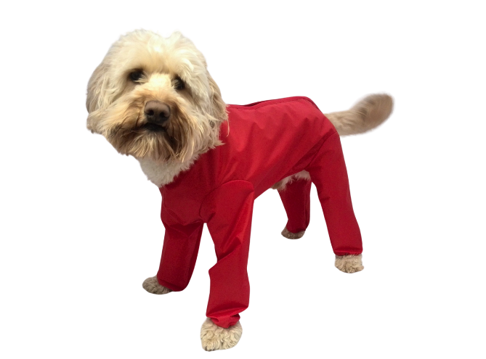
Thanks again for all your support, love and licks.

