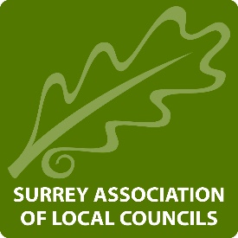

Surrey ALC Ltd.
Agenda for a Board Meeting of Surrey ALC Ltd. to take place at
Centenary Hall, Wheelers Lane, Smallfield, Surrey, RH6 9PT on 9th January 2020 at 1000
Item No. | Item Description | Action(s) | Who
 | Apologies for absence | To receive apologies for absence. | Chairman
 | Minutes of the previous meeting | To approve and sign the minutes of the meeting held on 24th September 2019 | The Board and Chairman
 | Finance | To receive an update report | CEO
 | Chairman’s Report on actions since last Meeting | To receive an update report | Chairman
 | CEO report | To receive updates from the CEO to include Health & Wellbeing and the staff update | CEO
 | Officer report | To receive an update from the DCEO | DCEO
 | Output and actions from the away day held on 7/10/2019 | To receive an update from the DCEO | DCEO
 | Spring Conference | To note arrangements | DCEO
 | Strategy Review | To receive an update from the Chair and CEO | CEO
 | Events and training | To note upcoming Three Counties Training events. | CEO and the Board
 | NALC update | To receive an update on any NALC matters since the last meeting. | CEO
 | SERCAF | To receive an update on any SERCAF matters since the last meeting. | CEO
 | Updates from Directors | To receive any updates from Directors | DCEO and the Board
 | 2020 dates | To note the Surrey ALC meeting cycle for 2020 (previously circulated) | The Board

