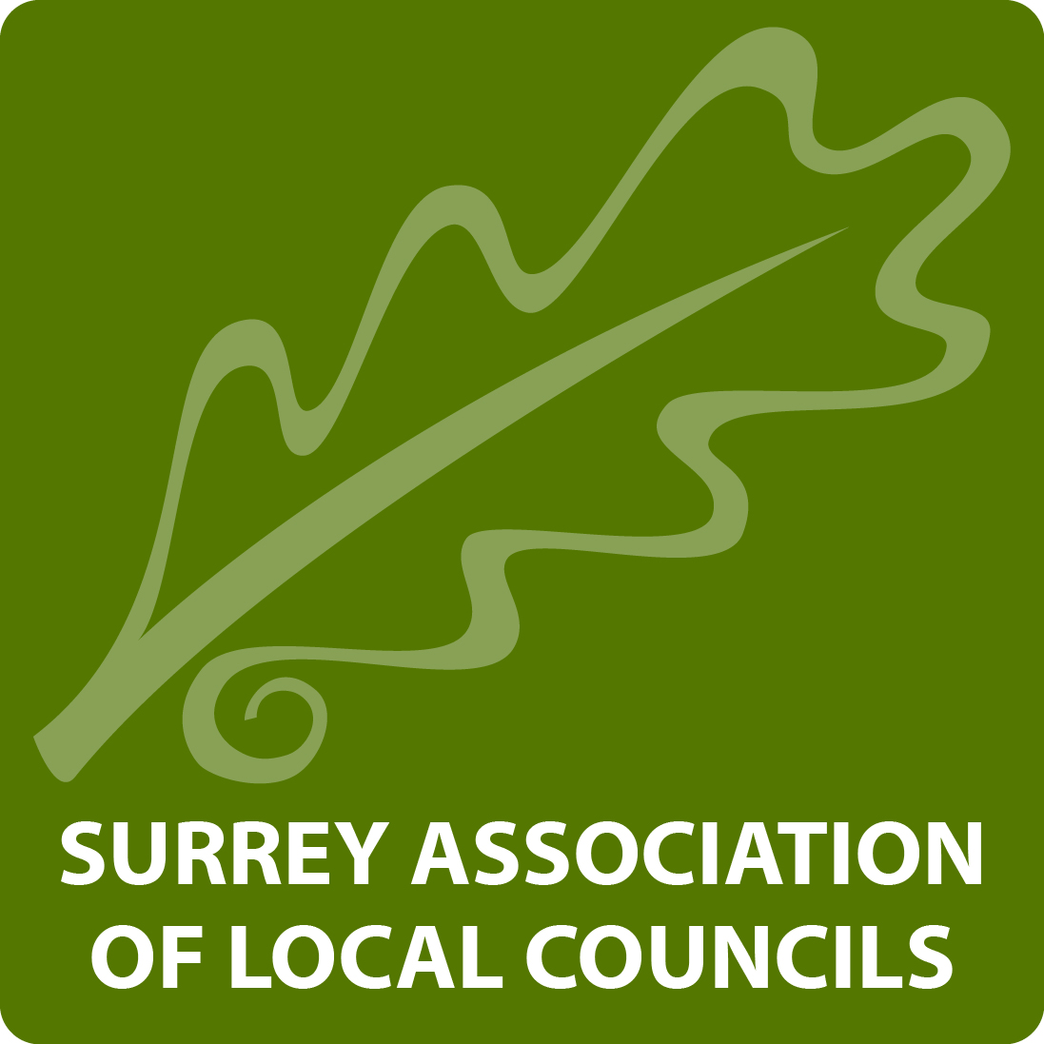
SURREY ASSOCIATION OF LOCAL COUNCILS
Suite C, Sackville House, Brooks Close, Lewes, East Sussex, BN7 2FZ
Minutes of the Annual General Meeting 2018
The Annual General Meeting of Surrey ALC Limited took place on Thursday 15th November 2018 at 9:50am in the Grand Hall, Dorking Halls, Reigate Road, Dorking

Attendance –
Directors – Richard, Olliver, Graham Alleway, Dr Paul Cragg, Harry Fitzgerald, Steve Cosser and Mark Mulberry

Members –
See full attendance list on third page.
Officials –
Michael More-Molyneux , (President), Liz Cutter (Vice President), Chris Howard (Vice President), Betty Ames (Vice President), Peter Perdue (Council Rep), Trevor Leggo (CEO Surrey ALC), Anne Bott (Deputy CEO Surrey ALC), Anna Beams (Office, Training & Events Manager), Jodi Wilson (Office, Finance Clerk) and Paul Richards (Office, Clerk to the Boards)

1. Welcome by the President –
The Surrey ALC President, Michael More-Molyneux HM Lord-Lieutenant of Surrey, welcomed all in attendance. He thanked all parishes for their continued hard work for the important role they played across the County.
2. Apologies –
No apologies were noted.
3. Minutes of the Annual General Meeting –
The minutes of the Annual General Meeting held on 12th October 2017 were approved and signed.
4. Presentation of the Annual Report and Accounts for the Year Ended 31 March 2018 –
The Chairman presented the previously circulated Annual Report and Accounts for the Year Ended 31st March 2018.
5. Election of the Directors –
Following questions and observations from Members, the following nominated Directors were elected to the Board:
Graham Alleway – West End Parish Council
Stephen Cosser – Godalming Town Council
Dr Paul Cragg – Worplesdon Parish Council
Harry Fitzgerald – Dormansland Parish Council
Mike Goodman – Windlesham Parish Council
Stuart McLachlan – Capel Parish Council
Peter Perdue – Newdigate Parish Council
Roger Taylor – Hedleys Solicitors LLP
Mark Mulberry – Mulberry and Co

6. Election of Chairman –
The President thanked the former Chairman, Dr Richard Olliver for his outstanding service to the Board. Cllr Harry Fitzgerald was re-elected Chairman of SALC.
7. Election of Vice Chairman –
Cllr Stephen Cosser was elected Vice Chairman of SALC.
8. Appointment to outside bodies –
The following appointments were made to represent Surrey ALC Ltd. on outside bodies –
- Surrey Hills Partnership – Liz Cutter, Vice President
- South East Regional County Association Forum (SERCAF) – The Chairman and Vice Chairman
- National Association of Local Council (NALC) – The Chairman
- Surrey Countryside Rural Enterprise Forum (SCREF) – Christine Howard
9. Election of Vice Presidents –
Cllr Liz Cutter, Cllr Betty Ames & Mrs Christine Howard were re-elected. Dr Richard Olliver was elected.
10. Any other matters –
There were no other matters.

SIGNED……………………………………………………………………………………………. 29th October 2019

Surrey AGM & Conference - 12th Oct – Member Attendance
Council Name |  | Name
 | Betchworth Parish Council |  | J Hardy
 | Bisley Parish Council |  | Cllr. Malcolm Vaughan
 | Bletchingley Parish Council |  | Linda Baharier
 | Buckland Parish Council |  | Debbie Jones
 | Burstow Parish Council |  | Jeannie Ryan
 | Burstow Parish Council |  | Debbie Hale
 | Burstow Parish Council |  | Ian Wates
 | Busbridge Parish Council |  | John Graves
 | Caterham Valley Parish Council & Oxted Parish Council |  | Maureen Gibbins
 | Caterham Valley Parish Council |  | Cherie Callender
 | Chiddingfold Parish Council |  | Tim Forrest
 | Churt Parish Council |  | Dawn Barrow
 | Churt Parish Council |  | David Crossley
 | Claygate Parish Council |  | Mark Sugden
 | Cranleigh Parish Council |  | Beverley Bell
 | Cranleigh Parish Council |  | Soo Simmonds
 | Cranleigh Parish Council |  | Beverley Bell
 | Cranleigh Parish Council |  | Soo Simmonds
 | Crowhurst Parish Council |  | Christine Pudney
 | East Horsley Parish Council |  | Nick Clemens
 | East Horsley Parish Council |  | Stephen Groom
 | Effingham Parish Council |  | Cliff Hackett
 | Ewhurst Parish Council |  | Mike Turner
 | Ewhurst Parish Council |  | Jane Bromley
 | Farnham Town Council |  | Carole Cockburn
 | Farnham Town Council |  | Mike Hodge
 | Headley Parish Council |  | David Preedy
 | Headley Parish Council |  | Jon Laverty
 | Horley Town Council |  | Cllr Mike George
 | Horne Parish Council |  | David Brown
 | Horne Parish Council |  | Alison Brown
 | Leigh Parish Council |  | Adria Kinloch
 | Leigh Parish Council |  | Joanne Cambra
 | Mickleham Parish Council |  | Rev. David Ireland
 | Ockley Parish Council |  | Dick Thomas
 | Ripley Parish Council |  | Jennie Cliff
 | Shalford Parish Council  Shalford Parish Council |  | Alan Midgley  Nigel Keane
 | Shere Parish Council |  | Raymond Smith
 | West End Parish Council |  | Adrian Page
 | West Horsley Parish Council |  | Mel Beynon
 | Whyteleafe Village Council |  | John Cheetham
 | Windlesham Parish Council  Windlesham Parish Council |  | Barry Stacey  Ursula Trentham
 | Wonersh Parish Council |  | Rod Weale
 | Worplesdon Parish Council |  | Sandra Morgan
 | Worplesdon Parish Council |  | Gaynor White
 | Worplesdon Parish Council |  | Chris Venables
 | Worplesdon Parish Council |  | Nigel Mitchell
 | Worplesdon Parish Council |  | Jane Wray

