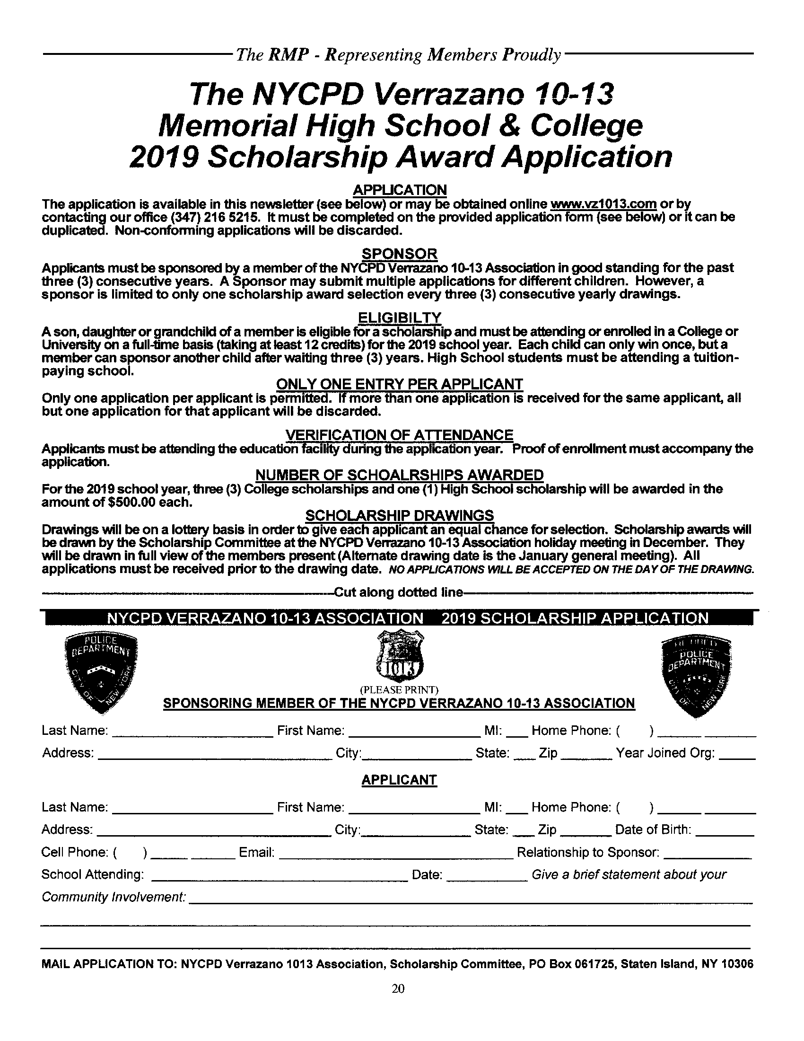

**NYCPD VERRAZANO 10-13 ASSOCIATION 2020 SCHOLARSHIP APPLICATION**

**2020 Scholarship Award Application**