HOT DOGS
All the Way 2.85
(mustard, slaw, onions, chili)
Onion Dog 2.75
(mustard, onions, chili)
Slaw Dog 2.85
(mustard, slaw, chili)
Chili Dog 2.75
(mustard, chili)
Cheese Dog 3.15
(mustard, melted cheese, bacon bits)
Sausage Dog 3.50
(mustard, grilled peppers & onions)

Plain Dog 2.25
(plain with ketchup or mustard)
Make it a Beef Dog, add 1.55

HAMBURGERS
Western Wrangler 5.65
(BBQ sauce, cheese sauce, real bacon pieces & grilled onions)

Supreme 6.75
(2 patties, special sauce, lettuce and cheese)
Madison 4.75
(mayo, lettuce, tomato, onion)
Roxburger 4.25
(mustard, ketchup, pickle, onion)
Old Timer 4.60
(mustard, chili, onion)
Plain Hamburger 3.75
(with mayo, mustard or ketchup)

Add cheese to any hamburger .75
Regular Combo 3.50
(Sm fries, potato chips or sm tater tots & med drink)

Stuart-Size 3.95
(Lg fries, potato chips or lg tater tots & large drink)

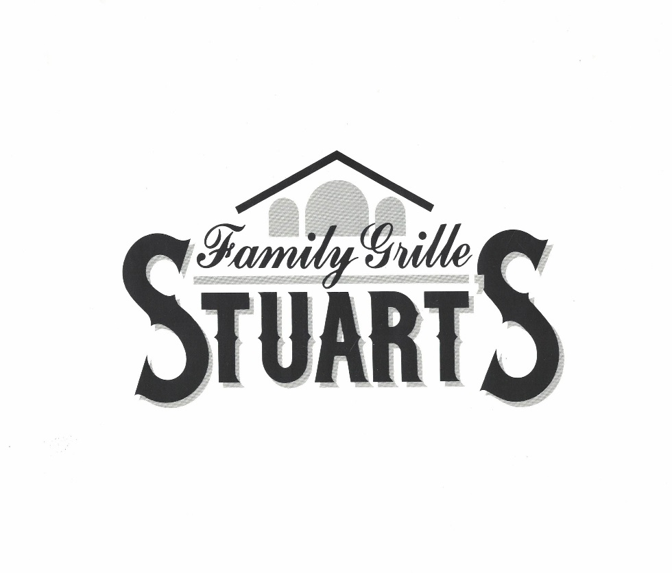
BREAKFAST BISCUITS
Made from scratch every morning!
Chicken 4.10
Country Ham 2.90
Sausage 2.45
Steak 3.25
Bacon 3.30
Bologna 3.15
Tenderloin 3.45
Egg 1.95
Gravy 2.99
Butter 1.45
Add egg to any biscuit 1.00
Add cheese to any biscuit .75
Add tomato to any biscuit .79
Biscuit Combo 3.50
(Tater Tots or small fry & medium drink)

BREAKFAST PLATTER
Start your day off right with 2 scrambled eggs, choose tater tots, fries or grits, add toast or a biscuit, and pick your choice of
Sausage, Bacon, Country Ham, Steak,
Tenderloin or Fried Chicken 7.99

BREAKFAST TRAY
Build your own breakfast! Choose any combination of the items listed below:
Bacon (4 slices) 3.80
Country Ham 2.80
Chicken 4.25
Sausage 2.20
Steak 3.15
Tenderloin 2.90
Gravy 1.85
Egg 1.40
Tomato (3 slices) 1.99
Grits 1.35
Biscuit 1.65
Toast 1.75

French Toast 3.95
Donut Rounds ½ doz .2.99 1 dozen 4.75

Tater Tots small 2.05 large 2.85
Grits small 1.35 large 1.95

Look inside for PARTY BISCUITS!

104 S. Madison Blvd
Roxboro, NC 27573
(336)597-2323
www.stuartsfamilygrille.com
@stuartsfamilygrille
@stuartsfamilygrille
Due to unexpected shortages in the supply chain, we may be unable to offer certain menu items at times. We appreciate your understanding and thank you for continuing to visit us.

You can now order online!
Visit our website or download our app for fast and easy ordering!

Hours of Operation
Monday–Friday 5am – 5pm
Saturday 6am – 5pm
Sunday 8am – 3pm

sunday

All prices subject to change without notice
SPECIALTY SANDWICHES
Fried Chicken 5.25
(mayo, lettuce, tomato, cheese)

Chicken salad 4.75
(lettuce & tomato on Texas toast)

BBQ 4.65
(chopped bbq, coleslaw)

Philly Cheese Steak 6.75
(Swiss cheese, grilled peppers & onions)

Classic Ham & Cheese 4.25
(ham, swiss, mayo, lettuce, tomato on hoagie roll)

BLT 4.95
(bacon, lettuce, tomato on Texas toast)

Grilled Ham & Cheese 3.60
(ham, American cheese on Texas toast)

Grilled Bologna 3.99
(mayo, lettuce, tomato, grilled onions)

Grilled Cheese 2.75
(2 slices cheese on Texas toast)

Regular Combo 3.50
(SM fries, potato chips or SM tater tots & MED drink)
Stuart-Size 3.95
(LG fries, potato chips or LG tater tots & LG drink)

SIDES
Corn Dog 2.75
French Fries small .….1.60 large 2.35
Chicken Bites small ……3.50 large 5.75
Chicken Salad 4.25
Cheese Fries 3.75
Chili Cheese Fries 4.75
Potato Chips 2.65
Tater Tots small .......... 2.05 large 2.85
Onion Rings 4.25
Hushpuppies ½ dz…. 1.99 1 dz 2.75
Potato Salad 2.95

STUART’S PLATTERS
Choose one of our delicious meats, any two of our tasty sides, add hushpuppies or a dinner roll, and finish with a 16oz drink.

Choose One
Chopped BBQ Fried Chicken Breast filet
Fried Pork Loin (2) Homemade Meatloaf
Hamburger Steak Chicken Salad
Chicken Bites

Choose Two
Turnip Greens Sliced Tomatoes Cabbage
Pinto Beans Green Beans Fried Okra
Potato Salad Yellow Corn Tater Tots
Cole Slaw French Fries
Sweet Potato Casserole
Mashed Potatoes w/Gravy

Platter (meat & 2 sides) 9.75
Platter (3 vegetables only) 7.75
Platter (4 vegetables only) 8.75

BBQ & STEW
BBQ Tray 6.25
(BBQ, slaw and 4 hushpuppies)
Brunswick Stew 5.99
(10oz bowl of stew with crackers or 4 hushpuppies)
Brunswick Stew Combo 9.75
(BBQ, stew, slaw and 4 hushpuppies)
BBQ Special (sandwich & cup of stew) 7.50
Brunswick Stew cup 3.50
Bowl of Pinto Beans 3.85

DESSERTS
Apple Turnover 1 for 1.65 2 for 2.99
Donut Rounds ½ doz .2.99 1 dozen 4.75
Cookies each 1.75
Chocolate Chip, Iced Oatmeal Raisin, Peanut Butter
Milkshakes 4.75
Chocolate, Vanilla, Strawberry, Cookies & Cream
Ice Cream Cup or Cone 1.95
Chocolate, Vanilla, Strawberry, Cookies & Cream
Add sprinkles .50

FRESH SALADS

Grilled Chicken Salad 9.50
Chef Salad 8.25
Garden Salad 7.25
Topped with Chicken Salad add 1.75

BEVERAGES
Best Brewed Iced Tea in Person County!
Small ….1.40 Med 1.50 Large 1.70

Pepsi Diet Pepsi Mt Dew Diet Mt Dew
Dr Pepper Lemonade Sierra Mist
Small 1.75 Med 2.10 Large 2.65

Coffee small 1.25 large 1.65
Orange Juice 2.25
Milk (plain & chocolate) small 1.70 large 1.95
½ Gallon Tea 3.25

BULK ITEMS

Green Beans pint …...5.50 quart 8.75
Pinto Beans pint ……5.50 quart 8.75
Fried Okra pint …... 5.99 quart 10.75
Mashed Potatoes
& Gravy pint …....5.50 quart 8.75
Yellow Corn pint …….5.50 quart 8.75
Turnip Greens pint……..5.50 quart 8.75
Cabbage pint……..5.75 quart 11.25
Cole Slaw pint …….5.50 quart 10.75
Sweet Potato
Casserole pint…...10.50 quart 19.50
Potato Salad pint……..7.25 quart 12.50
Diced Onions pint ….…3.60 quart 6.50

Chicken Salad pint 10.50
Chili pint…...9.25 quart 18.50
BBQ 1lb 12.00
Brunswick Stew quart 15.00

PARTY BISCUITS
One dozen bite-sized biscuits, perfect for parties, picnics and sharing!
Bacon, Sausage or Country Ham 9.75
Please call ahead 24 hours for ordering

