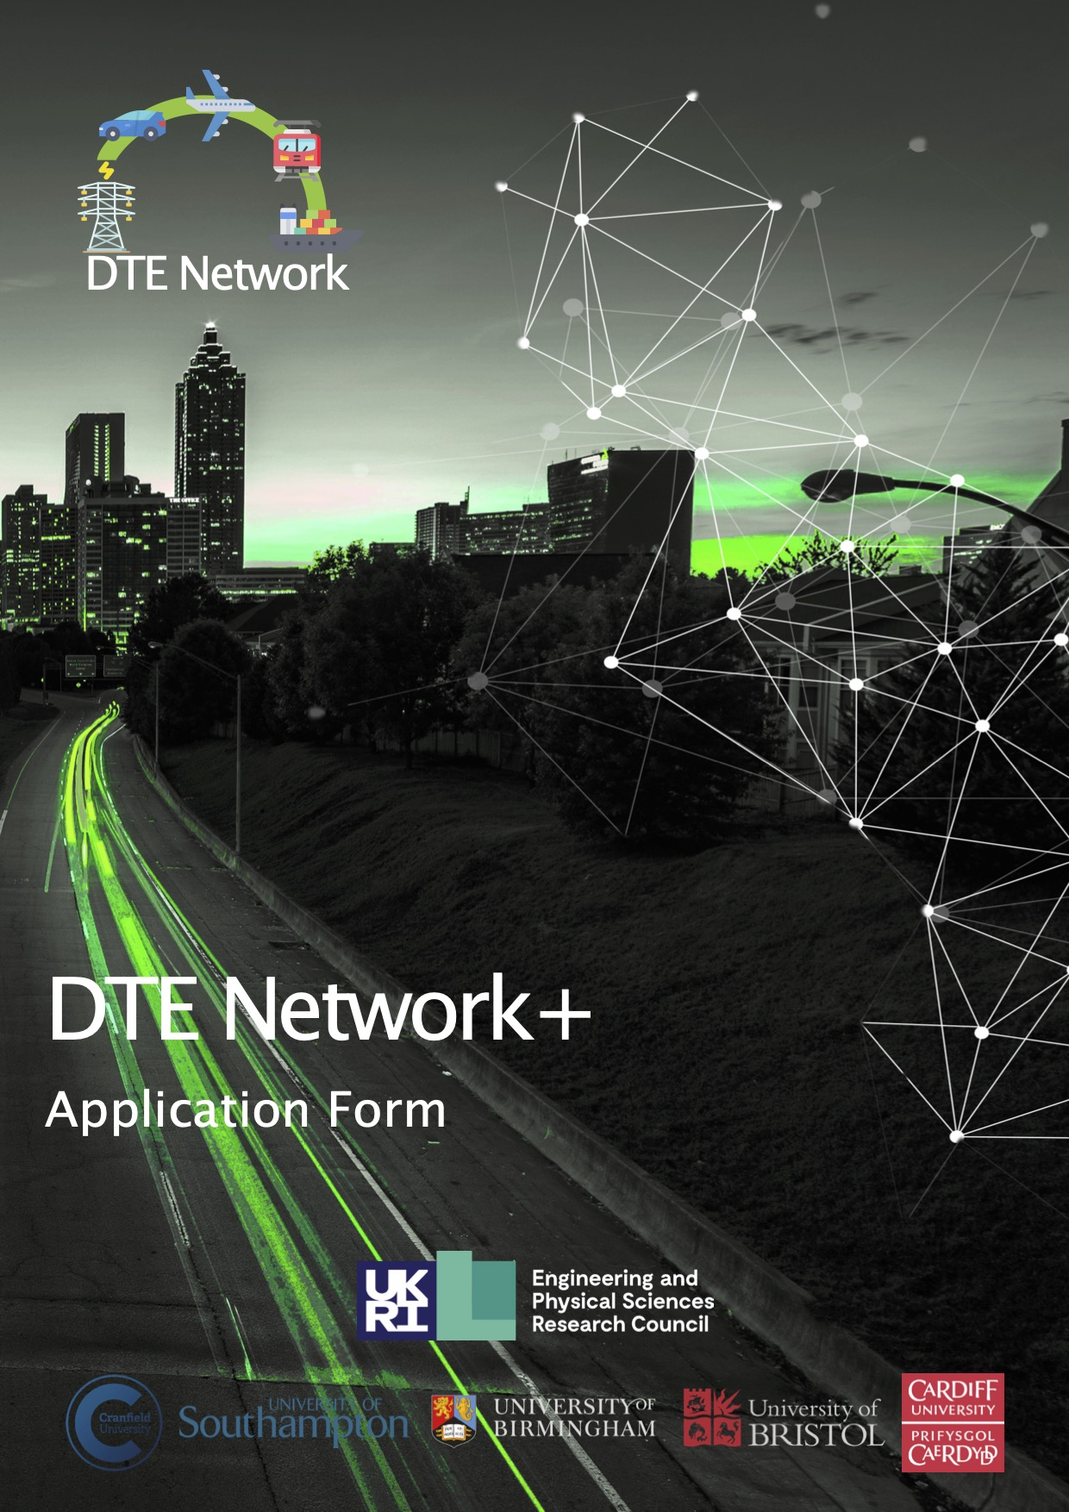

Funding available

Up to £200,000 of funding (at 80% Full Economic Costs) is available. We are planning to award 3 to 6 projects in this call.
There is no minimum project value but please note that no single application will be awarded more than £70,000 (80% Full Economic Costs).

If not, all funds are allocated, the Management Board retains the right to re-open the process to applications.

How to apply

Applicants should submit the application form available here from the Decarbonising Transport through Electrification (DTE), A whole systems approach website, to transport@dte.network by the deadline indicated.

The Network is unable to consider applications submitted after the deadline.

Key dates:
Call opens – launch date 26th of July 2021
New Deadline 17:00, 17th of September 2021
Funding decision 20th of October 2021
Expected start date 1st of November 2021
Expected end date Maximum 8 months after start date.

Key contacts:
Konstantinos Stamatis, Network Manager, stamatisk@cardiff.ac.uk
Professor Liana Cipcigan, Principal Investigator, cipciganlm@cardiff.ac.uk

General Guidance

The Call is competitive, so proposal authors are therefore recommended to closely study the Call for Proposals Framework and Framework and Consultation Document and ensure that their proposal clearly addresses the aspects that will be assessed.

Successful proposals will be aligned with the Workstreams and scope of DTE Network+.

This call for funding will place special emphasis on providing novel research ideas and collaboration with academics and industrialists/stakeholders.

Please discuss any questions with Work Streams leaders or any member of the DTE Network+ team who can be contacted by emailing transport@dte.network.

Separate documents to be attached and submitted with the proposal:

- Proposal Form

- A summary CV of the proposed candidate(s) and a list of publications from the proposed candidate(s)

- Letter(s) of Support

Application

Project Title | Proposal Number
 | Internal Use Only

Lead Applicant Details
Name
Role
Organisation
Web Address
Telephone
Email

Principle Investigator Details (if different to Lead Applicant)
Name
Role
Organisation
Web Address
Telephone
Email

Key Persons Contact Details for Project
Name
Telephone
Email

Project Partner Details (if applicable)
Name | Organisation

Co-Investigator Details (if applicable, copy and paste table as required)
Name
Role
Organisation
Web Address
Telephone
Email

Project Summary
Funding Sought (80% FEC)
Provisional Start Date
Project Duration

Please indicate the value and source of matched funding (if applicable)

Work Stream (WS) and Challenges Addressed

Tick the appropriate box(es) or insert “M” for the main WS and “S’ for the secondary WS.

WS1 Vehicles & associated technologies |  | Mid-term challenges
WS2 Charging infrastructure

WS3 Electricity as a transport fuel |  | Long-term challenges
WS4 Smart mobility

Please complete the following table.

Describe the project team/applicants relevant track records and current research areas: (max. 200 words)

Provide a brief summary of the project, including

- a list of roles and responsibilities
- desired outputs
- outcomes
- measures of success

(max. 300 words)

Alignment to research challenge(s) of DTE Network+:

Please view our website and framework document for more information (max. 150 words)

Project background and national importance:

(max. 150 words)

Describe your project’s scientific novelty and ambition:

(max. 150 words)

Describe your project’s scientific impact:

(max. 150 words)

Detail the aims and objectives of the project:

(max. 300 words)

Describe your project’s methodology and research activities include key deliverables:

(max. 600 words)

Management of the project:

(max. 150 words)

Project plan (e.g., Gantt chart) and deliverables:

Explain how you plan to engage with the DTE Network+ and its community:

(max. 150 words)

Project team:

Include external collaborators, industry partners and their contribution, and other sources of funding (if any).

Please indicate which members of the academic team are Early Career Researchers (ECRs).

Engagement with industrial partners and/or stakeholders. Potential for follow on funding:

(max. 150 words)

Justification of Resources:

Present a full justification for all resources being requested.

Letters of Support (no page limit):

Letters that show support for the proposal from stakeholders and a clear intention to engage with the DTE Network+ activities.

Letters should be on headed paper, signed and dated and submitted with your application, however given the current circumstances with COVID19 we understand this may be difficult. Please contact the DTE Network+ team at transport@dte.network

Covid-19 Contingency Plan:

Please indicate your contingency plans in response to lockdown or measures of social distancing.

Please identify if your research can be completed remotely and if you need to include laboratory research.

Total resources required for the project

Please include additional support from partners and third parties which may include potential funding received or required. Credit will be given for identifying external funding that complements the DTE Network+ funding.

Credit will be given for external funding or in-kind support e.g., from industry or other sources.

Project Budget |  | FEC (£) | 80% FEC (£)
Directly Incurred | Staff
 | Travel and Subsistence
 | Other
 | Sub-Total
Directly Allocated | Investigators
 | Estate Costs
 | Other
 | Sub-Total
Indirect Costs
Total

Equal Opportunities

The DTE Network+ is dedicated to address Equality, Diversity and Inclusion (EDI) within all aspects of its remit, please find relevant EDI documentation here. Accordingly, no eligible applicant will receive less favourable treatment on the grounds of gender, marital status, sexual orientation, gender re-assignment, race, colour, nationality, ethnicity or national origins, religion or similar philosophical belief, spent criminal conviction, age, disability, career breaks, paternity/maternity or adoption leave breaks. Applications will be assessed on their merits, in accordance with the evaluation criteria set for the call with all reviewers having received unconscious bias training and guidance.

Declaration

I understand that if I am awarded funding, I will be required to provide a short case study (by 1st June 2022) to illustrate outcomes of the awards and to a provide a brief account of expenditure. I will actively engage with the DTE Network+ activities and events.

Please note that the information on this form will only be used for the purposes of assessing the funding application and will only be shared with the DTE Network+ review panel for consideration/awarding.

Name(s) of applicant(s):

Signatures:

Applicants are asked to consult their university’s research office ahead of submitting a proposal to this call, in order to be clear of the requirements for meeting the deadlines set out in page 1 of this document.

Lead institution approval: I confirm that I have seen and authorise this application.

Print Name:

Signature:

Please send the completed proforma (as .pdf) to transport@dte.network by 17:00 on Friday 17th of September 2021.

We will acknowledge receipt of each proposal and assign a unique number.

