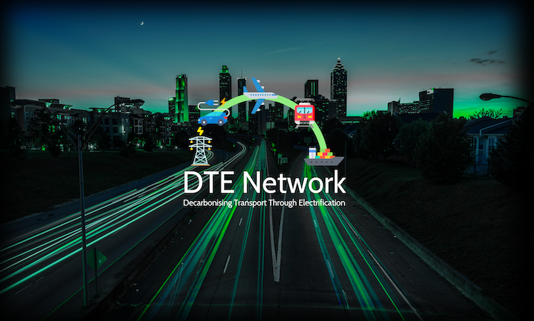







Equality, Diversity and Inclusion Monitoring Form

DTE Network+ is committed to equality of opportunity in everything we do. In order to monitor this, it is necessary to collect equality information from all applications.

The information collected will form a confidential statistical record/database which will not be used for any other purpose than to support the DTE Network+ and Cardiff University actions with regard to equality of opportunity.

Thank you for your assistance in completing this questionnaire.

Personal Information

Application Title:

Surname/Family Name:

Other name(s):

Title:

Name at birth, or any previous name:

Monitoring Information

Gender – I would describe myself as:

Male Female

Do you identify as:

Transgender Yes No Prefer not to say

Transexual Yes No Prefer not to say

Disability – Do you have a known disability?

Yes No Prefer not to say If yes, please specify:

Ethnic classification – I would describe myself as:

A. White
British Irish Other

B. Black or Black British
Caribbean African Other

C. Asian or Asian British
Indian Pakistani Bangladeshi Other Asian background

D. Mixed
White and Black Caribbean White and Black African
White and Asian Other Mixed background

E. Chinese

F. Other ethnic background

Sexual Orientation – I would describe myself as:

Bisexual Gay Gay woman/lesbian
Other Prefer not to say Heterosexual/straight

Religion and Belief – I would describe myself as:

Buddhist Christian Hindu Jewish Muslim
Sikh Other please specify: Prefer not to say

I confirm by ticking this box that the information given in this form, and on all other supporting documentation, is correct.

Signed: Date:

Please return this monitoring form with your application – it will be separated from all other supplied information before the application form is forwarded to the short-listing panel.

Who can I contact if I need help in completing the form?

If you have any questions which arise from completing this form, please contact on transport@dte.network

