Initial Enquiry Form
I understand that by completing this form that this is not a referral for support but provides Beyond The Hoard CIC with enough information to assess client suitability for support and to be able to provide potential referrer with advice and support.
Name of person completing the form
Organisation and Job role ( if appropriate)
Email address
Telephone number
Who is enquiry for support about?
Please circle or highlight

About myself About a person I am supporting

Please insert initials of person enquiring about so we can match enquiry form and referral form once received.

Housing situation
Please circle or highlight those that apply

Home Owner Living with Family or friends

Social Landlord Tenant Private Landlord Tenant

Council Tenant No fixed abode

Are you at risk of being asked to leave current property? Yes No

I consent to Beyond The Hoard CIC contacting me by telephone or Text. Yes No
I consent to Beyond The Hoard CIC contacting me by email. Yes No
I consent to Beyond The Hoard CIC contacting me by Post. Yes No

Additional information to help assess support needs
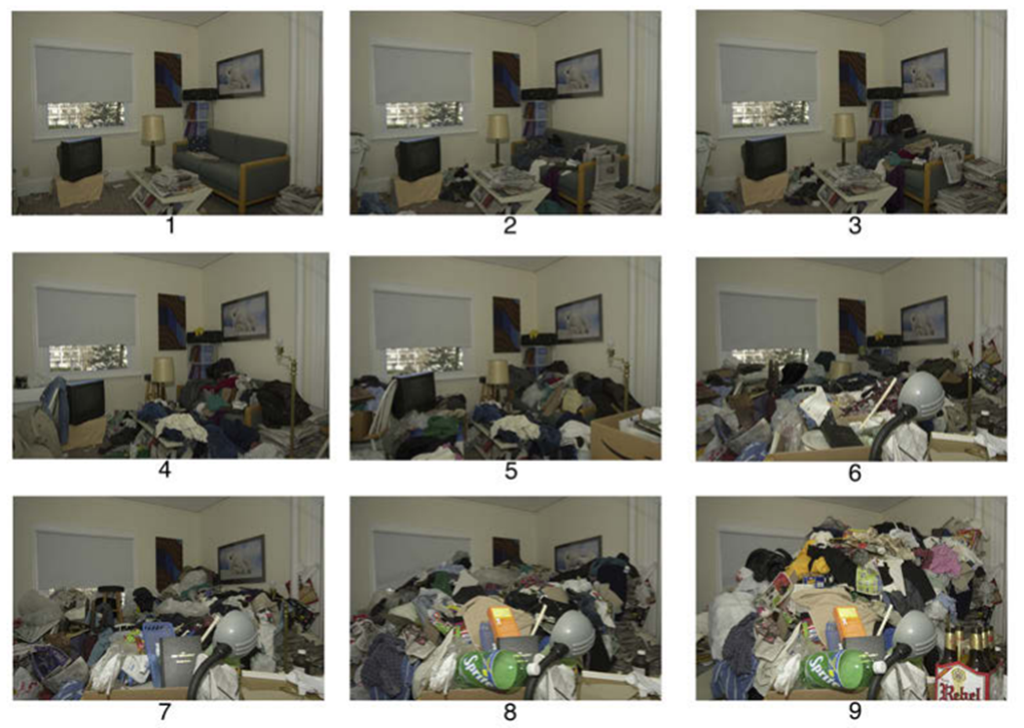

Clutter Image Rating (CIR)
please write number from scale above that relates to the level of clutter in the rooms below.
Kitchen | Bathroom | Dining room
Living room | bedroom | bedroom
Other spaces around the home, including garden, garages sheds or outbuildings. Please detail here.

Items that are hoarded in the home (circle or highlight all that apply)

- Paper
- Household waste
- Wet waste (body waste)
- Food
- Animals
- Clothes
- Furniture
- Special interest items
- Craft items
- Car/ engineering
- Woodworking items or tools
- Medical equipment
- Items from family members
Any other items not outlined above.

Known potential triggers for hoarding behaviour (circle or highlight all that apply)
Bereavement- human or pet
Loss of job
End of relationship
Childhood trauma
Raised in hoarded home
Special interests
Empty nest- children left home
Always hoarded items
Domestic abuse

Current or Previous support given.
Please detail interventions or support already offered or used.

Professionals or community organisations already supporting
Please give details of organisations that are currently providing support
Name and organisation | Contact details
Name and organisation | Contact details
Name and organisation | Contact details
Name and organisation | Contact details
Name and organisation | Contact details

Please tell us how you heard about Beyond The Hoard CIC (please circle or highlight)
Website Word of mouth Training

Support group Internet search.

Is client aware you have contacted Beyond The Hoard to enquire about a referral for support with hoarding behaviours? Please circle or highlight)
YES NO NOT SURE
Are you aware of Beyond The Hoard CIC charges for support? (please circle or highlight)
YES NO
Signature ( electronic accepted) Date:

Return the form by email where possible christine@beyondthehoardcic.co.uk
Or by post to Beyond The Hoard CIC, Office 1 & 2 Banbury House, Lower Priest Lane, Pershore, WR10 1BJ.
Please be aware our office is not open to the public, as we work mainly in the community access to the office is by invitation only.

