Directions for completing the Riverhead Rotary Scholarship

1. Download application and fill out. We expect the application to be typed and filled out using Google Docs, pdf, Word, or any similar program. Simply click in each text field and enter the pertinent information.
WE WILL NOT ACCEPT HANDWRITTEN APPLICATIONS
2. Part I and Part II are to be filled out by applicant
3. Part III is to be completed by your Guidance Counselor
4. Part IV is to be filled out by the applicant’s parent.
5. When the application is completed (application, transcript, Letters of Recommendation, etc.) are to be downloaded as pdfs then attached to an email that is sent to troth@eefgcorp.com. Please note, Part IV financials will already be uploaded via a secure link and need not be attached to this email.
Pk DO NOT USE THE GOOGLE SHARE BUTTON AS WE ARE UNABLE TO ACCESS THESE FILES ON OUR WEB SERVER AND YOUR APPLICATION WILL NOT BE CONSIDERED
6. All applications and pertinent files must be received by MARCH 20, 2026.The deadline is strictly adhered to.


2026 Riverhead Rotary College Scholarship Application

●Student must be a high school senior graduating in June 2026 and live within the Riverhead Central School District to apply
● Application deadline is MARCH 20, 2026 - no exceptions
● All attachments must be in PDF format ONLY. Please convert all google docs, word doc or page to a pdf before uploading and send all parts under ONE COVER.
● When emailed application is received, you will receive a verification email

Checklist for scholarship application. If the application is not fully completed, you will be scored a zero for missing information.

- Complete Part I
- Complete Part II Essay “Service Above Self”
- Guidance Counselor completes Part III and will provide your official transcript to you.
- Parent or guardian completes Part IV then attaches a copy of FAFSA Student Aid Report (SAR). Part IV will be uploaded separately to the secure link provided in the application.
- Email completed Parts I, II, III with all attachments to troth@eefgcorp.com

Scholarships Available
Bruce Stark Memorial Scholarship ~amount varies each year; last year was $25,000 paid out over 4 years. A or B average, varsity sports participation, community activities, business or financial per year for four years: Outstanding academic record, community service, extracurricular activities, and financial need.
Riverhead Rotary Scholarship ~ $8,000 award paid $2,000 per year. Outstanding academic achievement, community service, extracurricular activities, and financial need.
Tara J. Malanga Memorial Scholarship ~ $4,000 paid $1,000 per year for 4 years varsity sports participation (special emphasis on basketball or lacrosse) community service, A or B average, financial need.
Hallock Luce III Memorial Scholarship ~ $2,500 paid in first year. Outstanding academic record, community service, extracurricular activities, and financial need
Robert K. Boden Memorial Scholarship ~$1,000 paid in first year. Varsity sports participant, strong leadership skills, minimum B average.
Judge Allen Smith Memorial Scholarship ~ $1,000 paid in first year. Majoring in Law or Political Science.
Sheila Morreale Memorial Scholarship ~ $1,000 paid in first year. Community service oriented. Special aptitude and interest in the veterinary field or artistic endeavors.
Maureen Sanok Memorial Scholarship ~ $2,000 paid in first year. Community service oriented Given to students attending community college. Preference to students majoring in Education.

PART I

Name:
First Middle Last

Address:
Street

Town Zip

Cell Phone:

Email Address:

Number of Children in Family:

Number of Children Living at Home:

For 2026-2027 school year, number of children in family who will be attending college:
If applicable, write below the name of sibling, school attending, year they are in, and if graduate or undergraduate, part- time or full-time. Proof of enrollment may be required.

Sibling Name | School | Part/Full Time | Under Grad/Grad

- COMMUNITY SERVICE ACTIVITIES

Using the table below, submit all your community service activities including church, school, and/or community volunteer activities. Also include any awards or honors you have received related to these community service activities. Please describe service performed and hours. If you were a member of a group that performed service (Interact, Key Club, Wave to Wave, Student Govt, Church Group, etc.) please list the community services you performed while being a member of these groups.

For example: Riverfront Clean-Up/2025 - Helped Riverhead Rotary clean-up of Peconic waterfront - 4 hrs

Service/Year | Description (please break out Service Hours by Year) | Total Hours

B. EXTRACURRICULARS ACTIVITIES
Below, submit a list of all your extracurricular activities during your high school career.This would include athletics (JV, Varsity, or Unified Athletics ), clubs, tutoring, plays, musical theater, church groups, etc. Please indicate the grade you were in when you participated in and any titles held.

For example: Varsity Softball (Captain 12) 10, 11, 12
Key Club ( Secretary 11, Vice President 12) 9, 10, 11, 12

Name of Activity | Years of Participation

C. ACADEMIC HONORS OR AWARDS

Below, list off all your honors or awards, such as honor societies,Academic awards, state or County awards, etc. and the grade you were in when received. Also indicate any titles held.

Example: National Honor Society (President 12) 11,12
Newsday Scholar Athlete Field Hockey 12

Name of Activity | Year Earned

D. EMPLOYMENT RECORD
List below any jobs that you have held during your high school years.

Employer | Type of Job | Dates Worked | Hours per Week

E. List below your vocation interest and/or choice of college major:

F. COLLEGES TO WHICH YOU APPLIED.Please list below the colleges you applied to and if you have been accepted. We realize that you may not have heard back from many of your colleges before our deadline. You do not need to list colleges that you applied to and have already heard that you have not been accepted.

Name of College | Accepted

College you expect to attend:
Approx, annual cost per year as listed in university’s catalog::
List any scholarship(s) offered to date. If from one of your schools please state so and value per year.

Scholarship | Value per year

Part II Essay
Rotary is a worldwide organization of business professionals who provide humanitarian services, encourage high ethical standards in business, and build goodwill and peace throughout the world. As the world's first service organization, Rotary's goal is to make the world a better place by uniting persons of various cultures and beliefs.
The Rotary Club of Riverhead is made-up of 80+ business / community leaders who dedicate their life and time to follow the motto of “Service Above Self.” In daily life or in business transactions, we serve our community and our fellow man by putting other needs first. In the space below please share an essay of 600 words or less that expresses how your involvement in community service, teams, clubs, organizations, church activities, extracurricular activities, or employment best exemplifies your representation of the Riverhead Rotary motto, “Service Above Self.”
Please type below:

PART III
Please give this part to your Guidance Counselor to fill out. Have your counselor return to you along with any documents (i.e. transcript, letters of recommendation, etc.)that will be attached and uploaded with the final application.

- APPLICANT INFORMATION
Applicant’s Name:
Applicant’s Class Rank:
Applicant’s Weighted GPA: |  | Unweighted GPA:

BOTH WEIGHTS MUST BE PROVIDED

- Attach an Official Transcript

- You may briefly indicate any special attributes or circumstances that you believe would have a bearing on the applicant’s qualifications for this scholarship.

PART IV
To be completed by parent(s) or legal guardian(s) and uploaded via a certified link provided within the document. If you cannot upload, financial documents for any reason please see alternate directions at bottom of page.

Applicant’s Name:

An award will be given to a high school senior in Riverhead HS and/or a student residing in RCSD, for the purpose
of funding his/her education beyond high school. This award will be made on the basis of character, scholarship,
activities, interest, need and promise of future leadership and service. All other factors being equal, financial need
is an important factor. It is for this reason that we ask you to complete fully and accurately the required information.
All information will be kept strictly confidential by limited members of the selection committee.

Mother’s Name:

Father’s Name:

Legal Guardian’s Name If applicable

Mother’s Employer:

Father’s Employer:

A copy of the student’s FAFSA (Free Application for Federal Student Aid) and SAR (Student Aid Report)
must be attached to this application, please see instructions below.
Failure to provide all information will affect the applicants scholarship ranking.

To complete the financial scoring process of your application, it will be necessary to securely upload copies of certain pages from the FAFSA and the parents 2024 US income tax return form 1040 page 1 with the Social Security numbers redacted to complete the application. This information will be uploaded directly via encryption to Ron Farnworth, CPA, the accountant that oversees the financial aspects for our rotary scholarship. No other individual within Rotary will have access to this information.

Please note, if you do not provide this additional financial information prior to the required deadline, the student's application will still be considered, but will score a zero under the financial section.

Please provide screenshots of the certain pages of the FAFSA Submission Summary as follows (the examples provided are from 2024-25 FAFSA). If you are having issues following you may provide Nicole Ratti at the guidance office with printed copies of the documents in a separately sealed envelope addressed to:
Riverhead Rotary – CONFIDENTIAL Attn: Ronald G Farnworth CPA
THE DOCUMENTS MUST BE IN HER OFFICE BY 3 PM MARCH 20TH TO QUALIFY

- Please provide a screenshot or print out the Eligibility Overview Tab, listing the Estimated Federal Student Aid.
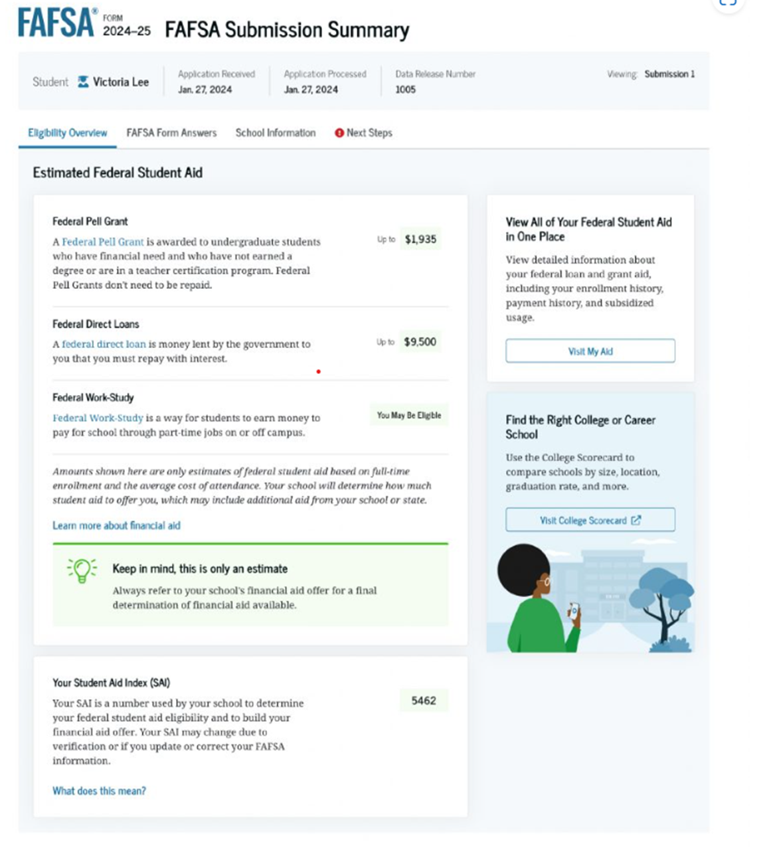

- Please provide a screenshot of the FAFSA Form Answers tab with the Personal Identifiers section and sections 1-3 expanded disclosing the derail entries on those sections for both the student and parent sections.

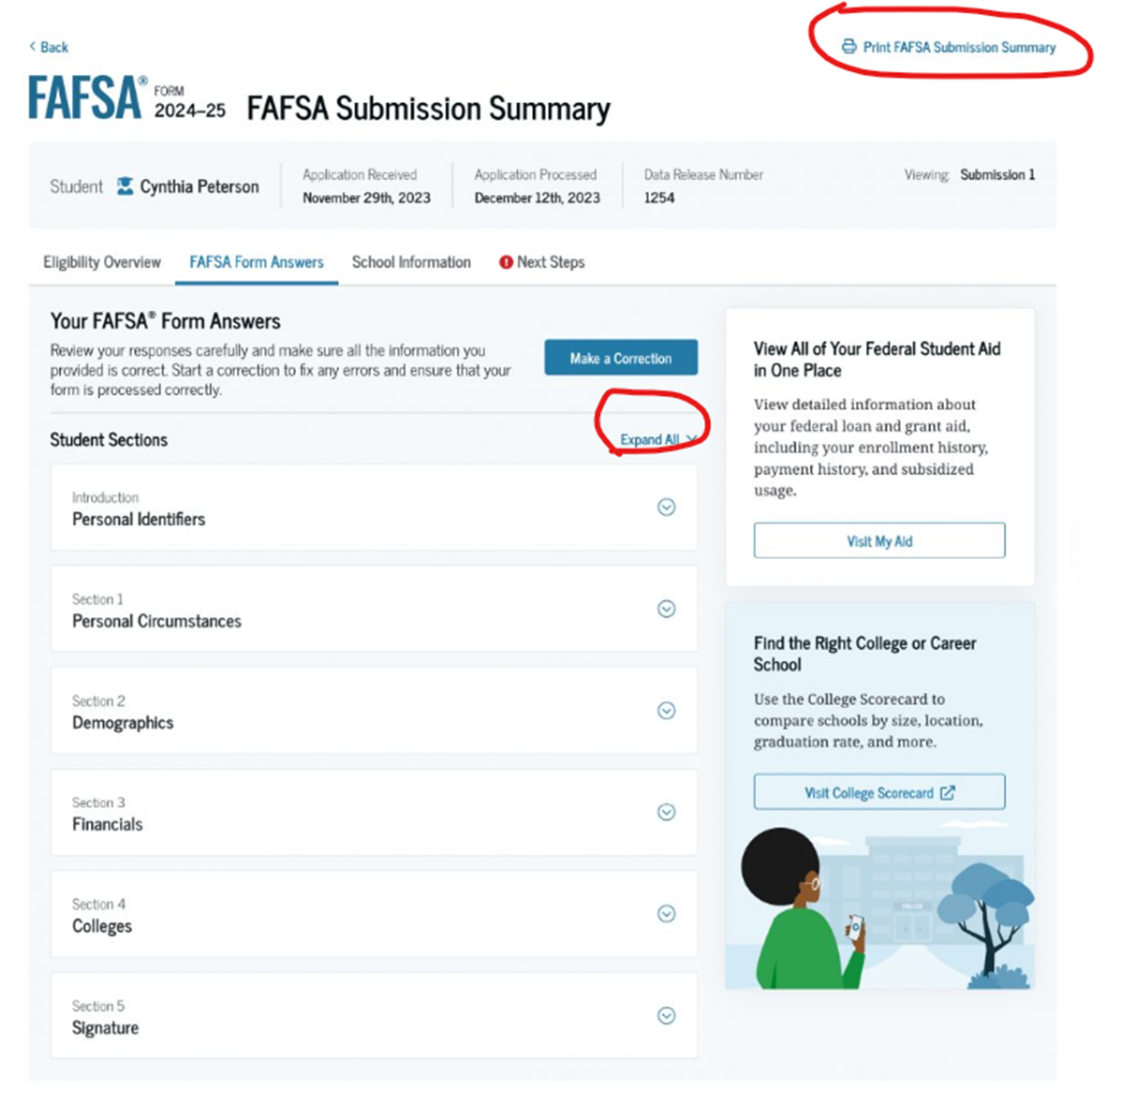

- Please provide a copy of page 1 of your parents 2024 Form 1040 Form 1040 US Income Tax Return with the Social Security Number redacted.
- Upload all documents to the secure portal by clicking on the following link:Click Here to Upload Files Securely

- Enter your email address, first and last name in the left panel:

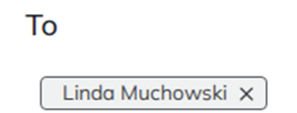
The following window below will appear.
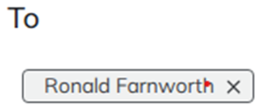

Delete the default email and choose from the drop down menu.

- Enter Rotary Scholarship in the subject line.
- Indicate in the body of the message that you are submitting the FAFSA and Tax Return Data for the Rotary Scholarships.
- Please provide a telephone number in case we need to contact you.
- Attach FAFSA and Tax Return documents and hit send.
- Sign Affidavit below

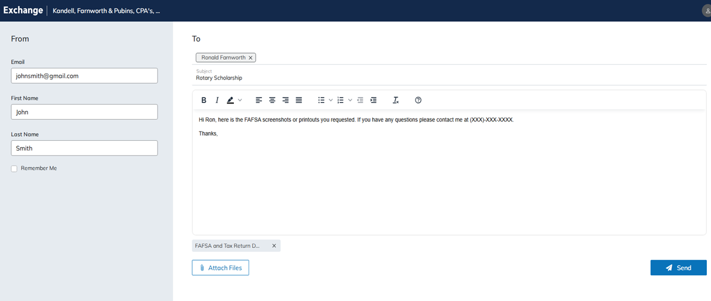
Here is an example of how the exchange email should look:

If you are unable to securely upload the documents, you may provide NIcole Ratti at the RHS guidance office with printed copies of the documents in a separately sealed envelope addressed to:

Riverhead Rotary - CONFIDENTIAL
ATTN: Ron Farnworth CPA

If you have any question concerning the information requested, please do not hesitate to contact me directly at 516-658-4556

Ronald G. Farnworth

Parent/Guardian Signature______________________________________Date _____________
The information provided is correct, to the best of my knowledge

