AUSLMAT Sri Lanka Aid Mission Report 2022
After a long absence owing to the 2019 Easter Bombings and the COVID-19 pandemic, members of the AUSLMAT team were overjoyed to return on a medical mission to Sri Lanka from 16-30 August, 2022. Lead by AUSLMAT President Dr Erosha Premaratne and Vice-President A/Prof Andrew Cochrane, the team of 10 included doctors, a nurse and volunteers.
Over the course of the trip, the team visited 7 hospitals in predominantly regional areas of Sri Lanka; District Hospital (DH) Negombo, Teaching Hospital (TH) Anuradhapura, TH Jaffna, DH Dehiattakandiya, Sirimavo Bandaranaike Specialised Children’s Hospital (Peradeniya), TH Karapitiya (Galle) and Lady Ridgeway Children’s Hospital (Colombo).
Throughout the trip, the AUSLMAT team was able to distribute much needed medical supplies to various hospitals, including sutures and surgical supplies for the liver transplantation unit at Colombo North TH Ragama, diabetes testing equipment, gauze and cotton wool to Negombo DH, pediatric supplies and anaesthetic airway equipment to SBSCH Peradeniya and diabetes testing equipment to TH Anuradhapura. We donated dental supplies, diabetes testing equipment, cotton and gauze to DH Dehiattakandiya. A supply of coronary angioplasty stent and balloon catheters generously donated by Medtronic Australia was gifted to the Cardiology Unit at TH Karapitiya, in addition to Isocal nutritional supplements, diabetes testing equipment, gauze and cotton wool. A supply of cotton wool and gauze were also sent to the Eye and Ear Hospital in Colombo. In addition to these items, AUSLMAT has so far sent AUD 164,000 medicines and medical equipment to public hospitals in Sri Lanka since the beginning of the financial crisis in May 2022.
The team were able to review the implementation and operation of equipment previously donated and, and it was great to see this equipment being put to valuable use. This included Phillips G30 Cardiac Monitoring systems donated to TH Anuradhapura, and High Dependency Unit facilities installed at DH Dehiattakandiya during the COVID-19 pandemic.
Community health clinics were conducted at Dehiattakandiya and Tissamaharama, where members of the medical team were able to provide endocrinology, obstetric medicine, cardiology and general medical consulting to the community members. At Tissamaharama, the AUSLMAT team met the grateful families of school children who had been supported with books and school equipment as part of the Keep Kids in School (KKS) sponsorship program.
The AUSLMAT team engaged in education sessions with medical and nursing staff at many of the hospitals visited. At TH Anuradhapura Emergency Department nurse Mr Bernard Robben and Emergency Doctor Dr Sayumi Jayasinghe gave an interactive teaching session on non-invasive ventilation which was well attended by nursing staff. The cardiac surgery team at Lady Ridgeway Hospital presented a series of complex congenital heart disease cases for discussion with A/Prof Andrew Cochrane. Dr Erosha Premaratne and Dr Nalin Dayawansa gave presentations on Diabetes and Heart Failure management at TH Karapitya in Galle hosted by the Sri Lanka Medical Association (SLMA).
AUSLMAT president Dr Erosha Premaratne made multiple appearances in Sri Lankan media promoting the work that AUSLMAT has been doing, and highlighting the importance of swift Health ministry co-operation in releasing and distributing donated equipment.
The busy hospital visits were broken up with sightseeing days including visits to the Hindu and Buddhist temples of Nainativu (Nagadeepa), the ancient rock fortress of Sigiriya, the scenic train ride from Kandy to Ella and safaries at Yala, Minneriya and Udawalawe National Parks. Our gratitude to Jetwing Ecotours for organizing out trip and for the supporting us throughout the trip.
Whilst the mission was a great success, there is always more work to be done. Amidst the ongoing economic hardship in Sri Lanka, many areas of need were identified where AUSLMAT and donors may be able to assist in the future. These include:
- Replacement batteries for Uninterruptible Power Supply (UPS) system for the paediatric cardiac catheterisation laboratory at SBSCH Peradeniya - AUD $18,000
- Purchase of an echocardiography machine and transoesophageal echocardiogram (TOE) probe to allow for increased cardiac surgery capacity at TH Jaffna - USD $59,000
- Construction of a new cardiac catheterisation laboratory at TH Karapitiya, Galle - AUD $600,000
- Construction of a new intensive care building at LRH, Colombo - USD 5 million.
- Construction of a new coronary care unit (CCU) at TH Anuradhapura
- Construction of new medical wards at DH Dehiattakandiya
Dr Nalin Dayawansa
Melbourne, Australia
10/11/2022

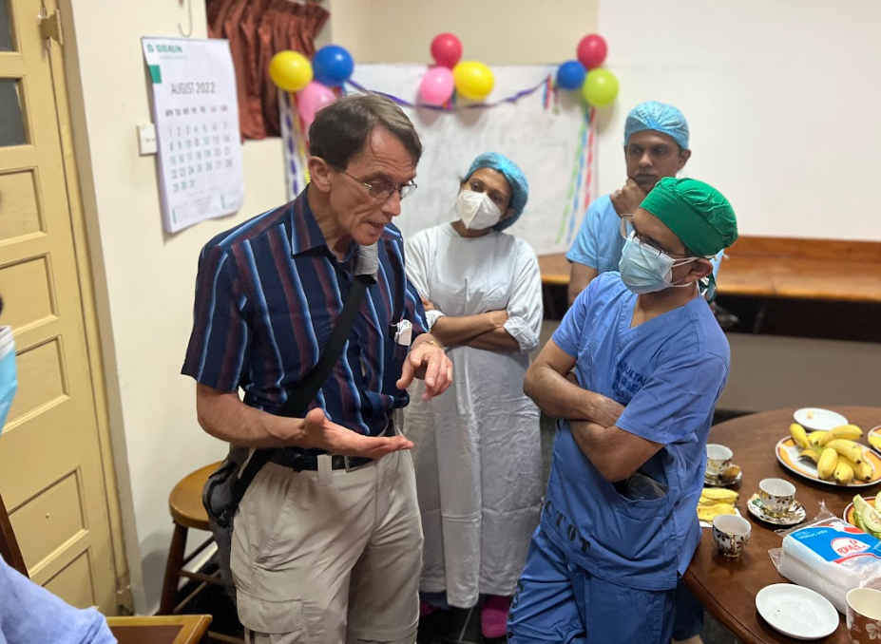
A/Prof Andrew Cochrane (Cardio-thoracic surgeon, Monash Heart) discussing complex paediatric cardiac surgery cases with Dr. Kanchana Slngappuli (Pediatric Cardiac surgeon) and other staff members of the cardiac surgery team at Lady Ridgeway Hospital.
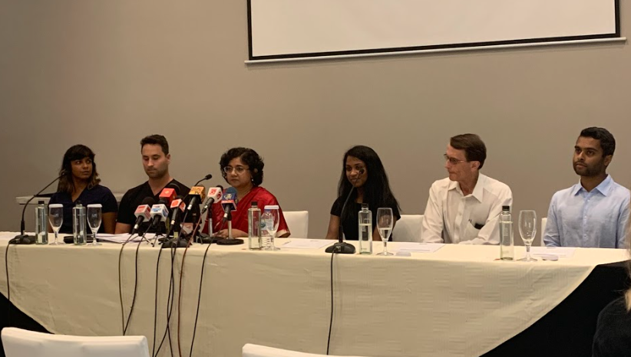
Televised press conference discussing the work done by AUSLMAT on the 2022 trip. L to R Dr. Sayumi Jayasinghe, Mr. Bernard Robbens, Dr. Erosha Premaratne, Dr. Hashinee Weradurage, A/Prof. Andrew Cochrane and Dr. Nalin Dayawansa.
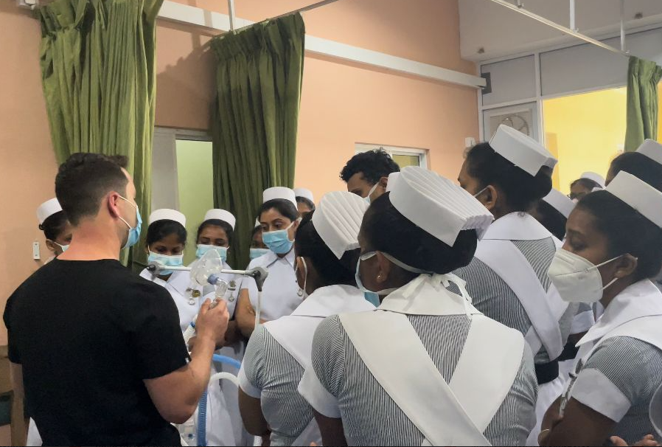
Mr Bernard Robben conducting a workshop on non-invasive ventilation with nurses at TH Anuradhapura
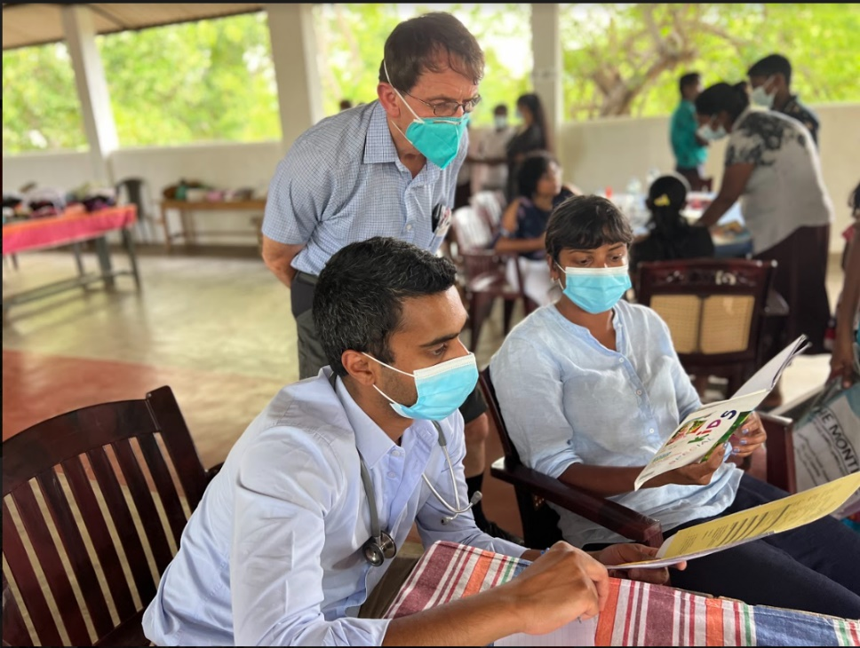
Community clinic at Tissamaharama
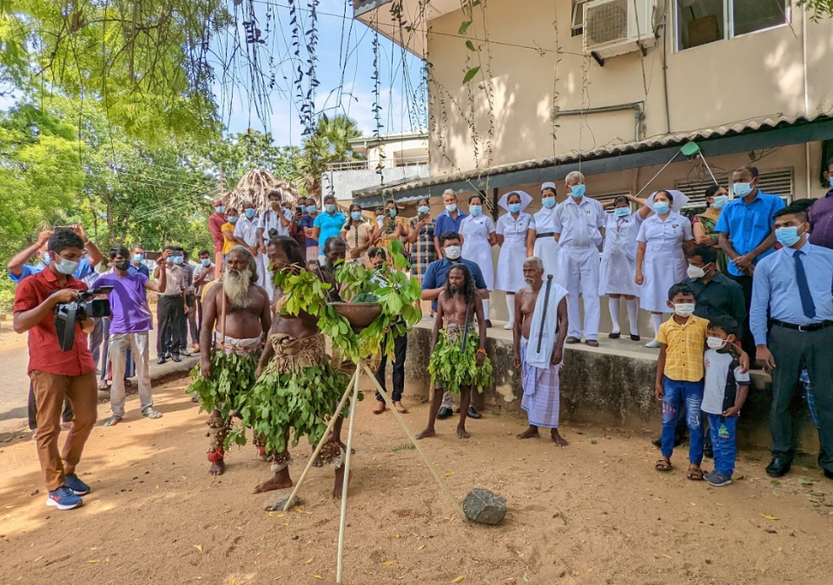
A warm welcome to Dehiattakandiya by the hospital staff and the local Indigenous community
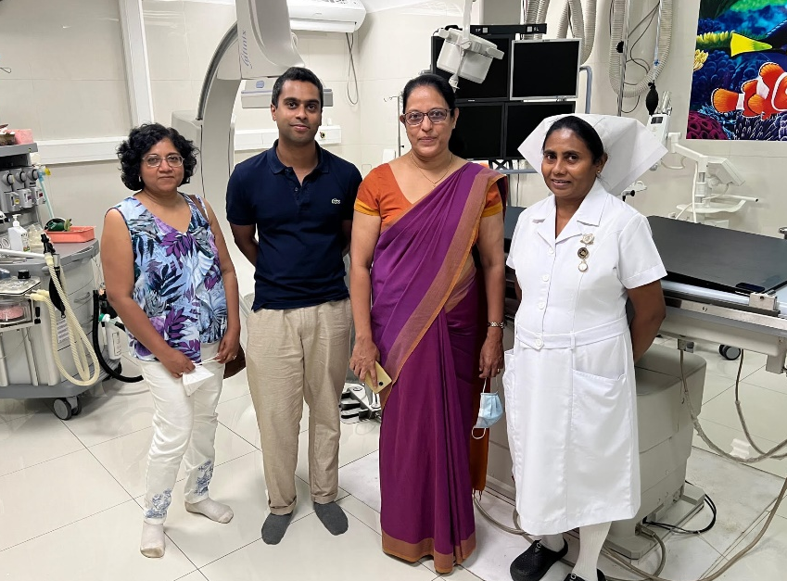
Dr Erosha Premaratne and Dr Nalin Dayawansa with SBSCH Paaediatric Cardiologist Dr Sunethra Irugalbandara in the Cardiac Catheterisation Laboratory at Sirimavo Bandaranayake Specialized Children’s Hospital, Peradeniya.

