PASTURED, NON-GMO PORK ORDER FORM - 2022

- I would like to purchase bulk pork by the _______________ (half or whole) hog.

Pricing:

Half Hog $6.25/lb x 125 lbs hanging weight = $730* ($125 deposit required)
Whole Hog $6/lb x 250 lbs hanging weight = $1350* ($250 deposit required)

*Note: total cost is an estimate only and will vary due to the unique hanging weight of each hog. Hanging weight might be +/- 30 pounds, which would change the total cost accordingly.

- Name: _____________________________________

- Email: ______________________________________

- Phone: cell home ______________________

- Included is a check made out to Seldom
Creek Farm to reserve my order.

Half Hog ($125 deposit required)
Whole Hog ($250 deposit required)

OR, I paid my deposit to @seldomcreekfarm on
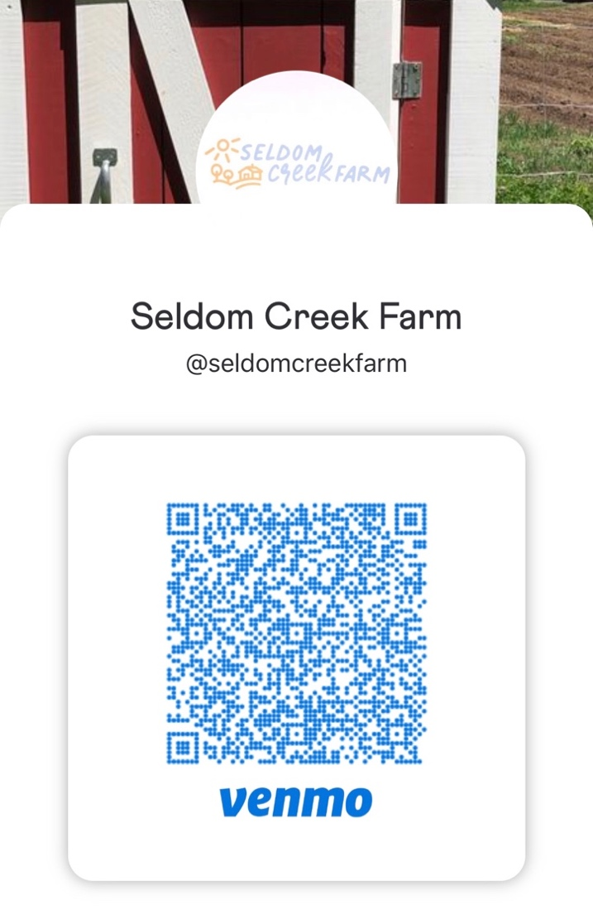
Venmo.

- I am interested in attending an on-farm event to see how the pigs are raised.
Days that work best for me are:
Tuesday morning
Tuesday evening
Friday evening
Saturday morning

- Please scan and email your order form to: rachael@seldomcreekfarm.com or snail-mail it to:
1898 McCabe Ave NE / Lowell, MI 49331.

Thanks for your order! We will contact you to arrange on-farm pick up – pork will be ready in October.

