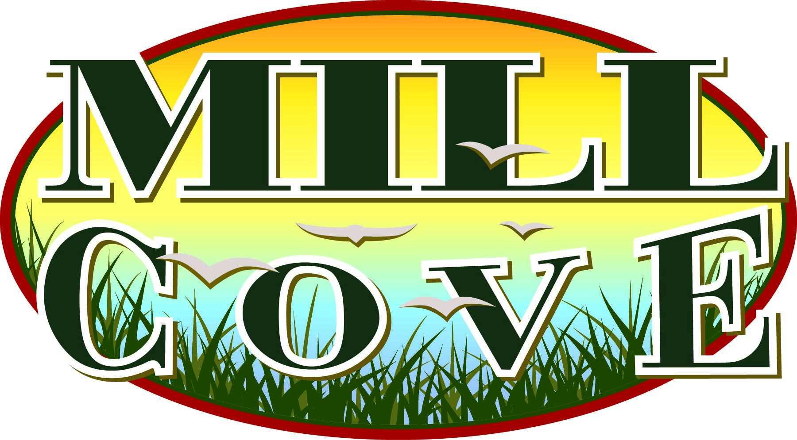
MILL COVE ENVIRONMENTAL EDUCATION CENTER
MILL COVE, INC.
MEMBERSHIP / CONTRIBUTION FORM
Mill Cove, Inc. is a 501(c)(3) organization working to enhance the Mill Cove area for recreation and environmental educational purposes. Our overall goal is the development of an Environmental Education Center at the site. Membership Categories
_______Landmark Partner ……. $1,000 or More
______Benefactor……. $500 to $999 ______Conservator……. $250 to $499
______Sustaining……. $100 to $249 ______Supporting ………$51 to $99
______Family …………. $50 ______Individual ………. $35
Additional Donation __________________________

Checks should be made payable to Mill Cove, Inc. Mill Cove, Inc. is a 501(c)(3) organization and is registered with the Pennsylvania Charitable Commission. Please complete the information above and below and mail to:
Mill Cove, Inc.
P.O. Box 262
Mansfield, PA 16933

Name______________________________________________________________________________
Please Print
Address____________________________________________________________________________

City/State/Zip Code___________________________________________________________________

Phone #: ___________________________________ E-Mail____________________________________

www.millcoveinc.org

