Order for Worship for the 11th Sunday after Pentecost
August 16, 2020

Prelude Prelude in F major J. S. Bach/Amy Watt

Words of Welcome

Call to Worship based on Psalms 107, 133, Isaiah 56
Praise the Lord, all you nations!
For he is good and his mercy endures forever.
Let the redeemed of the Lord say so
from the east and from the west,
from the north and from the south.
They cried to the Lord in their trouble,
and he saved them from their distress.
Let us thank the Lord for his steadfast love and
for his wonderful works to humankind.
“My house shall be called a house of prayer for all people,” says the Lord.
How very good and pleasant it is
when kindred live together in unity!

Prayer of the Day

Hymn #432 “How Clear Is Our Vocation, Lord”” Green, 1981/Parry, 1888

How clear is our vocation, Lord, when once we heed your call
To live according to your word and daily learn, refreshed, restored,
That you are Lord of all and will not let us fall.

But if, forgetful, we should find your yoke is hard to bear;
If worldly pressures fray the mind and love itself cannot unwind
Its tangled skein of care: our inward life repair.

We marvel how your saints become in hindrances more sure:
Whose joyful virtues put to shame the casual way we wear your name,
And by our faults obscure your power to cleanse and cure.

In what you give us, Lord, to do, together or alone,
In old routines or ventures new, may we not cease to look to you:
The cross you hung upon, all you endeavored, done.

Prayer of Confession

Merciful God, we humbly confess our sins and ask you to forgive us. Deliver us from lack of reverence for truth and beauty, from cowardice that dares not to face the truth, from putting down our neighbors, from intolerance or cruel indifference, from being satisfied with things as they are in our communities and in the world, from failing to share your indignation about injustice, from token concern for the poor and lonely people, and from confusing faith with good feeling or love with wanting to be loved. Have mercy on us in you loving-kindness and let the peace of Christ rule in our hearts. Sustain us with your Holy Spirit, so we remember that the sharing of our faith may become effective only when we perceive all the good that we may do for Christ. Amen.

Assurance of Pardon

Prayer for Illumination

Readings from Holy Scripture Matthew 15:21-28 and Romans 11:1-2a, 29
Sermon “The gifts and the calling of God are irrevocable”
Affirmation of Faith from Confession of Belhar, 1986 PC (USA)
We believe that Christ’s work of reconciliation is made manifest in the church as the community of believers who have been reconciled with God and with one another.

We believe that this unity of the people of God must be manifested and be active in a variety of ways: that we love one another; that we experience, practice and pursue community with one another; that we pray together and together serve God in this world.

We believe that the church is called to be the salt of the earth and the light of the world, that the church is called blessed because it is a peace-maker, that the church is witness both by word and by deed to the new heaven and the new earth in which righteousness dwells.

We believe that God’s life-giving Word and Spirit has conquered the powers of sin and death, and therefore also of irreconciliation and hatred.

We believe that God’s life-giving Word and Spirit will enable the church to live in a new obedience, which can open new possibilities of life for society and the world.

The church must therefore stand by people in any form of suffering and need, which implies, among other things, that the church must witness against and strive against any form of injustice, so that justice may roll down like waters, and righteousness like an ever-flowing stream.

To the one and only God, Father, Son and Holy Spirit, be the honor and the glory for ever and ever. Amen.

Hymn #754 “Help Us Accept Each Other” Kaan/Potter, 1974

Help us accept each other as Christ accepted us;
Teach us as sister, brother, each person to embrace.
Be present, Lord, among us and bring us to believe
We are ourselves accepted, and meant to love and live.

Teach us, O Lord your lessons, as in our daily life
We struggle to be human and search for hope and faith.
Teach us to care for people, for all, not just for some,
To love them as we find them, or as they may become.
Let your acceptance change us, so that we may be moved
In living situations to do the truth in love;
To practice your acceptance until we know by heart
The table of forgiveness, and laughter’s healing art.

Lord, for today’s encounters with all who are in need,
Who hunger for acceptance, for justice and for bread.
We need new eyes for seeing, new hands for holding on:
Renew us with your Spirit, Lord, free us; make us one!

Prayers of the People

The Lord’s Prayer

Offering of Our Gifts
Invitation
Offertory “Humble Thyself” Hudson/arr. Hayes/Amy Watt
Doxology
Prayer of Dedication

Lord, we long for you and pray that you will bless and multiply our offerings so that all people will know about the fullness of life that have been given to us in Christ Jesus. We thank you for the astonishing variety of cultures in our communities and for ever-widening circle of friendship. We glorify you not only by our obedience to the confession of the gospel of Christ but also by the generosity of our sharing with other people. By your Holy Spirit make us one with Chris, one with each other, and one in ministry through Jesus Christ, our Savior. Amen

Hymn #318 “In Christ There Is No East or West“ Oxenham/Reinagle, 1836

In Christ there is no east or west, in him no south or north,
But one great fellowship of love throughout the whole wide earth.
In Christ shall true hearts everywhere their high communion find;
His service is the golden cord close-binding human heart.

Join hands, disciples of the faith, whate’er your race may be.
All children of the living God are surely kin to me.
In Christ now meet both east and west; in him meet south and north.
All Christly souls are one in him throughout the whole wide earth.

Charge and Blessing

Go out into the world:
laugh, sing, and create.
Go out into the world:
explore, discover, and love.
Go out into the world:
believe, hope, and remember.
In Christ there is no east or west,
In him no south or north,
but one great fellowship of love.
May the peace of God the Father, the Son, and the Holy Spirit remain with you always.
Amen

Postlude “In the Bulb There is a Flower” Sleeth/John Emmons
~~~~

Today’s Prayer of the Day, Assurance of Pardon, Prayer for Illumination, Prayer of the People, Charge and Blessing are from the Book of Common Worship and Daily Prayer prepared by the Theology and Worship Ministry Unit for the Presbyterian Church (U.S.A.).
Our thanks for their participation in today’s service go to Danielle Allison, Jeff Allison, Pat Beaber, John Emmons, Pam Esbrandt, Debbie Evans, Mary and John Loetscher, Cathy Pruden, Stephanie Gregg, and Amy Glennon Watt.

Notes on today’s hymns from Glory to God: The Presbyterian Hymnal (2013):

“How Clear Is Our vocation, Lord,” a reflection on Christian vocation, was written to provide a new text for a pre-existing tune, and the poet has crafted his words so well that the two parts mesh smoothly. The tune is named for a noted English boarding school, whose music director was a friend of the composer.

“Help Us Accept Each Other” has the scriptural basis in Romans 15:7, recast a s a prayer in the opening lines of the first stanza. The many implications of living as people who have been accepted by God fill the remaining stanzas. This tune was composed for the first publication of the text.

The text of “In Christ There Is No East or West” formed a very small part of an elaborate Christian missionary pageant in the early 20th century, yet it has endured while the grander aspects of that production have faded away. It is set to a simple 19th-century tune that does not get in the way of its message.

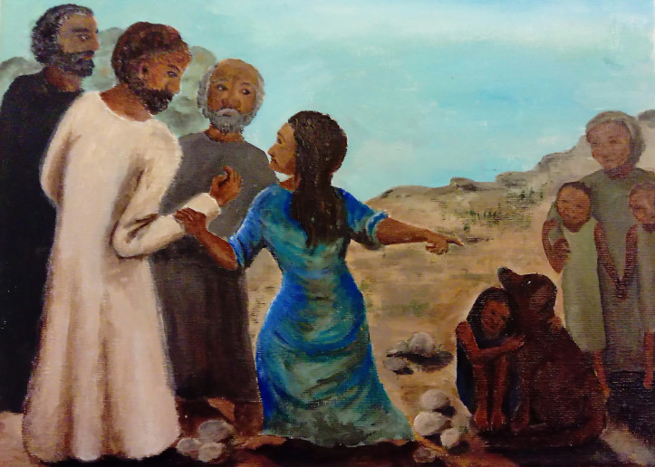
“Jesus and the Canaanite Woman” @ https://reverendally.files.wordpress.com/2013/04/

