**Order for Worship for the 10th Sunday after Pentecost**

**August 9, 2020**

**Prelude**  “Allemande” from Suite No. 1 in G major *J. S. Bach/Chris Clark*

**Words of Welcome**

**Call to Worship** *Psalms 117, 96 NRSV*

Praise the Lord, all you nations! Extol him, all you peoples!

**For great is his steadfast love toward us,**

**and the faithfulness of the Lord endures forever.**

Sing to the Lord a new song; sing to the Lord, all the earth.

**Bless his name; tell of his salvation from day to day.**

Declare his glory among the nations, his marvelous works among all the peoples.

**For great is the Lord, and greatly to be praised.**

**Worship the Lord in holy splendor!**

**Prayer of the Day**

**Hymn #184** “Calm to the Waves” *Bringle/Pavlechko, 2002*

Calm to the waves. Calm to the wind.

Jesus whispers, “Peace, be still.”

Balm to our hears. Fears at an end.

In stillness, hear his voice. (2x)

**Prayer of Confession** *based on Colossians 3:12-17, NRSV*

**Merciful God, we humbly confess our sins and ask for your steadfast love. Even as God’s chosen ones, holy and beloved, sometimes we forget to clothe ourselves with compassion, kindness, humility, and patience. Sometimes, we forget to bear with one another and forgive each other, just as the Lord has forgiven us. Sometimes, we forget that only love to you, to our neighbor, and to all in your creation binds everything together in perfect harmony. Have mercy on us in your loving kindness and let the peace of Christ rule in our hearts, to which indeed we were called in the one body. Sustain us with your Holy Spirit and let the word of Christ dwell in us richly, so we remember that whatever we do, in word or deed, we do everything in the name of the Lord Jesus, giving thanks to God the Father and the Holy Spirit. Amen.**

**Assurance of Pardon**

**Prayer for Illumination**

**Readings from Holy Scripture** Matthew 14:22-33 and Romans 10:5-15

**Sermon** “Confess with Your Lips and Believe in Your Heart”

**Affirmation of Faith** *from A Brief Statement of Faith, 1991 PC (USA)*

**In life and death we belong to God. In sovereign love God created the world good. God makes everyone equally in God’s image, male and female, of every race and people, to live in one community. Like a mother who will not forsake her nursing child, like a father who runs to welcome the prodigal home, God is faithful. In gratitude to God, empowered by the Holy Spirit, we strive to serve Jesus Christ in our daily tasks and to live holy and joyful lives, even as we watch for God’s new heaven and new earth, praying, “Come, Lord Jesus!” With believers in every time and place, we rejoice that nothing in life or in death can separate us from the love of God in Jesus Christ, our Lord. Amen.**

**Hymn #353** “My Hope Is Built on Nothing Less” *Edward Mote, 1834*

My hope is built on nothing less then Jesus’ blood and righteousness;

I dare not trust the sweetest frame, but wholly lean on Jesus’ name.

On Christ, the solid Rock, I stand; all other ground is sinking sand, all other ground is sinking sand.

When darkness seems to hide his face, I rest on his unchanging grace;

In every high and stormy gale, my anchor holds within the veil.

On Christ, the solid Rock, I stand; all other ground is sinking sand, all other ground is sinking sand.

His oath, his covenant, his blood support me in the whelming flood;

When all around my soul gives way, he then is all my hope and stay.

On Christ, the solid Rock, I stand; all other ground is sinking sand, all other ground is sinking sand.

When he shall come with trumpet sound, O may I then in him be found,

Dressed in his righteousness alone, faultless to stand before the throne.

On Christ, the solid Rock, I stand; all other ground is sinking sand, all other ground is sinking sand.

**Prayers of the People**

**The Lord’s Prayer**

**Offering of Our Gifts**

Invitation

Offertory “I Need Thee Every Hour” *A. Sherwood Hawks/Amy Watt*

Doxology

Prayer of Dedication *based on 2 Corinthians 9:6-15*

**Lord, we give thanks to you with our whole hearts. You provide us with every blessing in abundance, so that by always having enough of everything, we may share abundantly in every good work. We glorify God not only by our obedience to the confession of the gospel of Christ but also by the generosity of our sharing with other people. We long for you and pray that you will bless and multiply our offerings so that all people will know about the fullness of life that have been given to us in Christ Jesus. Thanks be to God for the indescribable gift of God’s loving grace! Amen.**

**Hymn #834** “Precious Lord, Take My Hand**“** *Thomas Dorsey, 1938*

Precious Lord, take my hand; lead me on, help me stand;

I am tired, I am weak, I am worn.

Through the storm, through the night, lead me on to the light;

Take my hand, precious Lord, lead me home.

When my way grows drear, precious Lord, linger near;

When my life is almost gone,

Hear my cry, hear my call, hold my hand lest I fall,

Take my hand, precious Lord, lead me home.

**Charge and Blessing** *based on 1 Corinthians 16:13-14*

Go out into the world to love and serve the Lord:

Stand firm in your faith,

Be courageous,

Be strong.

Let all that you do be done in love.

**With God’s help we will.**

May the peace of God the Father, the Son, and the Holy Spirit be with you always.

**Amen**

**Postlude** Gavotte in G major *J. S. Bach/Amy Watt*

~~~~

*Today’s Prayer of the Day, Assurance of Pardon, Prayer for Illumination, and Prayer of the People are from the Book of Common Worship prepared by the Theology and Worship Ministry Unit for the Presbyterian Church (U.S.A.).*

*Our thanks for their participation in today’s service go to Danielle Allison, Chris Clark, Roger Leigh, Mary and John Loetscher, Linda and Kelly Townsend, Stephanie Gregg, and Amy Glennon Watt.*

*Notes on today’s hymns from Glory to God: The Presbyterian Hymnal (2013):*

*“Calm to the Waves” is built on two movements within the brief hymn. The first half of the refrain text deals with the external environment, while the second half concerns our interior response. Similarly, the first half of the music gradually moves upward, while the direction of the second half is downward, enhancing a sense of centeredness. Mary Louise Bringle is Professor of Philosophy, Religion, and French at Brevard College in North Carolina. On Sunday mornings, she teaches adults at her local Presbyterian Church.*

*“My Hope Is Built on Nothing Less” develops the imagery of Jesus’ remark in Matthew and Luke that those who believe in him and act on that belief are like someone who builds a house on a rock. The text is set to a tune created for it by a prolific 19th century American composer and editor.*

*“Precious Lord, Take My Hand” is a black gospel hymn that sprang out of the author’s deep personal loss (the death of his wife and newborn son). It has brought solace to many. Known as the “father of gospel music,” Thomas Dorsey thought his fingers were playing new music, but they unlocked a deep memory of a tune almost a century old.*

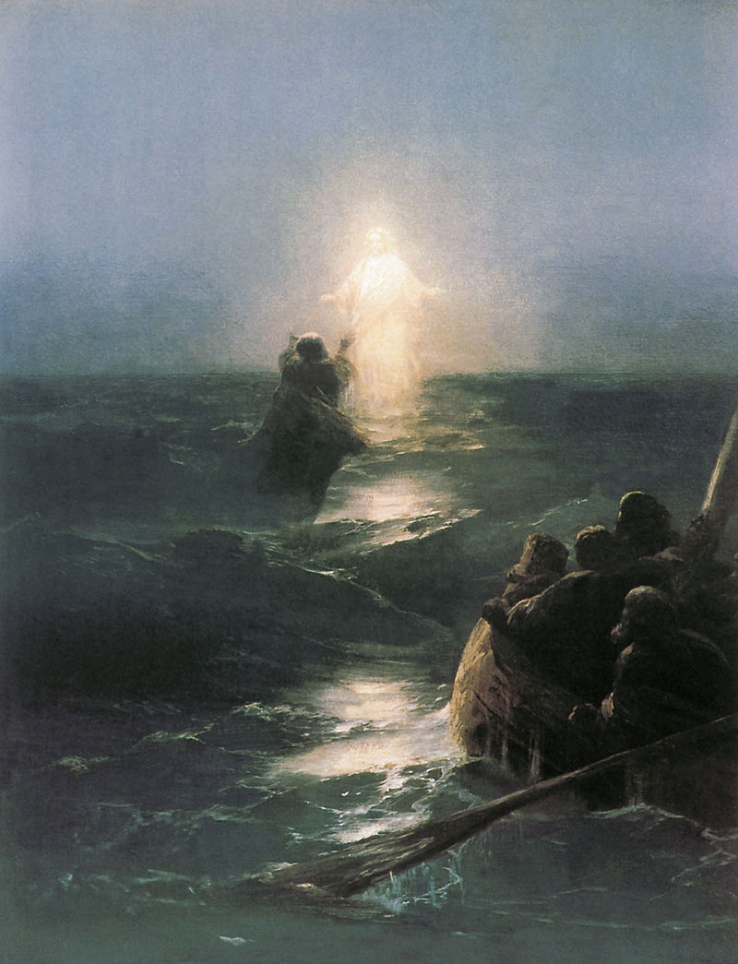

**“Jesus Walking on Water” (1890) Painting by an Armenian Romantic artist Ivan Aivazovsky.**