Notice of PUBLIC HEARING and BUDGET SUMMARY
Notice is hereby given that the Town of Greenfield, Monroe County, Wisconsin,
will hold a public hearing on the town’s proposed 2026 budget on
Monday, November 10, 2025- 7 p.m.
at the Greenfield Town Hall, 11575 Fisher Road in Tunnel City, WI. Immediately following the public hearing, a Special Town Elector Meeting will be held to approve the 2025 town’s tax levy to be collected in 2026. Our regular monthly township meeting will follow immediately afterward. The proposed budget in detail is available for inspection at the clerk’s office by appointment and at this meeting. The following is a summary of the proposed budget:

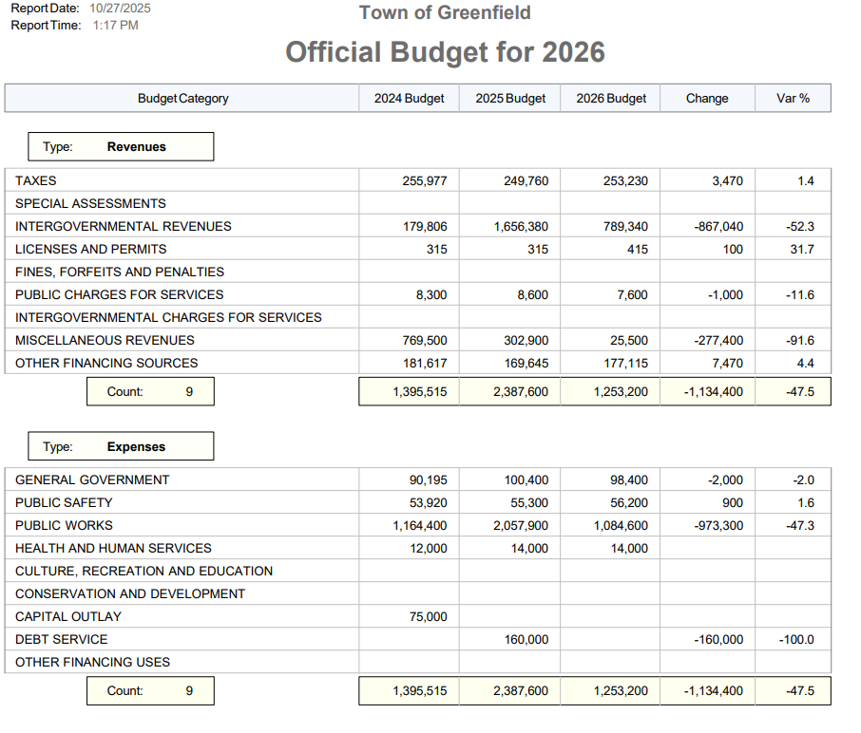
Posted this 27th day of October, 2025 by Deb Stott, Clerk

