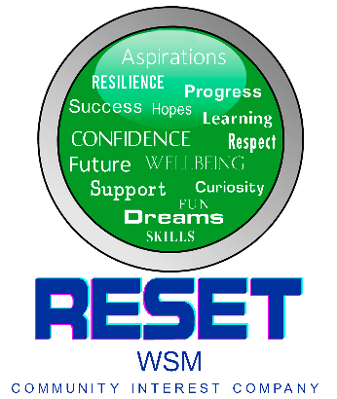
Nomination form
Reset WSM
North Somerset Youth Awards

Nominator Information
Name
How do you know the young person?
Your contact details
Phone
Email

Nominee Information
Name
Age
Address
Education setting
Phone number
Email
Parent/carer name
Phone number
Email
Please write here if we should contact the young person directly, their parent/ carer or both.

Please highlight the category you want to nominate for:
Superhero | Art and Culture
Caring | Fundraising
Environmental | Learning
Sporting | Team or Group
Service to children

The following information will be used to go to a panel to decide the finalists and winners of the 10 categories. All names will be made anonymous.
Please tell us why you want to nominate them for the award.

Tell us what makes them stand out.

Tell us why they should win the award.

By completing this form, I consent that I give permission for Reset WSM CIC to process my information.

I confirm that by completing and returning this form I have gained permission from the nominee and their family/carer and that they give consent to be nominated.

Please return all completed nomination forms to admin@resetwsm.co.uk

