**Nomination form** 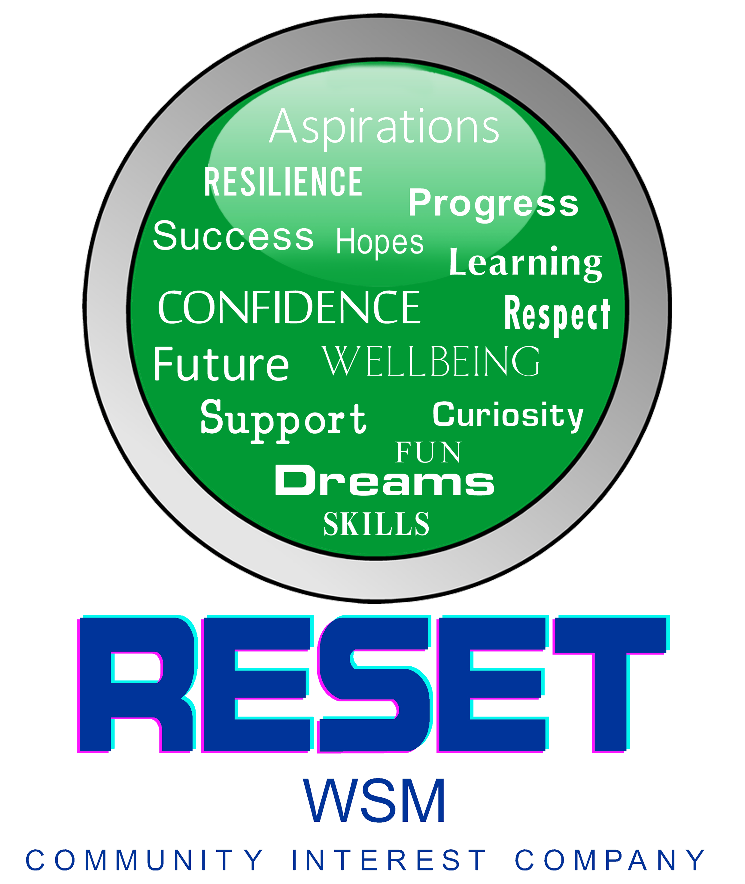

Reset WSM

North Somerset Youth Awards

|  |  |
| --- | --- |
| Nominator Information | |
| Name |  |
| How do you know the young person? |  |
| Your contact details | |
| Phone |  |
| Email |  |

|  |  |
| --- | --- |
| Nominee Information | |
| Name |  |
| Age |  |
| Address |  |
| Education setting |  |
| Phone number |  |
| Email |  |
| Parent/carer name |  |
| Phone number |  |
| Email |  |
| Please write here if we should contact the young person directly, their parent/ carer or both. | |
|  | |

|  |  |
| --- | --- |
| **Please highlight the category you want to nominate for:** | |
| Service to Children | Art and Culture |
| Caring | Enterprise |
| Environmental | Learning |
| Sporting | Team or Group |
| Children’s Team | Superhero |

The following information will be used to go to a panel to decide the finalists and winners of the 10 categories. All names will be made anonymous.

|  |
| --- |
| Please tell us why you want to nominate them for the award. |
|  |

|  |
| --- |
| Tell us what makes them stand out. |
|  |

|  |
| --- |
| Tell us why they should win the award. |
|  |

By completing this form, I consent that I give permission for Reset WSM CIC to process my information.

I confirm that by completing and returning this form I have gained permission from the nominee and their family/carer and that they give consent to be nominated.

Please return all completed nomination forms to [admin@resetwsm.co.uk](mailto:admin@resetwsm.co.uk)