

420 D St.
Marysville, CA 95901
530-415-7777

4141 Northgate Blvd Suite 1B
Sacramento, CA 95834
916-759-3580
(Sacramento location calls only)

1420 Roseville Pkwy Ste. 140-358
Roseville, CA 95661
916-996-5977
(Roseville location calls only)

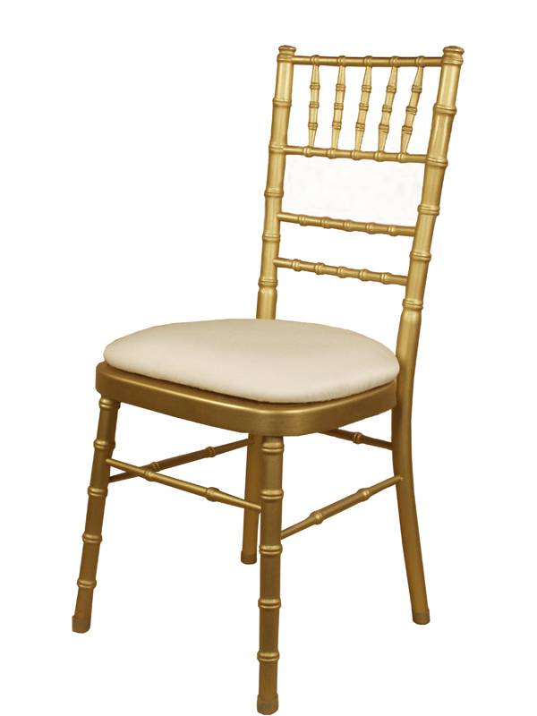
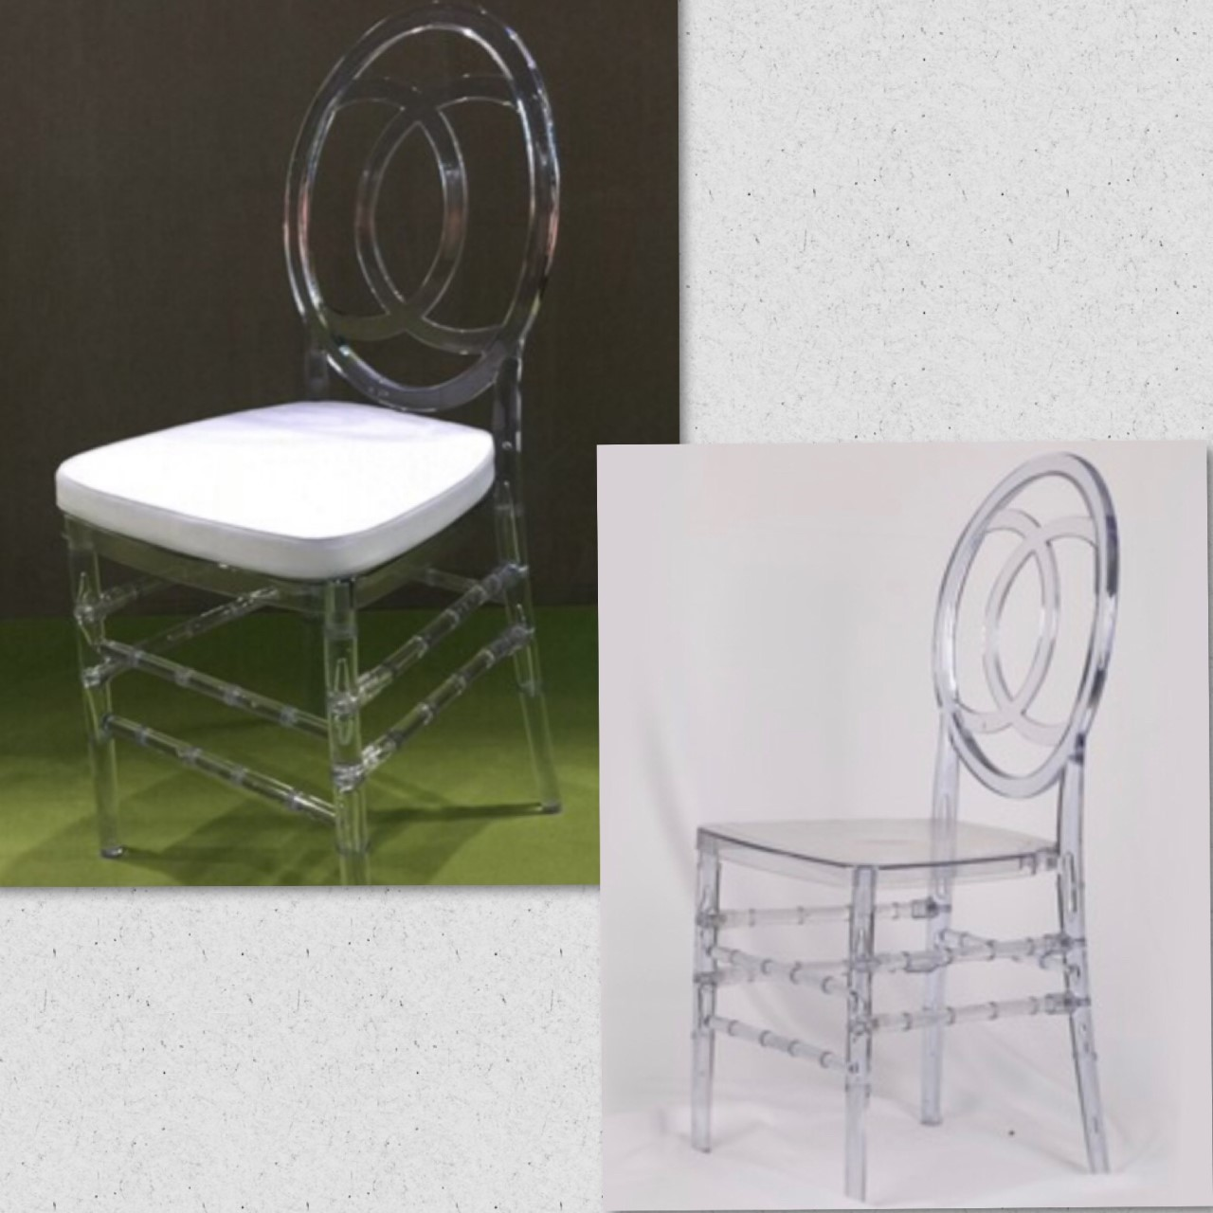
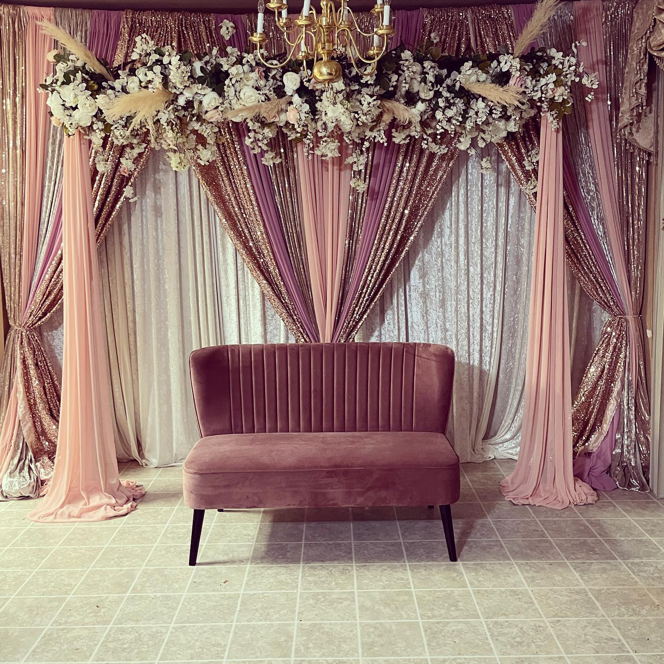
WE WILL WORK WITH YOUR BUDGET!!!
Call us today to setup a consultation.
Our wedding decor includes:
Table covers, chair covers, chair sashes, overlays, one main backdrop, elegant entrance decor, table covers for buffet tables, three different centerpieces and an elegant stage setup. We set up everything and after the event, we take it all down.
TABLES
Banquet Plastic 6 foot $9.00
Banquet Plastic 8 foot $10.00
Round Plastic 5 foot $11.00
Bar Stool Tables $12.00
CHAIRS
Plastic Folding Chair $1.00
Chair Cover $2.00
Satin White Universal
Satin Gold Universal
Satin Black Universal
Polyester White Banquet
Polyester White Folding Chair
Polyester Ivory Folding Chair
Chair Cover w/ Tie $2.50
Chair Cover Tie $0.50
Chiavari Chairs W/ cushions $3.75
min order 100 Delivery Only
Wedding Folding Chair Resin $2.50
Wooden Resin Chair $ 3.00
W/ cushions min order 100 Delivery Only
Ghost Chair/ Double Fish Chair $4.00
W/ cushions $5.00
min order 100 Delivery Only
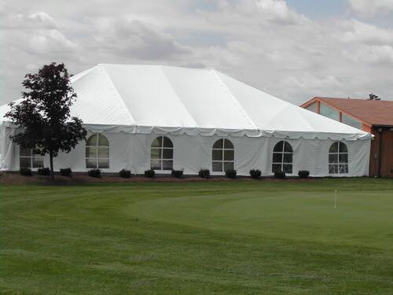
CANOPIES/ TENTS
20x20 $350 W/Sides +$100
20x30 $450 W/Sides +$125
30x30 $650 W/Sides +$150
30x40 $800 W/Sides +$175
30x50 $950 W/Sides +$200
30x60 $1150 W/Sides +$225
30x70 $1400 W/Sides +$250
30x80 $1700 W/Sides +$300
Draping Tent $100-$300
Café Lighting for Tent $100-$450
*We now have weekly rates*
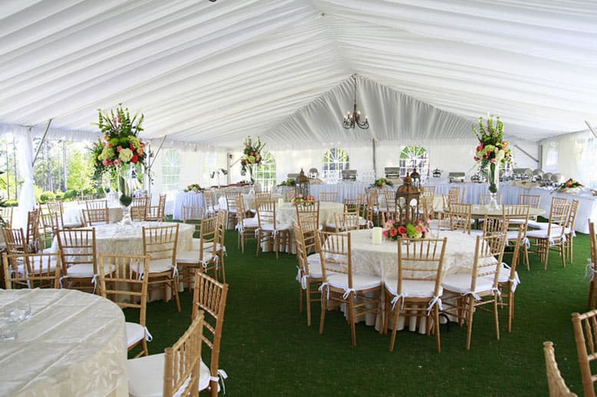
WE NOW HAVE TENT LINERS
Tent Liner 30x30 $445
Tent Liner 30x40 $610
Tent Liner 30x50 $775
Tent Liner 30x60 $940
Tent Liner 30x70 $1,125
Tent Liner 30x80 $1,300

MACHINES
Fog Machine $35
Hot Dog Machine $30
Nacho Machine $20
Popcorn Machine $35
Margarita Machine $30
Chocolate Fountain $15
Snow Cone Machine $30

STAGE
4x8 Stage with carpet (8@) $30

DANCE FLOOR
3X3 Piece $15
Special 15x15 $300
Special 18x18 $435
Special 21x21 $535
(MUST BE SET UP ON A FLAT SURFACE! IF THE AREA HAS GRASS/GRAVEL CUSTOMER MUST ORDER A 16x16 STAGE PLUS A 15x15 DANCE FLOOR $540)

BAR
Bar (10ft wide) $250
Included 4 bar pieces & 9 display cases

SPECIAL SEATING
Small- Large Couches $250-$400
Purple Velvet Chairs (2) $65
Chairs w/ Gold Covers (2) $45
Big Throne Chairs $75
Small Throne Chairs $50
Huge Throne Chairs $250 Green Steel Bench $100
White Steel Bench $100
Yellow Wooden Bench $150
Multi-Colored Wooden Bench $75

LINENS
Table Clothes:
90x156 Banquet (Rectangular) $12
120" Round $12
Rectangular Pintuck $16
120” Pintuck or Pin wheel $16
Napkins $0.50
Organza Overlays 54X54 $5
Sequin Overlays $5
Table Runners (burlap, lace, organza) $3
Burlap w/ lace runner $5
Sequin Runners $5

BACKDROP PANELS
Satin solid/Organza (10-12ft) $10
Sequin/Heavy Pattern w/ Sequin
(10-12ft) $20
Crushed Sheer Voile–White (18 ft.) $25
Voile–Ivory (40 ft.) $80

POKER
Poker Chips $10
Projector w/ Screen $95
Project Only $55 Screen Only $55

INDIAN WEDDING
Jago $25
Jago Stick $10
Kirpan $10
Dholki $40

LIGHTS
Wall Washing Light $20
Disco Ball 12" $15

WEDDING ACCESSORIES
Flower Wall 8ft x 8ft $325
LOVE Sign $250
Cake Knife Set $5
Metal Arch Frame $50
Money Tree Large $10
Silver Cake Plate $20
Gold Cake Plate $20
Wedding Arch Background $55
(4 white pillars & 1 arch)
Wedding Gate $150
Acrylic Stands ( S, M, L) $13-$35
Metal Wedding Arch $50
Hollywood Style Stanchions $80
(6 stanchions & 4 ropes in blue or red)
Red Carpet $75
Barrels Table $100
Barrels $25
Bible Stand $10
White Plastic Urns (2 @) $5
Steel Urns (2 @) $7
Steel Stands 3ft (2 @) $7
Steel Stands 2ft (2 @) $5
Lantern 25 inch $12
Lantern 18 inch $10
Lantern 12 inch $7
Crystal Chandelier $50
Light up Chandelier $55
Small Peacocks (1) $20
Large Peacocks (1) $50

GLASSWARE
Pitcher Glass $2
Pitcher Plastic $1
Goblets $0.40
Round Mirror $2
Square Mirror $2

CHINA & FLATWARE (White)
All plates: Dinner, Salad, etc. $0.40
Coffee Cup $0.40
Saucer $0.40
Charger (Colors: Gold/Silver) $1
Charger (Clear Gold Beaded) $2
Spoons, Forks, Knife, etc. $0.30
ALL CHINA/FLATWARE MUST COME BACK RINSED (NO FOOD CONTENTS)

PUNCH BOWLS & TRAYS
5 gallon punch dispenser $10
Punch Fountain $10

CHAFING DISHES
7 qt. Chafing $13

COFFEE URNS
12-30 cup $7
25-65 $9
40-100 cup $12

