

420 D St.
Marysville, CA 95901
530-415-7777

Instagram
JsPartyRentalsAndDecor

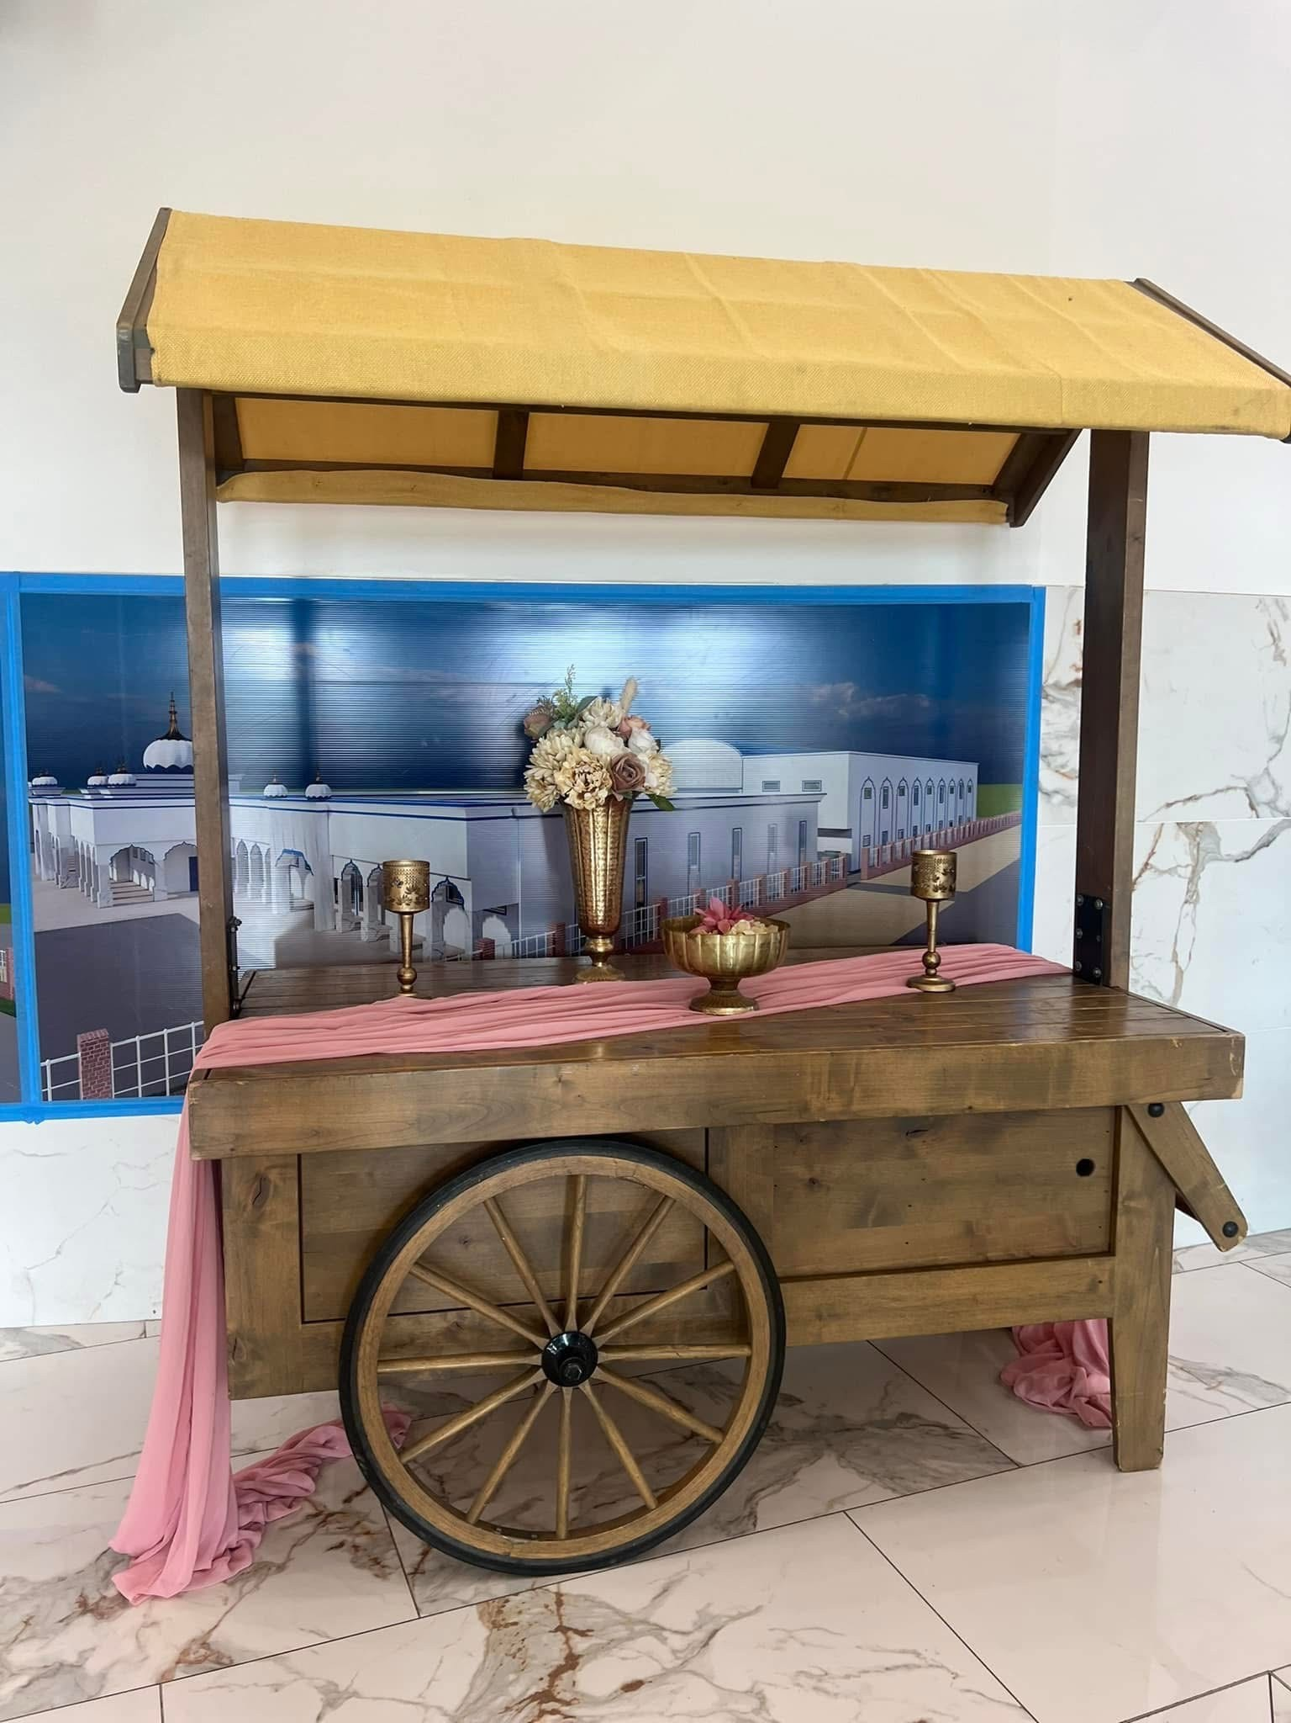
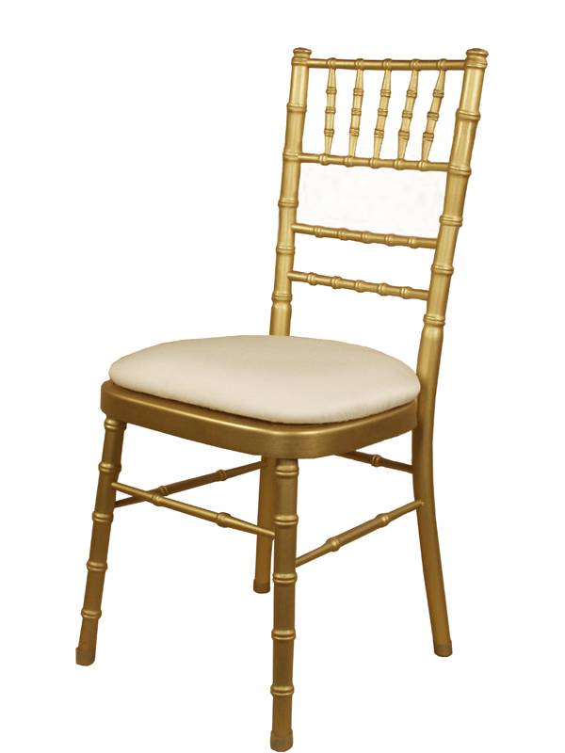

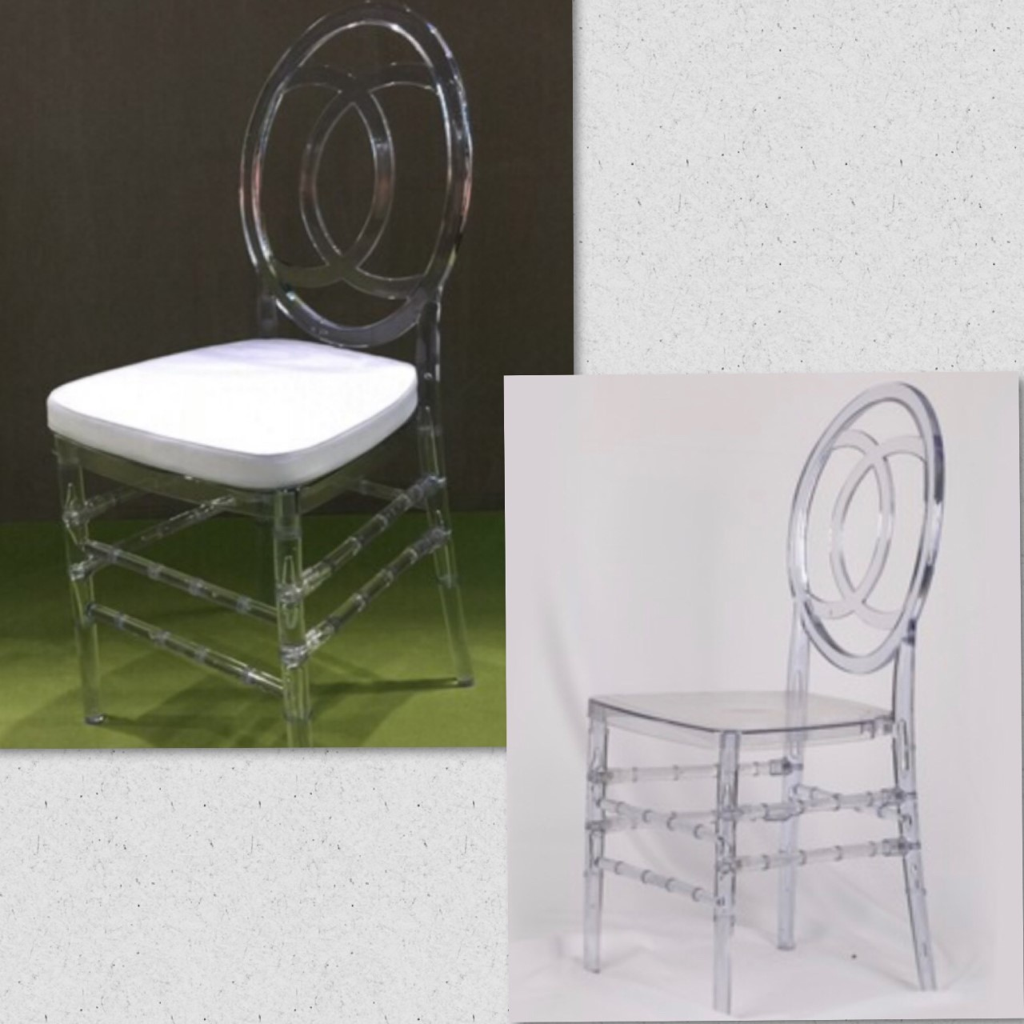

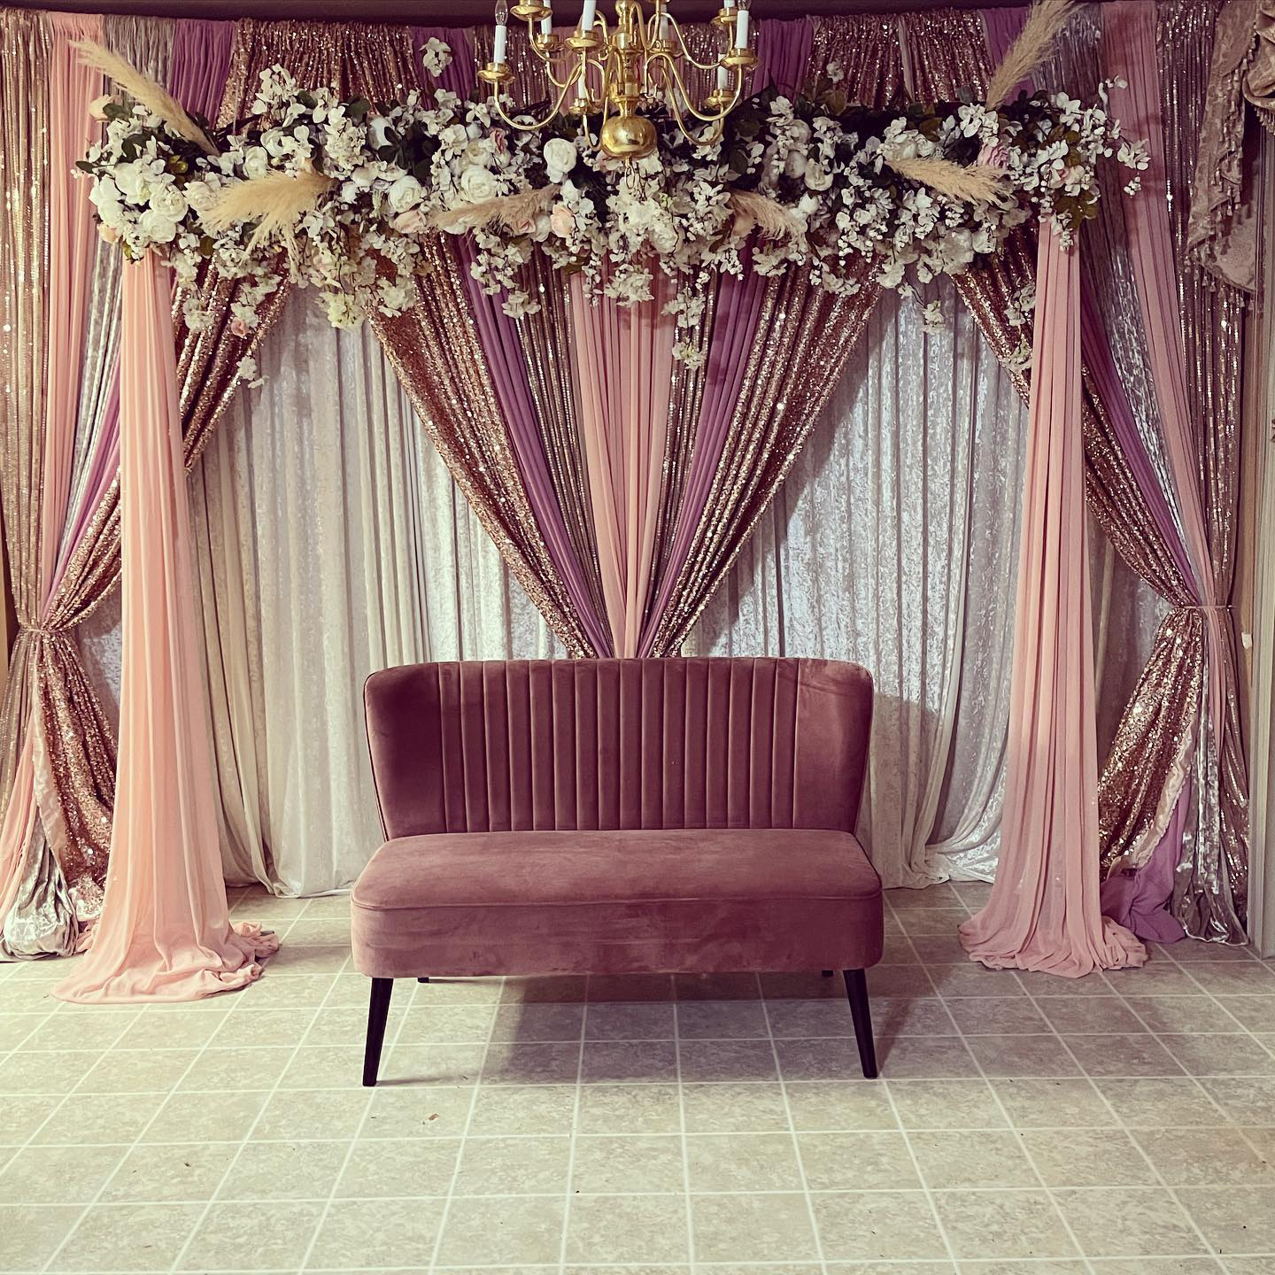
Call us today to setup a consultation.
Our wedding decor includes:
Table covers, chair covers, chair sashes, overlays, one main backdrop, elegant entrance decor, table covers for buffet tables, three different centerpieces and an elegant stage setup. We set up everything and after the event, we take it all down.
TABLES
Banquet Plastic 6 foot $10.00
Banquet Plastic 8 foot $11.00
Banquet Wood 96”x30” $11.00
Round Plastic 5 foot $12.00
Bar Stool Tables $13.00
Kid’s Table $13.00
Round Wood Table with Umbrella Hole $15.00
White Vinyl Umbrella with Stone Base$12.00

CHAIRS
Plastic Folding Chair $1.10
Chair Cover $2.25
Satin White Universal
Satin Gold Universal
Satin Black Universal
Polyester White Banquet
Polyester White Folding Chair
Polyester Ivory Folding Chair
Chair Cover w/ Tie $2.75
Chair Cover Tie $0.60
Chiavari Chairs W/ cushions $3.75
min order 100 Delivery Only
Kid’s Chiavari Chair $5.50
Wedding Folding Chair Resin- White $3.00
Wooden Resin Chair $3.25
W/ cushions min order 100 Delivery Only
Ghost Chair/ Double Fish Chair $4.50
W/ cushions $5.50
min order 100 Delivery Only
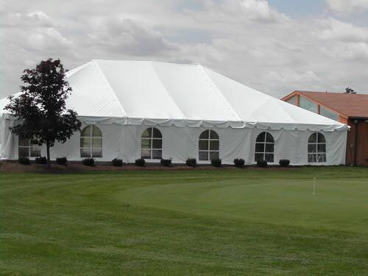
CANOPIES/ TENTS
20x20 $400 W/Sides +$100
20x30 $600 W/Sides +$125
30x30 $850 W/Sides +$150
30x40 $1000 W/Sides +$175
30x50 $1200 W/Sides +$200
30x60 $1400 W/Sides +$225
30x70 $1650 W/Sides +$250
30x80 $1950 W/Sides +$300
Draping Tent $100-$300
Café Lighting for Tent $25 each
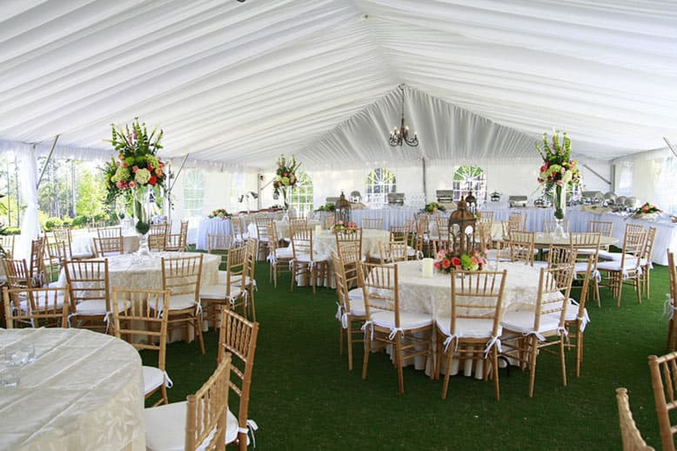
WE NOW HAVE TENT LINERS
Tent Liner 30x30 $470
Tent Liner 30x40 $635
Tent Liner 30x50 $800
Tent Liner 30x60 $965
Tent Liner 30x70 $1,150
Tent Liner 30x80 $1,350
MACHINES
Fog Machine $40
Hot Dog Machine $35
Nacho Machine $25
Popcorn Machine $40
Margarita Machine $35
Chocolate Fountain $20
Snow Cone Machine $35
STAGE
4x8 Stage with carpet (8@) $40
Stage 12x16 with stairs $300
DANCE FLOOR
Brown Color Dance Floor
Special 15x15 $350
Special 18x18 $485
Special 21x21 $585
White Dance Floor
Special 15x15 $550
Special 18x18 $685
Special 21x21 $785
(MUST BE SET UP ON A FLAT SURFACE! IF THE AREA HAS GRASS/GRAVEL CUSTOMER MUST ORDER A 16x16 STAGE PLUS A 15x15 DANCE FLOOR)

BAR
Led Bar $300
Non-LED Bar $250
SPECIAL SEATING
Small- Large Couches $250-$400
Purple Velvet Chairs (2) $65
Chairs w/ Gold Covers (2) $45
Big Throne Chairs $75
Small Throne Chairs $50
Huge Throne Chairs $250 Green Steel Bench $100
White Steel Bench $100
Yellow Wooden Bench $150
Multi-Colored Wooden Bench $75
LINENS
Table Clothes:
90x156 Banquet (Rectangular) $14
120" Round $14
Rectangular Pintuck $16
120” Pintuck or Pin wheel $16
Napkins $0.70
Organza Overlays 54X54 $7
Sequin Overlays $7
Table Runners (burlap, lace, organza) $4
Burlap w/ lace runner $7
Sequin Runners $7
BACKDROP PANELS
Satin solid/Organza (10-12ft) $12
Sequin/Heavy Pattern w/ Sequin
(10-12ft) $22
Crushed Sheer Voile–White (18 ft.) $30
Voile–Ivory (40 ft.) $90
INDIAN WEDDING
Jago $25
Jago Stick $10
Kirpan $10
Dholki $40
LIGHTS
Wagon $250
Wall Washing Light $20
Disco Ball 12" $15
WEDDING ACCESSORIES
Flower Wall 8ft x 8ft $325
LOVE Sign $250
Mr. & Mrs. Sign $250
Donut Wall $100
Cake Knife Set $5
Metal Arch Frame $50
Money Tree Large $10
Silver Cake Plate $20
Gold Cake Plate $20
Wedding Arch Background $55
(4 white pillars & 1 arch)
Wedding Gate $150
Acrylic Stands ( S, M, L) $13-$35
Metal Wedding Arch $50
Hollywood Style Stanchions $80
(6 stanchions & 4 ropes in blue or red)
Tinsel Barrier Stanchions $25 set
Red Carpet $75
Barrels Table $100
Barrels $25
White Plastic Urns (2 @) $5
Steel Urns (2 @) $7
Steel Stands 3ft (2 @) $7
Steel Stands 2ft (2 @) $5
Lantern 25 inch $12
Lantern 18 inch $10
Lantern 12 inch $7
Crystal Chandelier $50
Light up Chandelier $55
Small Peacocks (1) $20
Large Peacocks (1) $50
Large 40” Igloo Cooler $40
Metal Wash Basins 24” Diameter $25
40 Gallon Metal Troughs $35
Cambro Beverage Container $25
Poker Chips $20
Projector w/ Screen $110
Project Only $55 Screen Only $55
GLASSWARE
Pitcher Glass $2.50
Pitcher Plastic $1.50
Goblets $0.50
Stemless Wine Glasses $0.90
Martini Glasses $0.90
Champagne Glasses $0.90
Cocktail Glasses $0.90
Round Mirror $4
Square Mirror $4
Mason Jars $0.90
CHINA & FLATWARE (White)
All plates: Dinner, Salad, etc. $0.50
Coffee Cup $0.50
Saucer $0.50
Charger (Colors: Gold/Silver) $1
Charger (Clear Gold Beaded) $2
Spoons, Forks, Knife, etc. $0.40
ALL CHINA/FLATWARE MUST COME BACK RINSED (NO FOOD CONTENTS)
PUNCH BOWLS & TRAYS
5-gallon punch dispenser $15
Punch Fountain $15
Metal Fancy Fountain $35
CHAFING DISHES
7 qt. Chafing $15
COFFEE URNS
12-30 cup $10
25-65 $15
40-100 cup $20

