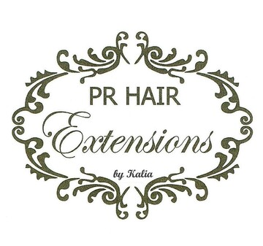
PR Hair Extensions will be at Booth 1760 at IBS, NYC March 13-15,2022 at Javits Center
Hair Stylists can Earn Basic Extensions Certificate by Completing a 1 Hour Course
New York City, NY, February 26, 2022 -For Immediate Release – PR Hair Extensions located at 27-24 Hoyt Avenue South, Long Island City, NY will be taking part in the New York International Beauty Show (IBS). The show to be held on March 13-15, 2022 at the New York Javits Center is a gala event for Beauty Professionals and Suppliers.
The show features Beauty Lectures, Seminars, Guest Speakers, Classes, along with new product introductions and the largest exhibition of beauty supplies and accessories. The best value 3-Day Exhibit Hall Pass includes unlimited access to the exhibitions space and 80 + classes for $99.
PR Hair Extensions will be at Booth 1760 in the IBS Exhibition Hall. Fresh off a successful engagement at New York Fashion Week, Kaliopi Matheakis, owner, and operator will be offering a one-hour hair extensions training course. Stylists who complete the one-hour training session will earn a Basic Hair Extension Certification.
During the one-hour training sessions at IBS, Ms. Matheakis will teach participants about the healthy application techniques for hair extensions, along with removal and maintenance processes. She will discuss and instruct on the procedures necessary for wearing semi-permanent extensions, including how to readjust, tighten and partially reattach on a routine schedule.
The lesson will also focus on the importance of hair extension client education. This includes educating hair extension clients in proper home maintenance such as shampooing and styling techniques. Throughout the training sessions hair extensions specialist Anh Duong will be on hand to assist and supervise the licensed stylists as they achieve their basic Hair Extension Certification.
All the necessary hair extensions and materials needed to complete the one-hour training session are included in the special show price. Kaliopi Matheakis will explore with stylists her expertise in a variety of hair extension techniques.
PR Hair Extensions will offer a complete selection of hair extensions and materials throughout the 3 Day IBS event at Booth 1760 in the Exhibition Hall. Kaliopi Matheakis offers one-on-one Advanced Hair Extensions Courses at the PR Hair Extensions Salon in Long Island City, NY. Detailed information and registration forms will be available at the show.
Kaliopi Matheakis has been a student and instructor in the art of hair extension application and design since 1999. Along with being a stylist, cosmetologist, instructor and consultant, Ms. Matheakis is the founder of a propriety brand of hair extensions. Visitors to the IBS Exhibition Hall on March 13-15, 2022, can take a deep dive into hair extension applications, products, and materials at the PR Hair Extensions Booth 1760.
Advanced courses taught by Kaliopi Matheakis at the PR Hair Extension Salon includes traditional and innovative applications of hair extensions. It also includes business training in how to conduct a consultation and how to properly price hair extensions and applications.
Media Contacts - PR Extensions Salon - (347) 858-6891

