Success Building Blocks Checklist - Completed

Block 1:
- My definition of leadership
- Understanding the difference between leadership & management – being a Complete Leader
- My vision - defined

Block 2:
- My distinct contribution - skills, talent, backstory
- My leadership philosophy
- My GPS – guiding principles statement
- My Business Partner Profile – financial stewardship

Block 3:
- Able to clearly identify essential results
- Adequately learned how to track activity
- Use of tracking tools
- Learned how to use appropriate time cycles

Block 4:
- My self-profile
- Team personality chart
- Team rapport check-up, individually & team
- Team morale check up
- Established community guidelines / team agreements

Block 5:
- Process in place, practicing continuous improvement
- Promoting culture of learning, sharing, innovation
- Seeing the value & use of the 1% edge

Block 6:
- Vision refresh – learning to “stretch grow” – vision evolution

Success Building Block #1:
Leading with a clearly defined understanding of what it means to “lead”.
​​

Need to be able to answer the question –
What is leadership? What is leading?
Difference between lead & manage
Destination beyond description

- My definition of leadership
- Understanding the difference between leadership & management – being a Complete Leader
- My vision – defined – a new destination

Notes:

Success Building Block #2:
Lead from my conscious commitment & distinct contribution:
​​

- My distinct contribution - skills, talent, backstory
- My leadership philosophy
- My GPS – guiding principles statement
- My Business Partner Profile – financial stewardship

Notes:

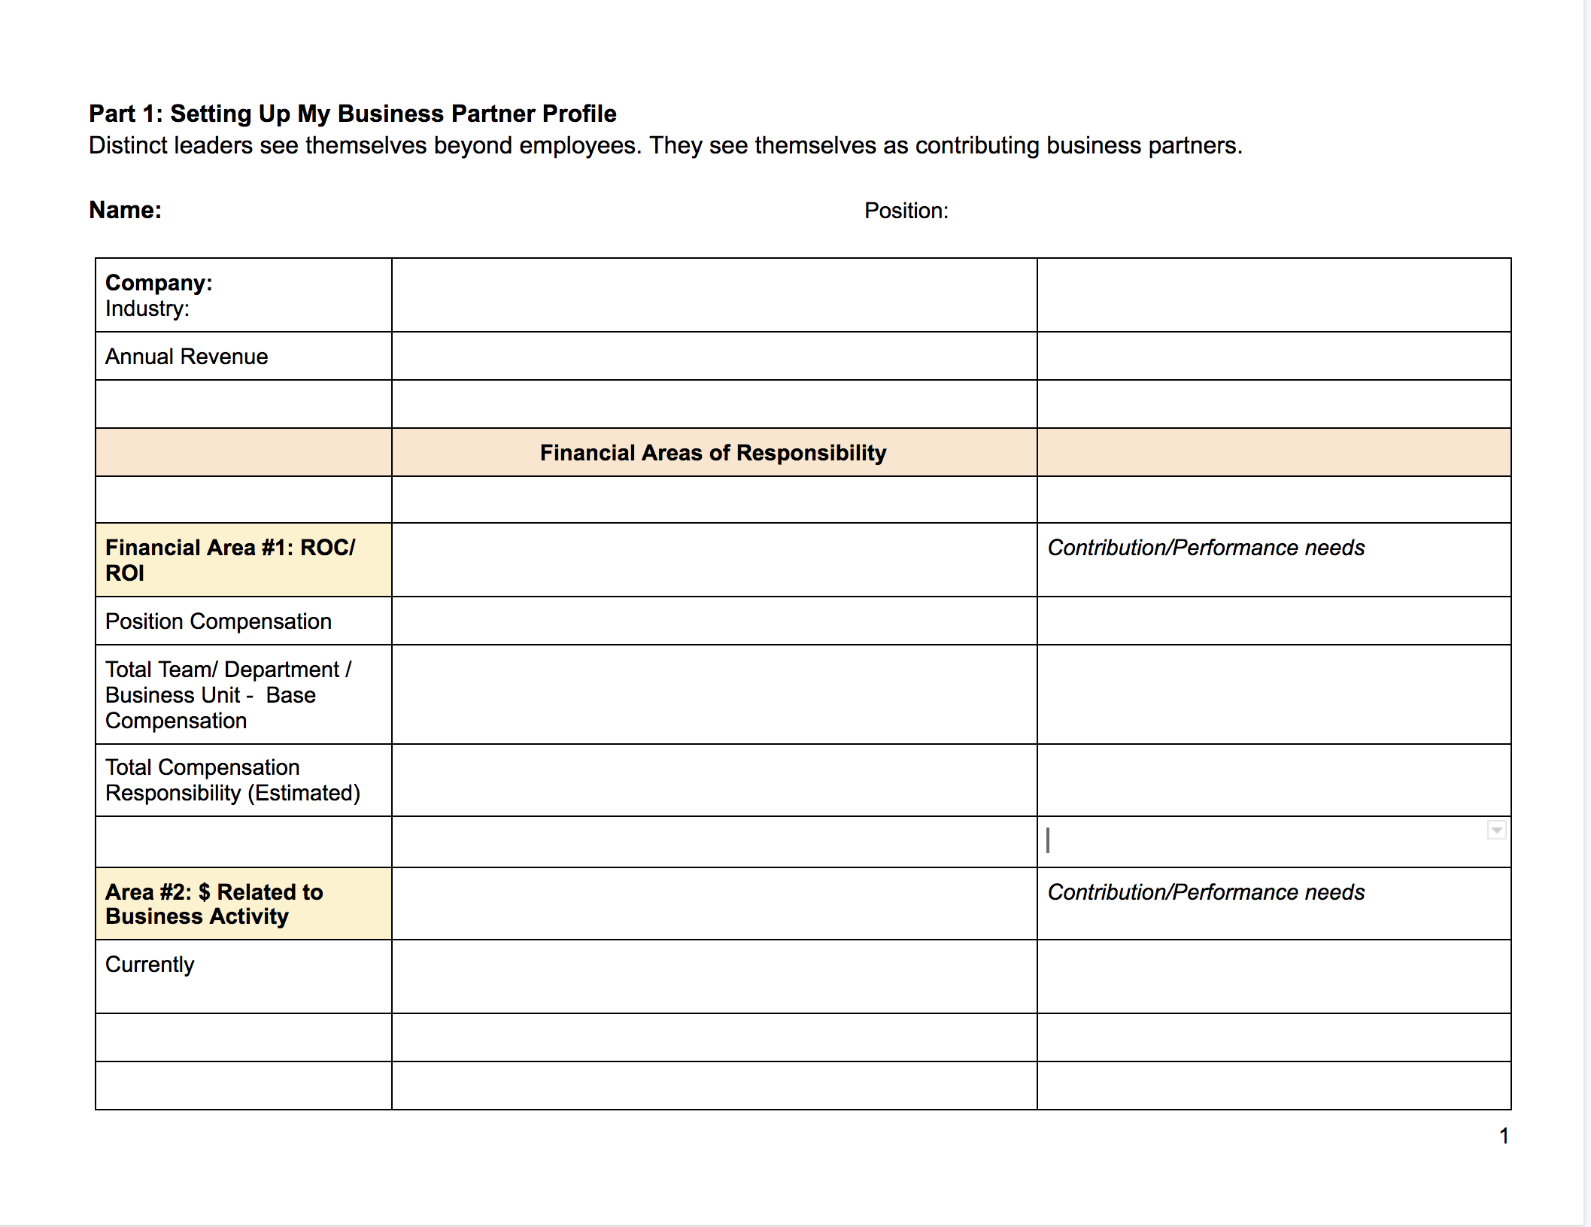

Success Building Block #3:
Lead through being results orientated

- Able to clearly identify essential results
- Adequately learned how to track activity
- Use of tracking tools
- Learned how to use appropriate time cycles

Lead from reality - keeping it real, lead from truth
What current results are you working with?
What new results does your vision suggest?
What new or current activity would be involved?
How do you want to track that?
The role of time cycles - what time cycle serves best results?
Using charts / bullseye, other tracking tools?

Notes

4: Lead by effectively achieving results through people - individual & teams

Talent management - know, assess, hiring,
Simple performance management
How people operate - boosting HQ
Constructive/ positive/ progressive/ accountability

- My self-profile
- Team personality chart
- Team rapport check-up, individually & team
- Team morale check up
- Established community guidelines / team agreements

Notes

