| Values Exercise |
Step 1: Check or circle all the words that “give you energy” – that really matter
Step 2: Pick out 5-7 of what you would consider your core => must haves
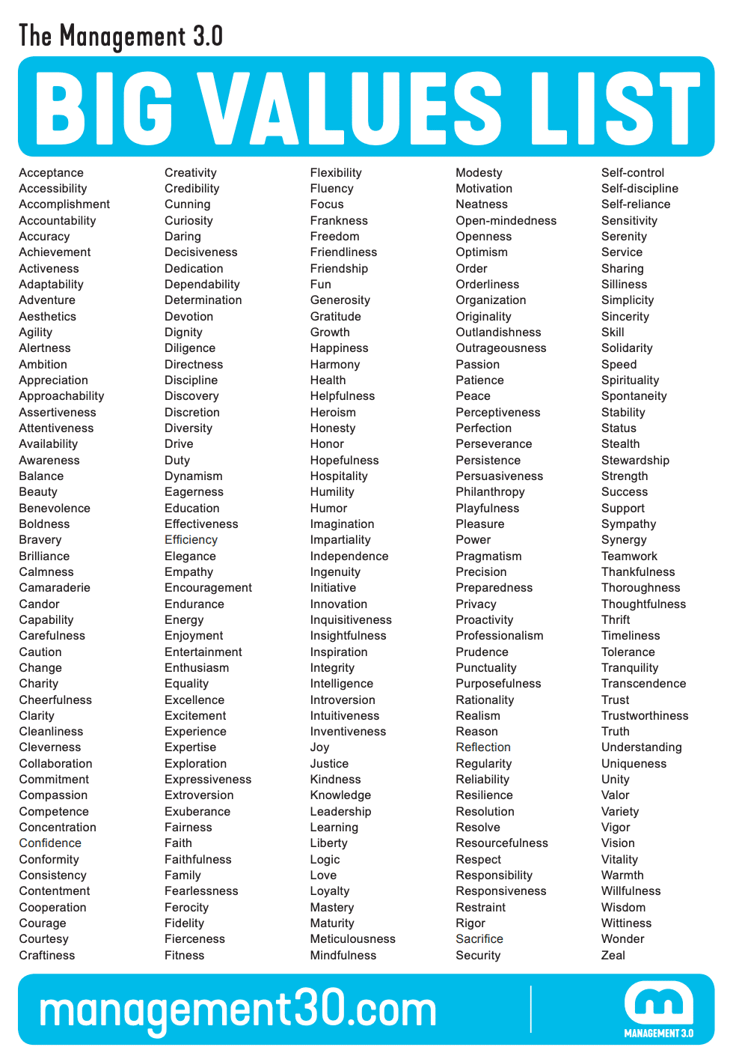

Beliefs:
Answer – what do you believe about yourself as a leader?
What do you believe about your team?

Crafting Your GPS – Guiding Principle Statement

I believe

I value

Therefore, I will… (how you will act as a leader)

State in a Paragraph: What is your overriding Leadership Philosophy

