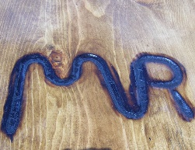 | Meadow Vue Ranch

Scholarship Application

Applicant Information
Full Name: |  |  |  | Date:
 | Last | First | M.I.

Address:
 | Street Address | Apartment/Unit #

 | City | State | ZIP Code

Phone: |  | Email

Parents or Guardian Name

Please Explain Why you would like to attend Meadow Vue Ranch Horse Camp
Type answer here

Please provide the reason you cannot afford to attend camp without a scholarship>
Type answer here

If you receive a scholarship you will have to pay for transportation to and from the Ranch

I affirm that all information in this application is correct and if my child is selected I will send a picture to cody@meadowvueranch so that the applicant can be recognized as the winner of a horse camp scholarship that may be used by Meadow Vue Ranch to promote the scholarship program

Signature: ______________________________________ Date: _________________________________

