COMMERCIAL ENTRANT APPLICATION
The Kailua-Kona Community Parade Association & the Rotary Clubs of Kona present:
The 36th Annual Kailua-Kona Community Christmas Parade
Saturday, December 10th, 2022, Start 5:00PM

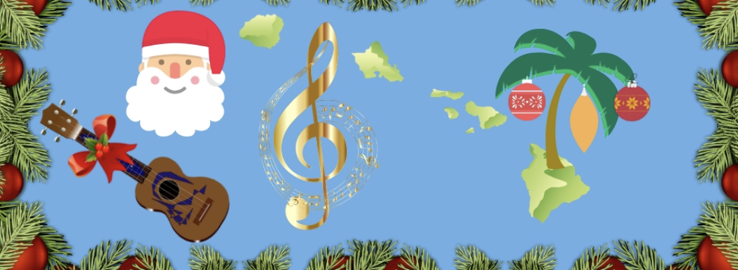

NA MELE O’ KALIKIMAKA
‘THE SONGS OF CHRISTMAS’ ISLAND STYLE

ENTRY DEADLINE SATURDAY DECEMBER 6th 2022
Visit our web site at www.paradesinkona.com

All entries received after the December 6th deadline and approved will be charged a late fee of $25.00.
If you have any questions regarding this application, deadline dates, entry fees, categories or for any additional information, please call 808-345-2108

Name of Individual/Business/Organization/Group:______________________________________________________________________________

Person in Charge:________________________________________________________________________________________________________

Address: _______________________________________________________________City: __________________________Zip:______________

Telephone: (required) ____________________________________________________

E-mail address: (required) ________________________________________________________________________________________________

Approximate number of participants in your entry: _______

Type & Size of Vehicle(s)* listed in the order in which they will be lined up: DECORATE ALL VEHICLES
Entries cannot have more than 3 vehicles (additional with approval) Motorcycles and ATV’s are not permitted.

1.) _____________________________________________________________________________ ______________ ft.
2.) _____________________________________________________________________________ ______________ ft.
3.) _____________________________________________________________________________ ______________ ft.

Does your entry have live singing? __ Yes __No Other music: ____ Yes ____No

Amplifying system: __ Yes __No Will your entry be lit up with lights? ___Yes __No

Entry Fees:

For all commercial entrants, the parade entrant fee is $175.00. Please make your check payable to the Kailua-Kona Community Parade Association. Please note that your entrant fee helps to offset the cost of putting on the Kailua-Kona Community Christmas Parade which is additionally supported by Rotary Club support. $50.00 of your fee will be donated to the Hawaii Island Food Basket as part of the 10th Annual Menehune Holiday Food Drive. We appreciate your kokua!

Amount Submitted: $_________ Make checks or money orders payable to: Kailua-Kona Community Parade Association

I, (we) do hereby waive and release the Kailua-Kona Community Parade Association, the Rotary Clubs of Kona, as well as the owners or management of the grounds or location where the event is held, from any and all claims of personal injury, bodily injury, property damage, other damages, losses and/or death that may arise from participation in this parade.

*All vehicle drivers in this entry will have a valid operator license and insurance for the vehicles being driven.

______________________________________________________
Name (Print)

______________________________________________________ ________________________
Signature Date

The 36th Annual Kailua-Kona Community Christmas Parade
NA MELE O’ KALIKIMAKA
‘THE SONGS OF CHRISTMAS’ ISLAND STYLE
Saturday, December 10th, 2022, Start 5:00 PM

SCRIPT FOR ANNOUNCER
Please type or print legibly
Name of Entry (from page 1) _______________________________________________________________________

Please provide a 30 second script (Maximum of 120 words). Key points to consider: Name of organization, purpose, what’s special about your organization, detail about individuals or vehicles in the entry. Please read your script allowed to maximize the 30 second maximum.

___________________________________________________________
___________________________________________________________
___________________________________________________________
___________________________________________________________
___________________________________________________________
___________________________________________________________
___________________________________________________________
___________________________________________________________
___________________________________________________________
___________________________________________________________
___________________________________________________________
___________________________________________________________
Awards: Commercial entries will be judged for Best in Theme and Best in Entertainment. In addition, there will be awards for Best Crowd Pleaser, Best Musical entry, Best Lighted entry and our Judges’ Special Award.

Delivery of your COMMERCIAL application DEADLINE December 6th:

Scan application to applications@ParadesInKona.com. Check delivery
via USPS with check made payable to the Kailua-Kona Community Parade Association
P.O. Box 1965 Kailua-Kona, HI 96745
Or drop off at the West Hawaii Civic Center Building C 2nd Floor Administration office

Questions 808-345-2108
The Christmas Parade Committee extends its warm aloha for your involvement and participation!

Rules and Guidelines
36th Annual Kailua-Kona Community Christmas Parade – December 10, 2022

Assembly Time and Parade Route: Parade participants MUST check in at the Kona Kekuaokalani Gym/Pool Complex no later than 4:00PM. Entrants staging on Loloku St. will receive separate notification at the application check in tent. The parade will start promptly at 5:00 pm and take the traditional route, Kuakini Hwy to Palani Road onto Ali’i Drive to Coconut Grove Marketplace.

Directions to the Assembly Area: We strongly recommend that you use Makala Blvd. (the road below K-Mart) to Kuakini Hwy going South to the gym. There will be parking for non-parade vehicles behind the gym on the Makai side. There will also be a drop-off area in front of the gym on Kuakini Hwy on the Makai side. Entrants that have been informed that they are staging on Loloku should go down Makala Blvd., make a left at Luhia, and then take the first right after Target, onto Loloku St.

Parade Vehicle Parking: Vehicles in the parade will be directed to their assigned positions. A parking slot for your entry will be numbered. Please back your vehicle in carefully as there will be many children at the assembly area. Larger trucks and floats will be directed to our separate staging area on Loloku Street.

Placement in Parade: The position of your entry in the parade will be given upon check-in on parade day at the Applicant Check In tent.

Vehicle Entry: If you are entering a vehicle DECORATE DECORATE DECORATE

We want everyone to enjoy themselves and show off their Christmas spirit.

Santa: NO SANTA CLAUS SUITS ALLOWED. Santa will be the last entry in the parade.

All Entries: Must be in good taste and suitable for an ohana “family” entertainment event and venue.

While in the Parade: To permit the announcers to adequately describe each entry please maintain a distance of 3 car lengths between entrants. Please show your kokua and do not crowd the entry in front of you at any time.

Handouts: Handing out of candy to the crowd is permitted by walkers only. Throwing of candy or objects from the vehicles or by marchers is strictly not allowed. Entrants ignoring this rule will be escorted out of the parade by the parade marshals. This is a serious safety concern. Children run into the street to get thrown candy. Safety first. Distribution of gifts, merchandise, literature, handouts or political materials must be approved well in advance (allow 14 days) by the parade committee. Squirt guns, silly string or other items potentially dangerous to spectators will not be allowed.

Changes in your Entry: For any changes to your entry prior to event day call 808-345-2108. Please advise of any changes a minimum 72 hours before the scheduled start of parade.

End of Parade: The parade officially ends at Walua Rd and Alii Drive. Vehicles are not permitted to enter or stop in front of Coconut Grove Marketplace at ANYTIME. This is a huge safety concern. All vehicles will continue south on Alii Dr., proceeding directly to Walua Rd. There will be disembarking area on the right side of Alii Drive in front of the grassy area at Huggo’s. Approved vehicles may disembark then proceed and turn onto Walua Rd. All other vehicles may slowly return to the gym via Kuakini Hwy from Walua Rd. The parade committee appreciates the safety and caution taken by your drivers.

Eligibility: The parade committee’s decision regarding all entrants, their eligibility, placement, and judging is final. Eligibility is based primarily on this being a family friendly ‘ohana’ parade.

I have read and understand the rules and guidelines.

______________________________________________________
Name (Print)

______________________________________________________ ________________________
Signature Date

