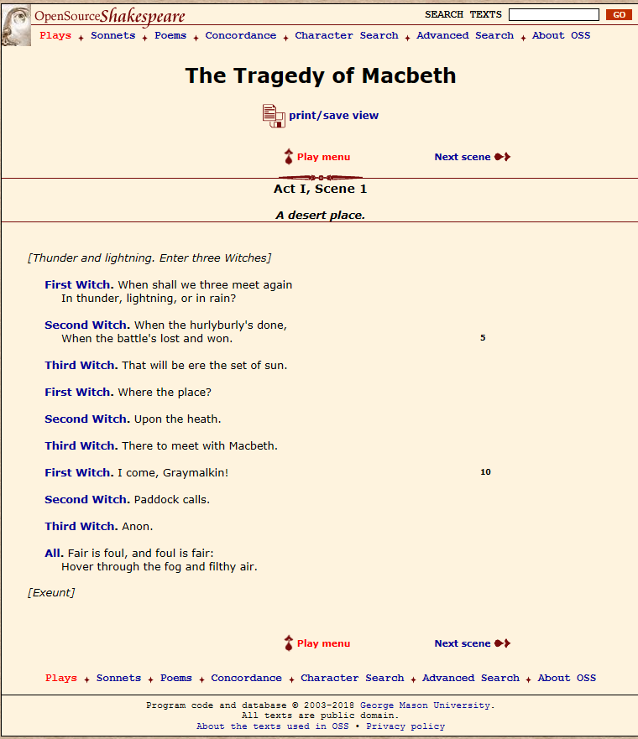

* [**Lady Macbeth**](http://www.opensourceshakespeare.org/views/plays/characters/charlines.php?CharID=ladymacbeth&WorkID=macbeth)**.** Give him tending; **385**  
  He brings great news.   
  *[Exit Messenger]*   
  The raven himself is hoarse   
  That croaks the fatal entrance of Duncan   
  Under my battlements. Come, you spirits **390**  
  That tend on mortal thoughts, unsex me here,   
  And fill me from the crown to the toe top-full   
  Of direst cruelty! make thick my blood;   
  Stop up the access and passage to remorse,   
  That no compunctious visitings of nature **395**  
  Shake my fell purpose, nor keep peace between   
  The effect and it! Come to my woman's breasts,   
  And take my milk for gall, you murdering ministers,   
  Wherever in your sightless substances   
  You wait on nature's mischief! Come, thick night, **400**  
  And pall thee in the dunnest smoke of hell,   
  That my keen knife see not the wound it makes,   
  Nor heaven peep through the blanket of the dark,   
  To cry 'Hold, hold!'   
  *[Enter MACBETH]* **405**  
  Great Glamis! worthy Cawdor!   
  Greater than both, by the all-hail hereafter!   
  Thy letters have transported me beyond   
  This ignorant present, and I feel now   
  The future in the instant. **410**
* [**Macbeth**](http://www.opensourceshakespeare.org/views/plays/characters/charlines.php?CharID=macbeth&WorkID=macbeth)**.** My dearest love,   
  Duncan comes here to-night.
* [**Lady Macbeth**](http://www.opensourceshakespeare.org/views/plays/characters/charlines.php?CharID=ladymacbeth&WorkID=macbeth)**.** And when goes hence?
* [**Macbeth**](http://www.opensourceshakespeare.org/views/plays/characters/charlines.php?CharID=macbeth&WorkID=macbeth)**.** To-morrow, as he purposes.
* [**Lady Macbeth**](http://www.opensourceshakespeare.org/views/plays/characters/charlines.php?CharID=ladymacbeth&WorkID=macbeth)**.** O, never **415**  
  Shall sun that morrow see!   
  Your face, my thane, is as a book where men   
  May read strange matters. To beguile the time,   
  Look like the time; bear welcome in your eye,   
  Your hand, your tongue: look like the innocent flower, **420**  
  But be the serpent under't. He that's coming   
  Must be provided for: and you shall put   
  This night's great business into my dispatch;   
  Which shall to all our nights and days to come   
  Give solely sovereign sway and masterdom. **425**
* [**Macbeth**](http://www.opensourceshakespeare.org/views/plays/characters/charlines.php?CharID=macbeth&WorkID=macbeth)**.** We will speak further.
* [**Lady Macbeth**](http://www.opensourceshakespeare.org/views/plays/characters/charlines.php?CharID=ladymacbeth&WorkID=macbeth)**.** Only look up clear;   
  To alter favour ever is to fear:   
  Leave all the rest to me.

|  |  |  |
| --- | --- | --- |
| **Act I, Scene 7**  ***Macbeth’s castle.*** |  |  |

---

|  |
| --- |
| *[Hautboys and torches. Enter a Sewer, and divers] [p]Servants with dishes and service, and pass over the stage. Then enter MACBETH]*   * [**Macbeth**](http://www.opensourceshakespeare.org/views/plays/characters/charlines.php?CharID=macbeth&WorkID=macbeth)**.** If it were done when 'tis done, then 'twere well  It were done quickly: if the assassination **475** Could trammel up the consequence, and catch  With his surcease success; that but this blow  Might be the be-all and the end-all here,  But here, upon this bank and shoal of time,  We'ld jump the life to come. But in these cases **480** We still have judgment here; that we but teach  Bloody instructions, which, being taught, return  To plague the inventor: this even-handed justice  Commends the ingredients of our poison'd chalice  To our own lips. He's here in double trust; **485** First, as I am his kinsman and his subject,  Strong both against the deed; then, as his host,  Who should against his murderer shut the door,  Not bear the knife myself. Besides, this Duncan  Hath borne his faculties so meek, hath been **490** So clear in his great office, that his virtues  Will plead like angels, trumpet-tongued, against  The deep damnation of his taking-off;  And pity, like a naked new-born babe,  Striding the blast, or heaven's cherubim, horsed **495** Upon the sightless couriers of the air,  Shall blow the horrid deed in every eye,  That tears shall drown the wind. I have no spur  To prick the sides of my intent, but only  Vaulting ambition, which o'erleaps itself **500** And falls on the other.  *[Enter LADY MACBETH]*  How now! what news? * [**Lady Macbeth**](http://www.opensourceshakespeare.org/views/plays/characters/charlines.php?CharID=ladymacbeth&WorkID=macbeth)**.** He has almost supp'd: why have you left the chamber? * [**Macbeth**](http://www.opensourceshakespeare.org/views/plays/characters/charlines.php?CharID=macbeth&WorkID=macbeth)**.** Hath he ask'd for me? **505** * [**Lady Macbeth**](http://www.opensourceshakespeare.org/views/plays/characters/charlines.php?CharID=ladymacbeth&WorkID=macbeth)**.** Know you not he has? * [**Macbeth**](http://www.opensourceshakespeare.org/views/plays/characters/charlines.php?CharID=macbeth&WorkID=macbeth)**.** We will proceed no further in this business:  He hath honour'd me of late; and I have bought  Golden opinions from all sorts of people,  Which would be worn now in their newest gloss, **510** Not cast aside so soon. * [**Lady Macbeth**](http://www.opensourceshakespeare.org/views/plays/characters/charlines.php?CharID=ladymacbeth&WorkID=macbeth)**.** Was the hope drunk  Wherein you dress'd yourself? hath it slept since?  And wakes it now, to look so green and pale  At what it did so freely? From this time **515** Such I account thy love. Art thou afeard  To be the same in thine own act and valour  As thou art in desire? Wouldst thou have that  Which thou esteem'st the ornament of life,  And live a coward in thine own esteem, **520** Letting 'I dare not' wait upon 'I would,'  Like the poor cat i' the adage? * [**Macbeth**](http://www.opensourceshakespeare.org/views/plays/characters/charlines.php?CharID=macbeth&WorkID=macbeth)**.** Prithee, peace:  I dare do all that may become a man;  Who dares do more is none. **525** * [**Lady Macbeth**](http://www.opensourceshakespeare.org/views/plays/characters/charlines.php?CharID=ladymacbeth&WorkID=macbeth)**.** What beast was't, then,  That made you break this enterprise to me?  When you durst do it, then you were a man;  And, to be more than what you were, you would  Be so much more the man. Nor time nor place **530** Did then adhere, and yet you would make both:  They have made themselves, and that their fitness now  Does unmake you. I have given suck, and know  How tender 'tis to love the babe that milks me:  I would, while it was smiling in my face, **535** Have pluck'd my nipple from his boneless gums,  And dash'd the brains out, had I so sworn as you  Have done to this. * [**Macbeth**](http://www.opensourceshakespeare.org/views/plays/characters/charlines.php?CharID=macbeth&WorkID=macbeth)**.** If we should fail? * [**Lady Macbeth**](http://www.opensourceshakespeare.org/views/plays/characters/charlines.php?CharID=ladymacbeth&WorkID=macbeth)**.** We fail! **540** But screw your courage to the sticking-place,  And we'll not fail. When Duncan is asleep—  Whereto the rather shall his day's hard journey  Soundly invite him—his two chamberlains  Will I with wine and wassail so convince **545** That memory, the warder of the brain,  Shall be a fume, and the receipt of reason  A limbeck only: when in swinish sleep  Their drenched natures lie as in a death,  What cannot you and I perform upon **550** The unguarded Duncan? what not put upon  His spongy officers, who shall bear the guilt  Of our great quell? * [**Macbeth**](http://www.opensourceshakespeare.org/views/plays/characters/charlines.php?CharID=macbeth&WorkID=macbeth)**.** Bring forth men-children only;  For thy undaunted mettle should compose **555** Nothing but males. Will it not be received,  When we have mark'd with blood those sleepy two  Of his own chamber and used their very daggers,  That they have done't? * [**Lady Macbeth**](http://www.opensourceshakespeare.org/views/plays/characters/charlines.php?CharID=ladymacbeth&WorkID=macbeth)**.** Who dares receive it other, **560** As we shall make our griefs and clamour roar  Upon his death? * [**Macbeth**](http://www.opensourceshakespeare.org/views/plays/characters/charlines.php?CharID=macbeth&WorkID=macbeth)**.** I am settled, and bend up  Each corporal agent to this terrible feat.  Away, and mock the time with fairest show: **565** False face must hide what the false heart doth know.   *[Exeunt]* |