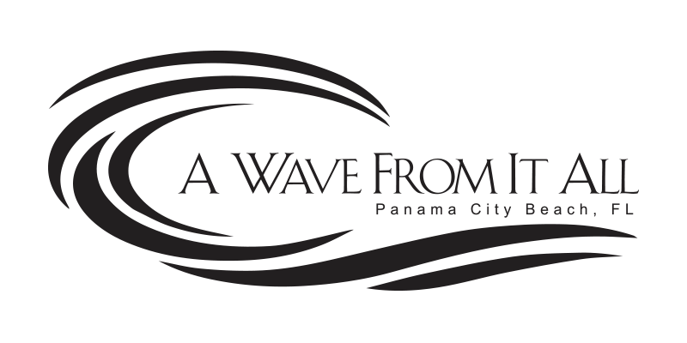
IMPORTANT PARKING INFORMATION

- We have ONE reserved parking space in the covered garage on Parking Level 1 (PL1) for your convenience.

- And, one additional spot that is first-come-first-serve in the overflow parking lot across the street.

- PLEASE NOTE our reserved spot is a very tight space and anything such as a large SUV or truck would find it difficult to navigate and would need to park in the overflow lot.

- If you have more than two vehicles and/or there is no availability in the overflow lot, there is a public parking lot next to the overflow lot that you can use for $6 per day.

- We are happy to reimburse one vehicle per day in the pay lot, just send us your receipt.

