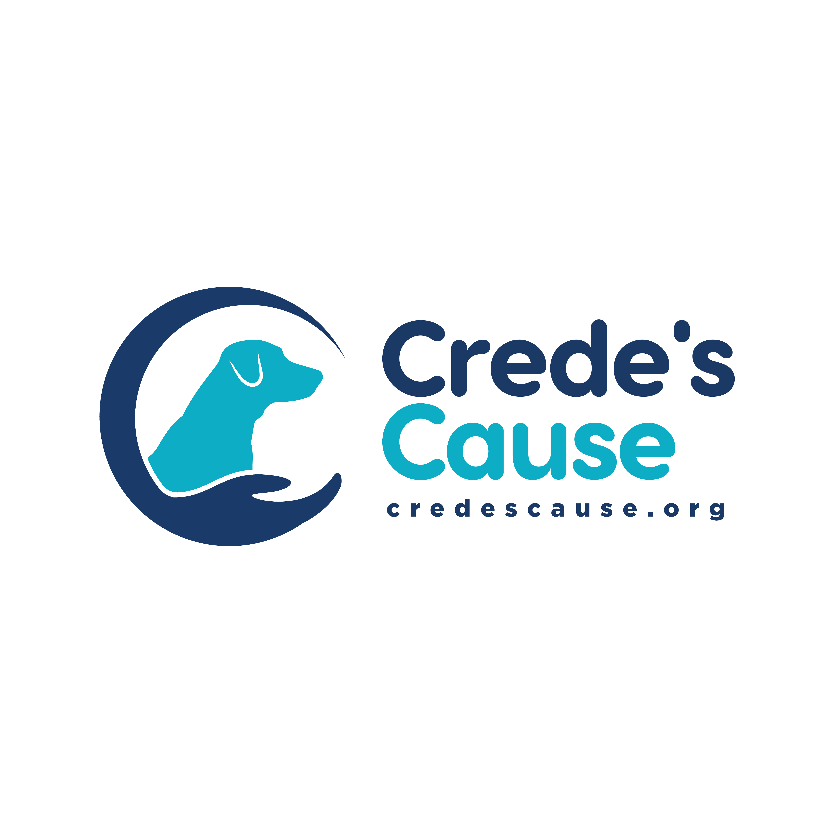
Owner Surrender Form

Please note animals are accepted into our program on a case-by-case basis based on the information you provide in this application, and an in-person assessment by a member of our staff. We reserve the right to refuse an animal based on our assessment, an animal’s behavior history, and health issues we may not be able to help with.

Please provide as much detail as possible so that we may better determine if we can find the right match for the animal you are surrendering.

Personal Information
Name: Date:
Address: Apt #:
City: State: Zip:
Email address: Cell #:
Your Date of birth: Drivers Lic #:

Household Information

# of people in your household: Adults: Children 12 and under: Teens over 13:
Type of home: Apartment ( ) Condo ( ) Single family ( ) Townhome ( ) Farm ( )
Describe your household: Active ( ) Noisy ( ) Quiet ( ) Average ( )
Employment: Full time ( ) Work from Home ( ) Retired ( )
(this helps us to determine if your pet needs someone home more often than not)

Animal Information

Type of animal: Dog ( ) Cat ( ) Gerbil ( ) Guinea Pig ( ) Hamster ( )
Breed: Gender: M ( ) F ( ) Spayed/Neutered: Y ( ) N ( )
Age/ DOB:

What reason are you surrendering this animal:

How long has this animal been in your care:
Where did you get your animal from: ( shelter, rescue, pet store)

Is your animal Microchipped: Please provide chip company and #:
Potty habits: House trained/ goes outside ( ) Pad trained ( ) Needs training ( )
Crate trained: Y ( ) N ( )
Does your pet enjoy any of the following: Walks on a leash ( ) Dog parks ( ) Needs fenced yard ( )
Small mammals: Enjoys being held ( ) Is social ( ) Is shy or timid ( )
Is your dog or cat friendly with other animals such as cats and/or dogs: Y ( ) N ( )
If not, please explain:

Does your pet have a bite history, please explain:

Is your animal up to date on rabies vaccine: Y ( ) N ( ) Date last received:
Can you provide vaccine records if your pet is accepted into our program: Y ( ) N ( )
Has your pet received Heartworm and flea/ Tick meds: Y ( ) N ( ) Date last received:
Does your pet have any medical issues we need to be informed of? If so, please explain:

Does your pet take any medications? Please list what and why:

What type/ brand of food do you feed your pet:

Animal Behavior Info
Please check all that apply and provide as much info as possible:
( ) Barks excessively:
( ) Separation anxiety:
( ) Other anxiety:
( ) Chewing:
( ) Escapes yard of home:
( ) Potty accidents in the home:
( ) Jumps on people:
( ) Nips people:

Animal Behavior Continued

( ) Protective behavior (guards humans, toys, food etc):
( ) Aggressive behavior:
( ) Fears: (loud noises, vacuums, cars, tall people, people wearing hats etc.):
Any other issues not listed here:

Has your pet ever attacked another animal:
Was the other animal hospitalized or died:

Training Information
Has your pet received any formal obedience training, if so, please provide info:

Does your pet know any commands:

Does your pet need to be in a crate when left alone: Y ( ) N ( )
Can your pet be left alone for at least 8 hours a day: Y ( ) N ( )

Please provide any other information that may better help us to place your pet:

Surrender acknowledgement:
I hereby certify that I am the rightful owner/keeper/caretaker of the animal(s) listed on this Owner Surrender Form. I acknowledge that by signing this form, I completely relinquish all claims of ownership of the listed animal(s). Neither my family, representatives acting on my behalf, nor I may assert present/and or future claims or litigations against Crede’s Cause.
I agree to hold harmless and indemnify Crede’s Cause, and its agents, and volunteers from all claims, demands, actions, causes of action, or liability of any kind arising as a result of or in connection with the adoption or other disposition of the listed animals. I understand this is a legally binding contract and cannot be rescinded.
I understand that once this animal is officially accepted by Crede’s Cause, I am no longer the owner and have no rights as to the placement of the animal(s) listed on this form. I will not be given any info as to the new owners or location of the animal(s) surrendered.
I certify that all information provided is true and no known changes in behavior or health have occurred since meeting with a representative of Crede’s Cause.
Crede’s Cause reserves the right to humanely euthanize an animal that has had a change in temperament or health that cannot be helped with training or medical intervention, and it has been determined there are no other options for the animal. You will NOT be notified if the animal has been euthanized.
By signing below, I acknowledge that I have read, understand and agree to the terms of the animal(s) surrender:

____________________________________________________________________________
Owner Signature Date

____________________________________________________________________________
Witness

