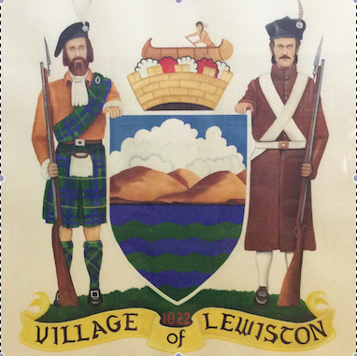
HISTORIC PRESERVATION COMMISSION - PUBLIC HEARING
Monday, January 10, 2022 - 6:00 PM
145 N 4th St., Lewiston, NY 14092
Please take notice that the Village of Lewiston Historic Preservation Commission will hold a Public Hearing on the advisability of Sec. 15-105 (c)(5) of the Criteria and procedure for designation of buildings, sites or districts; for local designation of 475 Ridge Street, Lewiston NY 14092, Tax ID #101.10-2-60
This meeting will be held in the Village Board Room in the Red Brick Municipal Building, located at 145 N. 4th Street Lewiston, NY 14092 on Monday, January 10, 2022 at 6:00pm.
All persons interested in this matter may attend the meeting and be heard.
Thank you,

Stephanie Longwell
Village Treasurer

