






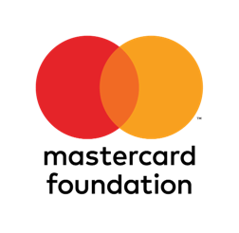
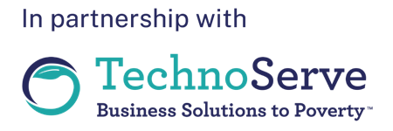

Entrepreneurship Skills for Blue Economy
PARTICIPANT WORKBOOK

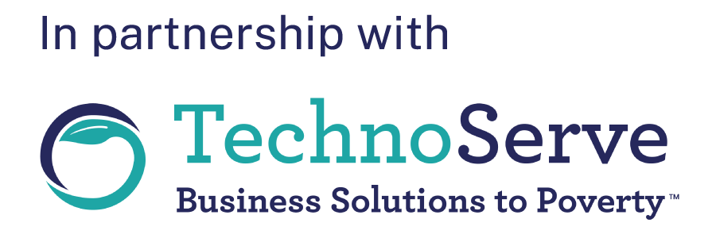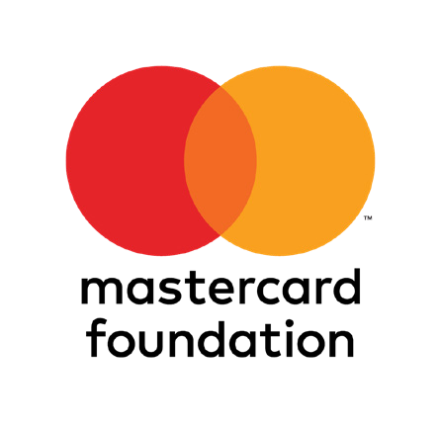

Entrepreneurship Skills for Blue Economy

PARTICIPANT WORKBOOK

Copyright ©2024
Technoserve
www. technoserve.org
All rights reserved. The content in this publication may only be reproduced with express permission in writing from Technoserve.

Entrepreneurship Skills for Blue Economy

Welcome Note

Welcome to this exciting journey of shaping the future of entrepreneurship in the Blue Economy! This workbook will take you through modules designed to help your business grow. Are you here to sharpen your skills or grow your business? We believe in your potential. Remember, success requires more than having an excellent idea; it requires curiosity, learning, and embracing challenges. With the right mindset, your goals can become your reality.
We wish you all the best on this adventure!

Commitment Letter

By joining this program, you’ll be making a leap toward building your business and contributing to the growth of the Blue Economy. In this journey, a lot of your commitment will make you successful and ultimately benefit from the experience.

I, , hereby commit to:
- Full participation during training sessions, discussions, and activities.
- Put into practice the knowledge and skills acquired from this program through developing my business.
- Be open to learn, receive feedback, and collaborate with my peers and mentors.
- Approach challenges in a resilient way with a positive attitude, recognizing these as opportunities for growth.
- Conduct myself with respect, integrity, and inclusivity at all times within this program.

Signature: …………………………

Date: ………………………………

BlueBiz Program | 5

Entrepreneurship Skills for Blue Economy

Table of contents
Welcome and Commitment 5
Welcome Note 5
Commitment Letter 5
Module 0: Introduction to TechnoServe and the
BlueBiz Program 9
Module Objectives 9
Introduction Activities 9
Understanding TechnoServe and BlueBiz 11
Benefits of Joining the Program 12
Gender-Safe Spaces 13
Module 1: Unlock Your Potential by Building Your
Soft Skills 16
Objectives of the Module 16
Introduction to Soft Skills 16
Activities: Island Resource Challenge and Mirror Exercise 17
Personality Profile and Types 19
Strengths and Weaknesses 21
Aspirations and Mission Statements 22
Module 2: Introduction to the Blue Economy 28
Objectives of the Module 28
Exploring Environmental Impacts 29
Steps to Environmental Sustainability 31
Opportunities and Risks in the Blue Economy 32
Vision and Role as a Business Leader 34

Module 3: Understanding My Business Model 36
Objectives 36
Case Studies: Mariam and the Triangle of Success 37
Characteristics of a Good Opportunity 38
The B-Canvas Model 39
Module 4: Understanding My Finances 44
Objectives 44
Case Study: Mama Karanga 44
Financial Concepts: Income, Expenses, and Cash Flow 46
Budgeting and Planning Activities 50
Module 5: Understanding My Markets 55
Objectives 55
Introduction to Marketing 55
Case Study: Aisha’s Cold Storage Business 55
Understanding Customer Segments 57
Assignment Activities 58
Module 6: Communicate and Connect 61
Objectives 61
The Communication Model 61
Relationship Mapping 62
Case Studies: Katana and Hamisi 64
Workbook for Growth and Investment Training 65
About My Business 65
Problem-Solving and Solutions 66
Customer Segments and Market Strategies 67
Financial Projections and Investment Requests 69














Module
0

Introduction to TechnoServe and the BlueBiz program


Entrepreneurship Skills for Blue Economy


Module Objectives:

Module 0:
Introduction to TechnoServe and the BlueBiz program
- Who is TechnoServe?
- Who is BlueBiz?
- Why join the program?
- What benefits will I gain from participating
- What benefits will my business gain from participating
- How can I best relate with my peers and trainers?

Introduction

Hello, nice to meet you!
In this exercise, you will get to know your classmates and introduce yourself.
Questions to discuss with your pair
- What’s your name?
- Where are you from?
- Which business do you operate?


Write down your expectations of the training


Write down the agreed ground rules

Who is TechnoServe?
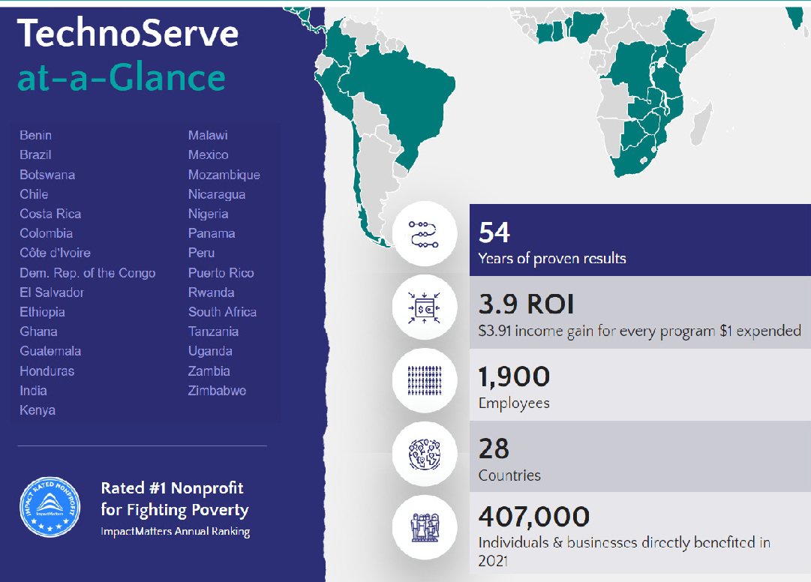
FunFact: TechnoServe was started in 1970 in Ghana

Why join BlueBiz

The program offers training modules on technical aspects, access to financial solutions, and links to the market.

Young people will be selected from among the program participants to give feedback, insights, and recommendations on the program’s implementation.


Young people have the opportunity to access the fund through pitching business ideas.

Program participants will gain direct links to markets based on their products.

As a young person, the program will help you grow your soft skills eventually boosting your confidence in your business and community.

What do I expect from the BlueBiz Program?

What is my motivation for the program?

Gender Safe Spaces
Question Card for Women

- In your families, as girls, what were you not allowed to do while growing up? What were you allowed to do as girls?

- In the Blue Economy, as women, what are you not allowed to do? What are you allowed to do as women?

- In your communities, as women, what are you not allowed to do? What are you allowed to do as women?
Question Card for Men

- In your families, as boys, what were you not allowed to do while growing up? What were you allowed to do as boys?

- In the Blue Economy sector, as men, what are you not allowed to do? What are you allowed to do as men?

- In your communities, as men, what are you not allowed to do? What are you allowed to do as men?

What did you learn today about gender-safe spaces?

Homework

Outline the different businesses that men engage in from women within your community. What does this have to do with what we have learned about the expectations of men and women in the community?













Module
1

Unlock your potential by building your Soft Skills

Entrepreneurship Skills for Blue Economy


Objectives of the module

Module 1:
Unlock your potential by building your Soft Skills
- Understand what soft skills are and how they promote my business.
- How do soft skills help me achieve my dreams and aspirations?
- How do I set long-term and short-term goals for my businesses?
- How can I develop resilience to overcome challenges in my business?

Introduction to soft-skills

- Technical Skills - These skills are commonly thought of as how to engage in the specific value chain i.e. farm or fish or understand the pricing of products.
- Soft Skills - These are skills like communication, problem- solving, thinking ahead, and managing interpersonal and family dynamics. Soft skills are critical to enhance young people’s business performance.
- Business Skills - Skills necessary for working for someone or making money on your own.

Technical Skills | Soft Skills | Business Skills

Island Resource Challenge activity questions

- Did you achieve your goals? Why or why not?

- What were the key factors to achieve your goal? How did you do it?

- Which skills did you have to practice in this exercise?



Mirror activity questions

- What one thing do you like most about what you see in the mirror?

- What two things would you like to improve on what you see?

- How does it make you feel?



Personality profile

In each column, score yourself either a 1, 2, 3 or 4.
  - 1 = Describes you the LEAST
  - 4 = Describes you the MOST

 | COLUMN ONE |  | COLUMN TWO |  | COLUMN THREE |  | COLUMN FOUR
EX | SAD | 1 | FUNNY | 3 | HAPPY | 4 | SILLY | 2
1 | Demanding |  | Loyal |  | Enthusiastic |  | Strong-willed
2 | Critical |  | Firm |  | Passionate |  | Decisive
3 | Cautious |  | Consistent |  | Convincing |  | Must win
4 | High standards |  | Tactful |  | People-oriented |  | Leader
5 | Logical |  | Supportive |  | Inspiring |  | Confident
6 | Careful |  | Good listener |  | Popular |  | Reckless
7 | Analytical |  | Gentle |  | Motivator |  | Dominating
8 | Looks for facts |  | Deliberate |  | Thoughtless |  | Outspoken
9 | Seeks quality |  | Cooperative |  | Charming |  | Confrontational
10 | Concerned |  | Polite |  | Emotional |  | Direct
11 | Quiet & reserved |  | Adaptable |  | Persuasive |  | Problem solver
12 | Orderly |  | Willing |  | Playful |  | Forceful
 | Column One Total |  | Column Two Total |  | Column Three Total |  | Column Four Total

If you scored highest in:
  - Column one you are a PLANNER
  - Column two you are a PEACEMAKER
  - Column three you are an EXPRESSIVE
  - Column four you are a GO-GETTER

Personality Types and Traits

EXPRESSIVE | PLANNER
- Receptive and welcoming.  - Never lacks “friends.”  - Talkative, even in new environments.  - Expresses personal views.  - Decisions are dominated by feelings.  - Fun loving.  - Good storyteller.  - Child at heart.  - Emotional and demonstrative.  - Lives in the present – spontaneous  Motto: Let’s do it the fun way! | - Emotionally sensitive to others.  - Industrious. Keeps busy and works according to plan.  - Detail conscious. Always needs more information and aims high.  - Persistent and thorough. Follow-up until the task is complete.  - Orderly and organized.  - Economical.  - Find creative solutions.  - Schedule oriented.  Motto: Let’s do it the right way!
GO-GETTER | PEACEMAKER
- Confident and visionary. Plans ahead.  - Decisive. Conclusive and final with opinions.  - Independent and self-sufficient.  - Aggressive. Pushes their way.  - Practical and productive. Result and goal-orientated.  - Delegates and insists on getting results.  - Thrives on opposition. Faces conflict head-on.  - Leads and organizes.  - Unemotional.  Motto: Let’s do it my way! | - Diplomatic. Will do anything to avoid confrontation.  - Dependable. Can be relied on.  - Takes time to make decisions.  - Accomplishes tasks with the least amount of effort.  - Calm - even under pressure.  - Easy to get along with.  - Works with others easily.  - Peaceful and agreeable.  - Low-key personality.  Motto: Let’s do it the easy way!

Strength and Weaknesses

 | STRENGTHS | WEAKNESSES
Expressive | - Curious  - Creative  - Charming  - Energetic and enthusiastic  - Volunteers for jobs  - Good sense of humor  - Doesn’t hold grudges  - Makes friends easily | - Undisciplined  - Not good at prioritizing  - Looks for credit for work  - Dominates conversations  - Makes excuses  - Poor listener  - Disorganized  - Never grows up
Planner | - Dependable  - Self-disciplined  - Perfectionist  - Maintains high standards  - Neat and tidy  - Creative  - Purposeful  - Idealistic | - Takes things personally  - Gets hurt or depressed easily  - Spends more time planning than doing  - Overly focused on details  - Deep need for approval  - Critical of others  - Puts goals beyond reach
Go-Getter | - Quick and decisive  - Strong-willed  - Practical and productive  - Self-sufficient and determined  - Not easily discouraged  - Establishes goals  - Moves quickly to action  - Sees the whole picture | - Bossy  - Stubborn  - Impatient  - Quick-tempered  - Inflexible  - Rude and tactless  - Possessive  - Little tolerance for mistakes
Peace Maker | - Never gets upset  - Likable  - Consistent  - Competent and steady  - Mediates problems  - Balanced  - Sympathetic and kind  - Patient | - Lack of drive and ambition  - Indecisive  - Unmotivated  - Procrastinates  - Avoids responsibility  - Resists change  - Unenthusiastic  - Too compromising

Spheres of Awareness
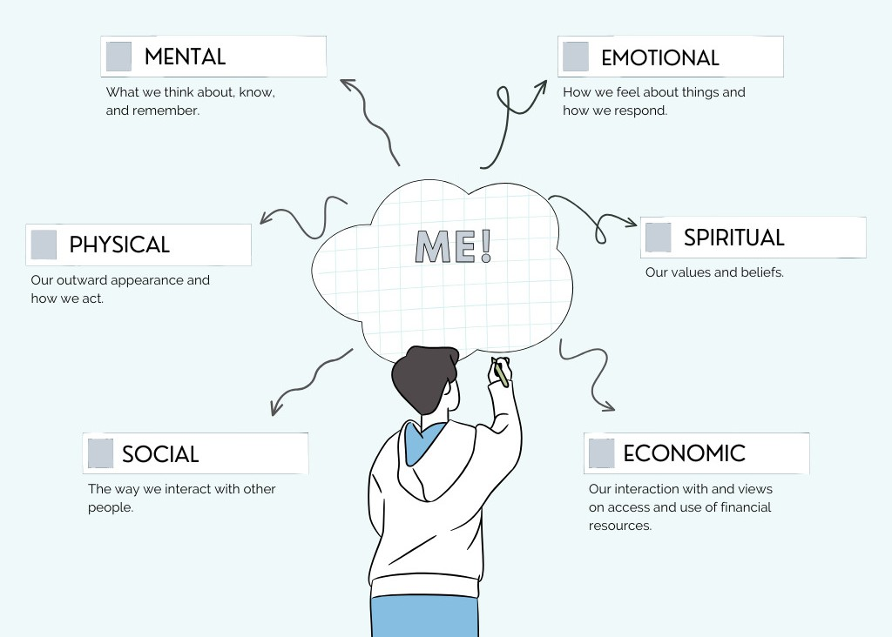

My aspirations and mission statement


Halima’s story

Halima has always dreamt of becoming a designer. She joined a college to study Arts and Design but had to drop out due to school fees; at that time, she had not yet specialized in one particular area.
Despite this setback, Halima remained passionate about learning, often experimenting with new techniques. However, she often finds that after perfecting these skills, they go to waste due to a lack of funds, which she feels limits her progress.
Halima has a long-standing interest in embroidery and has developed considerable skill with sewing and embroidery tools. She also has experience designing and making fashionable ladies’ wear. Recently, she became inspired by her cousin, Fatima, who runs a successful fish farming business. Fatima often shares her experiences with Halima, explaining how the demand for sustainable fish products is growing and how there are opportunities for creating added value in the market.
Seeing the potential in this industry, Halima began to explore how she could combine her love for design with her newfound interest in fish farming. She started thinking about designing functional, eco-friendly workwear for fish farmers and creating products that support sustainable practices in the industry, such as stylish, reusable fish bags or branding for locally sourced fish products.
Halima realized that her skills could be applied to create products that are both practical and aesthetically pleasing, catering to the needs of fish farmers like Fatima.
Halima would like to refine her skills further before she sets up her own business. She is confident that her interest in both fashion and fish farming can offer her a continuous challenge and allow her to contribute to her community in a meaningful way.
She is currently interested in getting an internship at a busy fashion house to gain more experience, while also learning more about the fish farming industry from Fatima. Her goal is to eventually start her own business, where she can combine her passion for design with sustainable fish farming, creating a unique niche that supports both industries.

Setting SMART goals
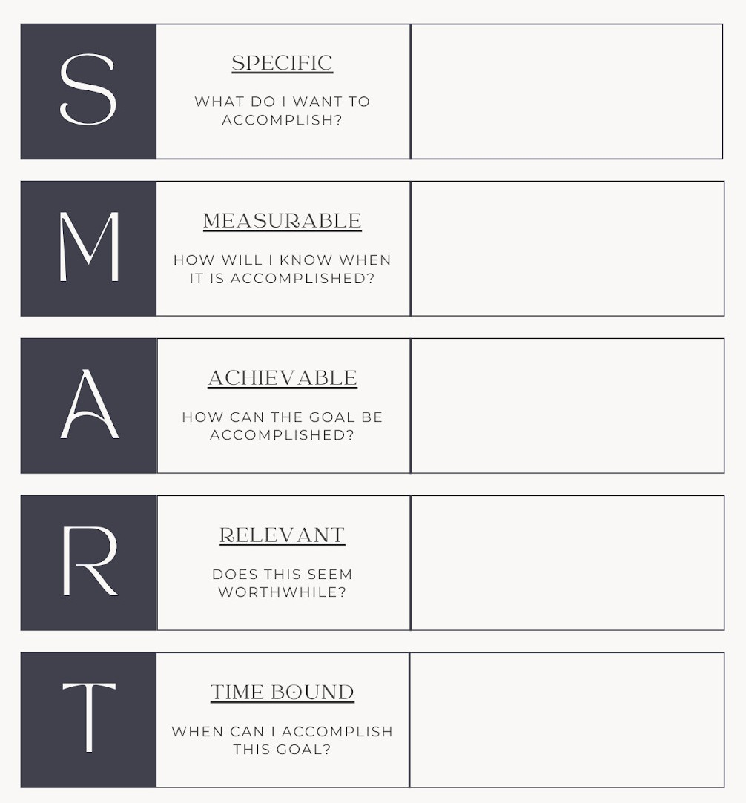

Write your short-term and long-term goals

Short Term Goals Long Term Goals

Overcoming Barriers to achieve my goals

What are some of the personal and cultural barriers that we come across when trying to achieve our goals and how can we overcome them?

Types of power
Power Within: Refers to self-awareness, self-esteem, identity, and self-affirmation. (knowing how to be).

Power To: The power that generates the capacity to make decisions, to have authority, and to find solutions to problems. It refers to intellectual capacities as well as to economic means, the capacity to access, control, and benefit from the means of production.


Power WITH: The ability to come together to negotiate and defend a common goal. It is the social or political power that emphasizes the notion of a common goal.

Daily Activities

- Imagine that this clock represents a typical day in your life
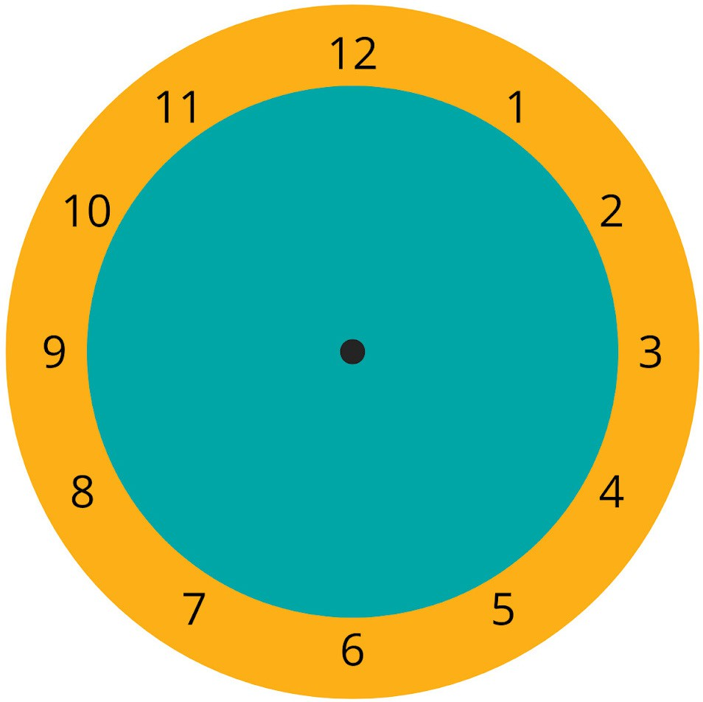
- Divide the clock into different sections to show how much time in a typical day you spend on the following activities:

  - Household chores
  - Childcare
  - Business or other income- generating activities
  - Personal time or leisure activities

Reflection/Homework

Take time to reflect on what you have learned in this session and write down one thing that you can implement immediately. You’ll share feedback in the next session.
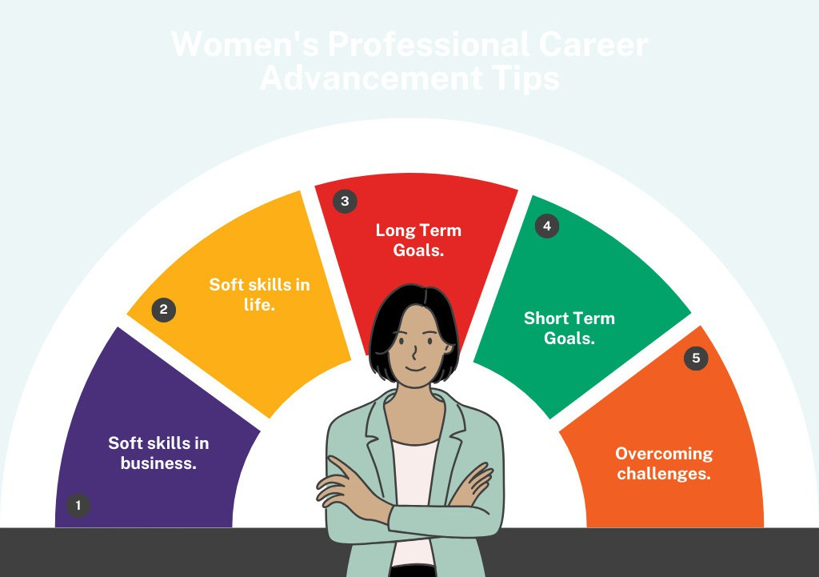

Module
2

Introduction to Blue Economy

Entrepreneurship Skills for Blue Economy


Objectives of the Module

Module 2:
Introduction to Blue Economy
- Understanding the importance of Blue Economy
- Define how climate change affects my business in the Blue Economy, community, and the environment
- What actions can I take to protect the ocean hence my business and community?
- What is my role and vision for the environment as a business leader?

Introduction of the module

Draw or write in one word the answers to one of the following questions

What do you or your community get from the ocean?

How do people around here use the ocean?

Step 1: What positive impact and benefit does your business create?

# | Questions | Yes, I do | I do not do it | Does not apply | Describe your actions
1 | Do you take care of the sea, rivers, or land in your daily work?
2 | Do you try to use less plastic or find other ways to reduce waste?
3 | Have you taken steps to keep the water clean when working?
4 | Do you plan to plant trees, clean the beach, or take care of mangroves?
5 | Do you avoid using harmful materials that can hurt the environment?
6 | Do you teach your workers or others about taking care of nature?
7 | Does your business support any projects that help the environment?
8 | Do you try to use natural resources carefully so they don’t run out?
9 | Do you use energy- saving methods in your business?
10 | Do you use local materials that are good for the environment?
11 | Do you believe your business is helping nature or your community?
12 | Does your business provide work for others in your community?

# | Questions | Yes, I do | I do not do it | Does not apply | Describe your actions
13 | Do you help young people learn new skills through your business?
14 | Do you sell your products or services locally, helping your community grow?
15 | Does your business work with other local businesses to help everyone succeed?
16 | Does your business invest in the community?

Based on your responses,

- How do these actions benefit your business and the environment?

- What are you committed to keep doing in the future?

Step 2: How can you reduce environmental harm caused by your business operations?

Questions | Yes, I do | I do not do it | Does not apply | Description
Do you think your business creates waste that harms the land or sea?
Do you use materials that can be dangerous to the environment?
Does your business cut down trees or remove plants that protect the land or water?
Do your business activities disturb wildlife or marine life?
Do you use too much water or resources that are hard to replace?

Based on your answers, reflect on the following questions:
  - What can you do to reduce waste from your business?
  - How can you protect resources moving forward? What could you use more carefully?
  - How can you educate others, such as workers, customers, family and friends?
  - Can you join community efforts or work with other businesses to reduce environmental impact?

Define one to three actions you’ll prioritize to reduce environmental harm:

1.

2.

3.

Step 3: Identify actions to decrease risk

Objective: Identify actions to decrease the risk of climate change, natural disasters, and ecosystem degradation that harm our businesses and communities:

Questions | Yes | No | Does not apply | How?
Has your business been affected by floods, droughts, or strong winds?
Does your business depend on the sea, rivers, or land that has been changing?
Have you noticed any damage to the land, sea, or plants where you work?
Do you think changes in nature or the climate will make it harder for your business in the future?

Based on your answers, reflect on the following questions:
- How can you protect your business from bad weather or changing climate?
- How can you reduce damage from storms or floods?
- What can you do to prepare for future droughts or water shortages?
- How can your community work together to reduce the impact of climate change or natural disasters?
- Can you work with other business owners to share water, tools, or knowledge when the weather or environment makes things difficult?

Define one to three actions you’ll prioritize to reduce risk for your business and community:

1.

2.

3.

Step 4: Identify opportunities

Questions | Yes | No | Does not apply | How?
Can you use waste or leftover materials from your business to create new products?
Can you save money by using fewer resources like water, energy, or materials?
Can you grow your business by creating goods that are better for nature or help restore the environment?
Are there ways to work with other businesses to share resources and reduce waste?
Can you attract more customers by promoting your business as environmentally responsible?
Are new markets or opportunities arising from protecting or improving the environment?

Based on your answers, reflect on the following questions:

- What opportunities seem more promising?
- Do you identify opportunities that are easier to leverage?
- Are there opportunities that can help you create a positive environmental impact and reduce harm or risks?
- What would it take?

Define one to three actions you’ll prioritize to leverage opportunities

Based on your answers in steps one to four, let’s summarize your priorities and define your role as an environmental steward and business leader in your community!

Actions that produce benefits and positive impact | Actions to reduce environmental harm | Actions to reduce climate risk | Actions to leverage opportunities

- What is your role as an environmental steward and business leader in your community?

- What responsibilities do you have as a business leader and environmental protector?

Module
3

Understanding My Business Model

Entrepreneurship Skills for Blue Economy


Objectives

Module 3:
Understanding My Business Model
- What stops my business from growing?
- What makes a business successful?
- How can I make the best use of available resources?

Questions:
What stops us from growing?

You have asked yourself:

Why hasn’t your company grown as you would like until today?

What do you think has slowed growth?

Write down here what stops you from growing your business:

Mariam’s case study

Mariam, a high-school graduate from Mida, Kenya, sought to augment her family’s income. Recognizing the potential of the Blue Economy, she ventured into beekeeping, focusing on mangrove honey. Joining a community forest association, she acquired initial resources and knowledge.
With her savings and a loan, she purchased four beehives and diligently learned beekeeping, emphasizing the unique qualities of mangrove honey. Her high-quality, organic honey gained popularity.
As her business grew, she educated her community about mangrove conservation and sustainable beekeeping, empowering other women. With support from her husband and the association, she expanded her operations, improved production techniques, and established a brand identity for her honey.
Leveraging social media and collaborating with local businesses, she effectively marketed her products.
Within a year, her production increased significantly, improving her family’s finances and enabling her to invest in her children’s education.
Motivated by her success, Mariam considered further expansion and diversification while remaining committed to mentoring aspiring beekeepers and promoting sustainability.
Her journey exemplifies the transformative power of entrepreneurship and environmental consciousness.

Triangle of success
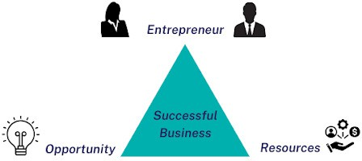

Characteristics of a good opportunity
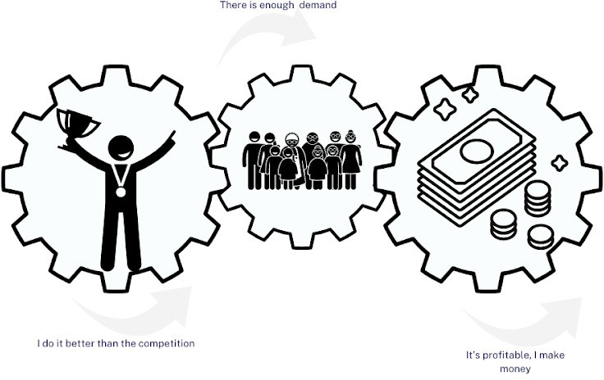

- Better than the competition: If they can do it better than the competition it could be a good opportunity.
- Enough demand: It is necessary to identify where consumer demand is directed, and analyze whether there are consumers interested in purchasing my product/service.
- Profitable: Make money selling that product/service.

To know which is the best option, you must analyze the growth opportunities, and to do this we will show you a very useful tool that analyzes both the product and the market.

BCanvas Model
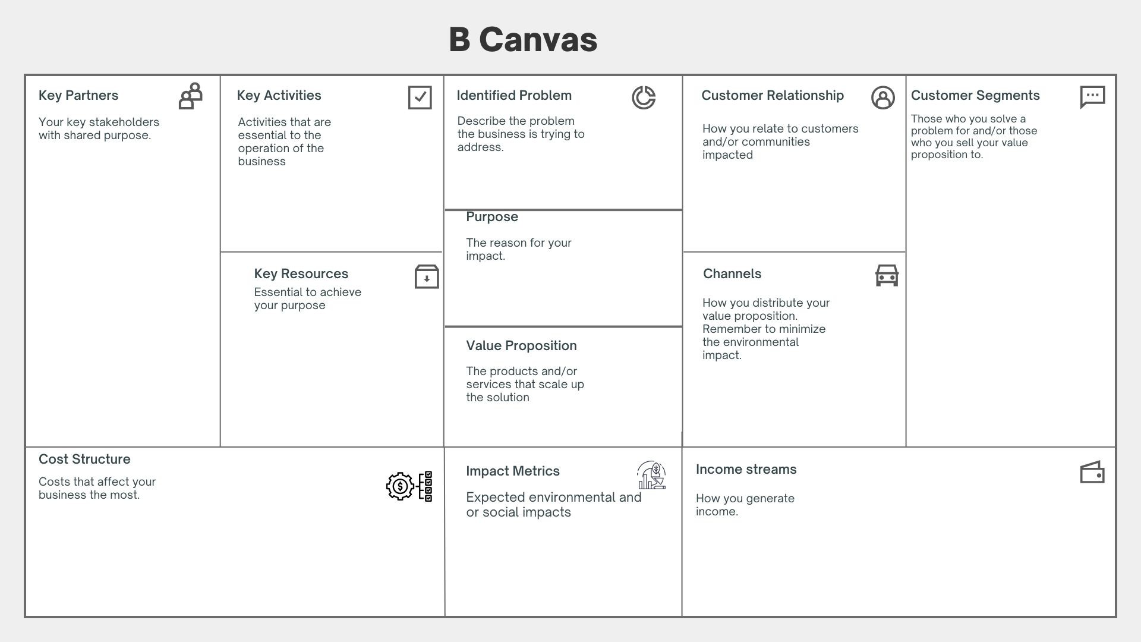

My Business Model (B-canvas)
Answer the following questions about your business model. Take them to complete your B-Canvas

Blocs | Questions | Answers
Problem | What customer problems do we help solve?  What customer needs do we satisfy?
Customer Segment | How to group your customers?
Unique value proposition | What are you selling?  Why do they buy from you rather than your competitors?
Channels | Through which channels do you sell?  How do you communicate with your customers?
Relation client | What type of relationship do you have with each of your customer segments?

Blocs | Questions | Answers
Sources of income | What are your main sources of income?
Key Resources | What resources are essential to running your business? (physical, human, intangible)
Key activities | What are the main activities to carry out for your business to function?
Key partners | Who are your main partners and suppliers?
Cost structure | What resources and activities require the most money in your business?
Purpose | What is the level of satisfaction (value) that your company offers to customers for the needs they experience?  What contributions does your company aim to make on an economic, social, and environmental level?
Impact measures | What are the economic, social, and environmental impacts of your business?  How do you minimize the negative impacts and  enhance the positive ones generated by your business for its growth?

Expand thinking questions Customer segments
- Who are the best customers?
- Will it be worth detecting a new customer segment?
- Could you reach a new geographic location?

Value proposition
- Can you improve the message you currently communicate about your business products?
- Can you identify unmet needs where? What do customers ask for that you don’t have?
- Could you improve the products or services even further?
- Does the competition offer more value than your business?

Channels
- Can we make any improvements in the distribution of products or services?
- How can we reach more people? Could you adopt new sales channels?

Customer Relationships
- Can we improve the way we relate to customers?
- How can we exceed their expectations?

Revenue sources
- How can customers be encouraged to buy more from your business?
- Is the business dependent on a few revenue sources? Are they sustainable?
- Can you generate new revenue sources?
- Can you raise the prices of your products or services?

Key activities
- Can any activity be performed more efficiently?
- Are you using your time wisely? What could be improved?

Key resources
- Are you getting the most out of your existing resources?
- How can you get more resources to scale your business?

Key partners
- Could you diversify your suppliers? Are there networks or business associations in your city that you can join?
- Can you make strategic alliances with other entrepreneurs?
- Could you partner with other entrepreneurs to buy inputs at scale?

Cost structure
- Can you reduce your fixed costs? Can you negotiate better prices for your resources?
- Can you buy supplies in bulk to reduce costs?
- Can you manage credit or payment facilities with your suppliers?

Module
4

Understanding My Finances

Entrepreneurship Skills for Blue Economy


Objectives

Module 4:
Understanding My Finances
- Which financial concepts can I use to manage my business effectively?
- Which practical skills can I use to track income, expenses, and cash flow?
- Which tools can I develop for budgeting, saving, and managing financial risks?
- How can I build a foundation for business growth?

Case Study: Mama Karanga and the Importance of Savings for Small Businesses

Background
Mama Karanga, a local street vendor in Kenya, is renowned for her delicious fried meat, known as Karanga. Her business is vital not only for her livelihood but also for her family’s well-being. However, Mama Karanga faced a significant cash flow challenge that jeopardized her operations and underscored the importance of financial management in small businesses.
The Challenge
One day, while operating her stall, Mama Karanga’s frying pan cracked. The cost to replace it was 1,500 Kenyan shillings. Unfortunately, Mama Karanga had no savings set aside, forcing her to borrow money from a neighbor. This debt strained her finances for weeks, as each sale went toward repaying the loan, leaving her with barely enough to meet her family’s basic needs. The stress of managing her finances during this period took a toll on her well-being.

The Turning Point
This experience prompted Mama Karanga to reevaluate her financial practices. She recognized the necessity of having a financial buffer

to manage unexpected expenses. Consequently, she began setting aside a small portion of her weekly earnings. At first, the amounts were modest, but over time, her savings accumulated into a small emergency fund.

Months later, when her gas cylinder required replacement, Mama Karanga was able to utilize her savings instead of resorting to borrowing. This proactive approach allowed her to manage the expenses smoothly without adding financial strain. The experience not only eased her financial burden but also gave her a sense of control and resilience against future challenges.

Lessons Learned
Mama Karanga’s story illustrates that establishing a savings habit, even in small increments, can significantly stabilize cash flow, reduce reliance on debt, and enhance resilience in the face of unforeseen expenses.

- What happened to Mama Karanga when her frying pan broke?
- How did borrowing money affect Mama Karanga’s business and her family?
- What new habit did Mama Karanga start after her experience with borrowing money?
- How did saving money help Mama Karanga when her gas cylinder needed to be replaced?
- What can other small business owners learn from Mama Karanga’s story about handling money?

Money In and Money Out
Income: “Income is the money your business earns. This could come from selling products, providing services, or any other way that brings money into your business.”

Activity: Income and Expense Sorting

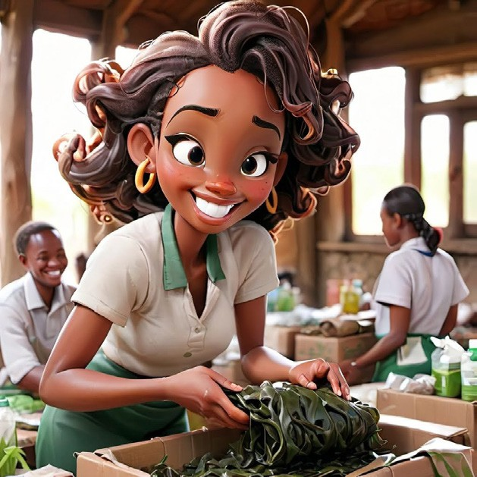
Categorise the following as either income or expense
Description: Entrepreneur packaging seaweed-based products for sale in a market setting
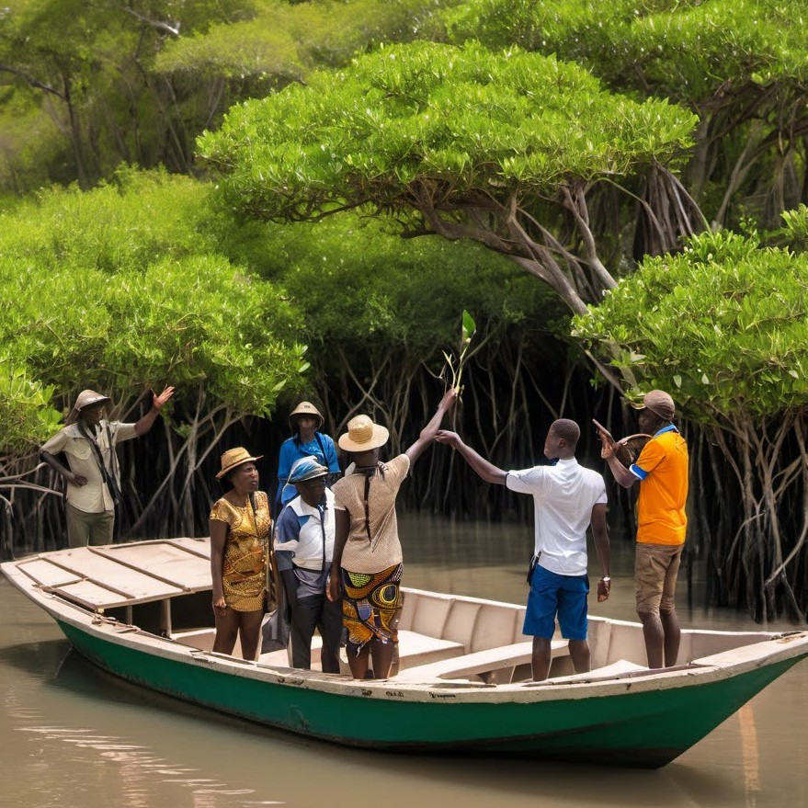
Income / Expense

Description: A guide showing tourists around a mangrove forest to make money

Income / Expense

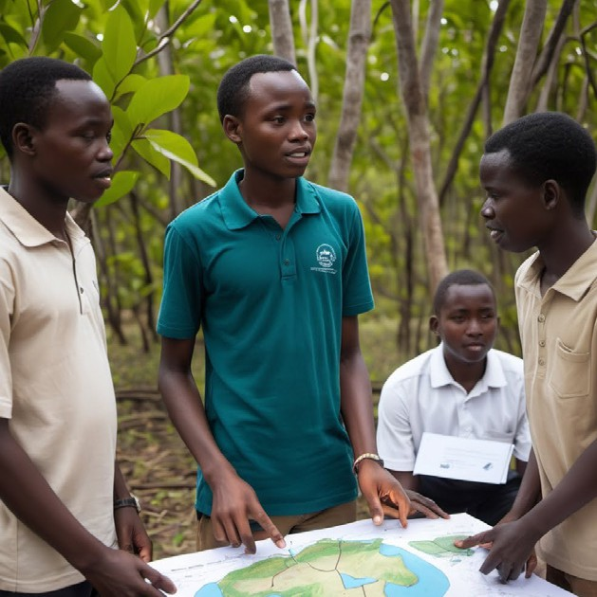
Description: A presenter with diagrams of mangrove ecosystems, discussing restoration techniques with community members, symbolizing consulting income.

Income / Expense

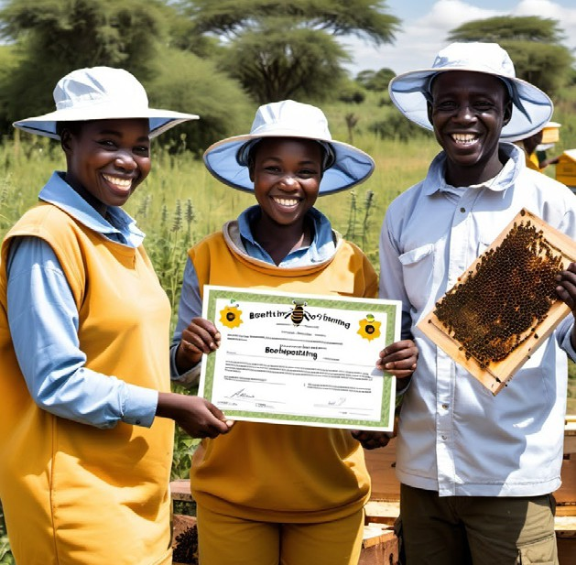
Description: Happy African Beekeepers received grant funding as an income source.

Income / Expense


Description: Utility bills and rental invoices on a table, representing monthly operational costs.

Income / Expense

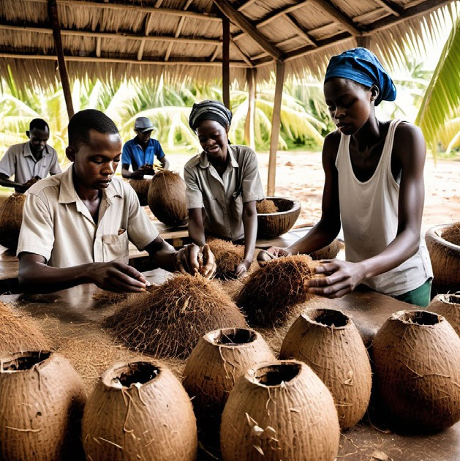
Description: Employees working in a coconut processing area with coconut husks and the owner will have to pay them a salary.

Income / Expense

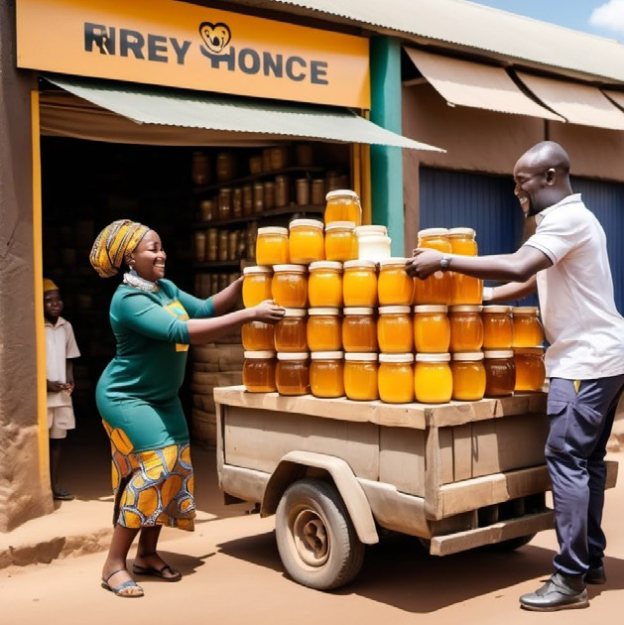
Description: A business owner offloading jars of honey from a delivery track that has just arrived and needs to be paid.

Income / Expense

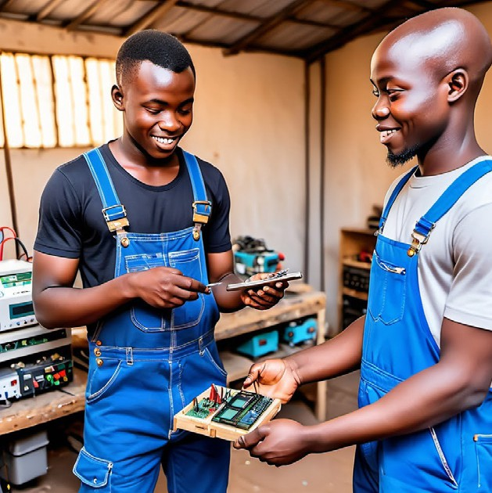
Description: A technician has just finished repairing the electricity and needs to be paid by the owner of the shop.

Income / Expense

Activity: Daily Tracking Exercise

To fill out the table, start by entering the date in the first column. In the second and third columns, record your daily income and expenses, respectively. In the fourth column, specify the type of expense, such as rent, groceries, or entertainment. Lastly, in the fifth column, add any additional notes or details about the transactions.

Date Income Expense Type of Expense Notes

Introduction to Cash Flow

Cash flow: Movement of money in and out of your business. When money comes in from sales or services, that’s positive cash flow. When money goes out for expenses like supplies or rent, that’s negative cash flow.
Cash Flow Tracking Exercise

 |  | Start Date
DAILY CASH FLOW |  | 1/1/2024 | 1/2/2024 | 1/3/2024 | 1/4/2024 | 1/5/2024
 |  | Mon | Tue | Wed | Thu | Fri
BEGINNING BALANCE |  |  | Kshs.0.00 | Kshs.0.00 | Kshs.0.00 | Kshs.0.00
CASH RECEIPTS | YTD
Sales Revenue | Kshs.0.00 |  |  |  | Kshs. - | Kshs. -
Customer Payments | Kshs.0.00 |  |  |  | Kshs. - | Kshs. -
Wholesale Orders | Kshs.0.00 |  |  |  | Kshs. - | Kshs. -
Interest Income | Kshs.0.00 |  |  |  | Kshs. - | Kshs. -
Tax Refund | Kshs.0.00 |  |  |  | Kshs. - | Kshs. -
Other Cash Receipts | Kshs.0.00 |  |  |  | Kshs. - | Kshs. -
Other | Kshs.0.00 |  |  |  | Kshs. - | Kshs. -
 | Kshs.0.00 |  |  |  | Kshs. - | Kshs. -
 | Kshs.0.00 |  |  |  | Kshs. - | Kshs. -
TOTAL CASH RECEIPTS | Kshs.0.00 | Kshs.0.00 | Kshs.0.00 | Kshs.0.00 | Kshs.0.00 | Kshs.0.00
CASH PAYMENT
Cost of Goods Sold | Kshs.0.00 |  |  |  | Kshs. - | Kshs. -
Supplier Payments | Kshs.0.00 |  |  |  | Kshs. - | Kshs. -
Employee Salaries | Kshs.0.00 |  |  |  | Kshs. - | Kshs. -
Rent for Retail Space | Kshs.0.00 |  |  |  | Kshs. - | Kshs. -
Utilities | Kshs.0.00 |  |  |  | Kshs. - | Kshs. -
Marketing and Advertising | Kshs.0.00 |  |  |  | Kshs. - | Kshs. -
Shipping and Logistics | Kshs.0.00 |  |  |  | Kshs. - | Kshs. -
Employee Benefits | Kshs.0.00 |  |  |  | Kshs. - | Kshs. -
Returns and Refunds | Kshs.0.00 |  |  |  | Kshs. - | Kshs. -
Others | Kshs.0.00 |  |  |  | Kshs. - | Kshs. -
 | Kshs.0.00 | Kshs. - | Kshs. - | Kshs. - | Kshs. - | Kshs. -
 | Kshs.0.00 | Kshs. - | Kshs. - | Kshs. - | Kshs. - | Kshs. -
 | Kshs.0.00 | Kshs. - | Kshs. - | Kshs. - | Kshs. - | Kshs. -
TOTAL CASH PAYMENTS | Kshs.0.00 | Kshs.0.00 | Kshs.0.00 | Kshs.0.00 | Kshs.0.00 | Kshs.0.00
NET CASH FLOW | Kshs.0.00 | Kshs.0.00 | Kshs.0.00 | Kshs.0.00 | Kshs.0.00 | Kshs.0.00

Activity: Projecting Cash Flow for One Week

Day | Cash In (Kes) | Cash Out (Kes) | Projected Balance (Kes)
Day 1
Day 2
Day 3
Day 4
Day 5
Day 6
Day 7

Introduction to Budgeting and Its Importance: Rukiya’s Study

Rukiya started a small waste collection business three months ago, aiming to make at least 10,000 KES daily. However, she’s been exploring additional income sources to support her financial goals. Yesterday, two new opportunities came her way, each with unique benefits and drawbacks.
The first offer is in the city as a seaweed marketing ocer an hour’s bus ride from her home in Shimoni in Kwale County , offering a salary 5% higher than her earnings from waste collection. The second is with a fishing cooperative, supplying fish to local vendors. This option is only a 20-minute commute, pays 2% less but comes with a supportive team and mentorship from experienced cooperative members. Her mother also suggested she consider joining the family’s apiculture farm, which produces honey and bee-related products.
Rukiya now has to carefully weigh these options, considering budgeting, managing potential risks, and planning for savings to meet her income goals and make the best decision for her future and help her make savings.

Rukiya is having a tough time deciding what to do, to save and manage the potential risks and how to plan for her business. Please help her make a decision on what job to take by helping create a saving plan.
Discussion Prompts for the trainer to the participants.
- Which option aligns best with Rukiya’s goals?
- How does each option support her ability to save weekly?
- What potential risks should Rukiya consider, and how might she manage them?
- If Rukiya chose one job, how could she budget to reach her 10,000 KES daily goal?

Budget for [Business name] in [financial year]
 | January |  | February |  | March |  | April
 | Budget | Actual | Budget | Actual | Budget | Actual | Budget | Actual
Income
Income 1
Income 2
Income 3
Income 4
Income 5

Total income
Expenses
Expense 1
Expense 2
Expense 3
Expense 4
Expense 5

Total expenses
Net income
Summary | Budget | Actual | Differences
January
Febuary
March
April

Assignment

Question | Your answer
1. What is special about your product or service? Why would a customer choose it over others?
2. Who are the main groups of customers you want to serve? How are they different from each other?
3. What benefits do your product or service give to customers? Why is this important to them?
4. How do you decide the price of your product? Could you change it to fit different customers’ needs?
5. Which ways (like word of mouth, social media, posters) would you use to tell customers about your product? Why are these ways good for your customers?
6. How could you make it easier or cheaper for customers to get your product? How would this change help your customers?

Based on the previous analysis, identify one to three actions you can immediately implement to reach more customers and sell more products.

Action 1:

When will you implement it?

Action 2:

When will you implement it?

Action 3:

When will you implement it?












Module
5

Understanding My Markets

Entrepreneurship Skills for Blue Economy


Objectives

Module 5:
Understanding My Markets
- How can I diversify my business?
- What are the key levers to sales growth?

- How can I use the BMC in my business?

Introduction to Marketing

Marketing is the art and science of choosing target markets, getting, keeping and growing customers, through creating, communicating and delivering a superior value proposition.

Aisha’s Case Study

Aisha, a young mother of 3 from Kikambala, Kilifi sold fried fish by the roadside for a living. After enrolling to the BlueBiz program Aisha gained knowledge on the blue economy sector and the existing opportunities. She learned that not only can she increase her income by leveraging on the ocean resources near her but she could also impact her community and environment.
After assessing the fishing value chain, Aisha noticed there were gaps. A lot of fish in her locality goes to waste from the point of harvest to consumption. The fishermen have to walk long distances to access the closest refrigerator hence there’s a lot of waste as most of the high value catch such as shrimp and lobsters can’t last long without refrigeration. She identified an opportunity to provide a cold storage facility nearby. Aisha’s business seeks to offer cold storage services in her local beach area. Let us walk through the value proposition for the cold storage services business.

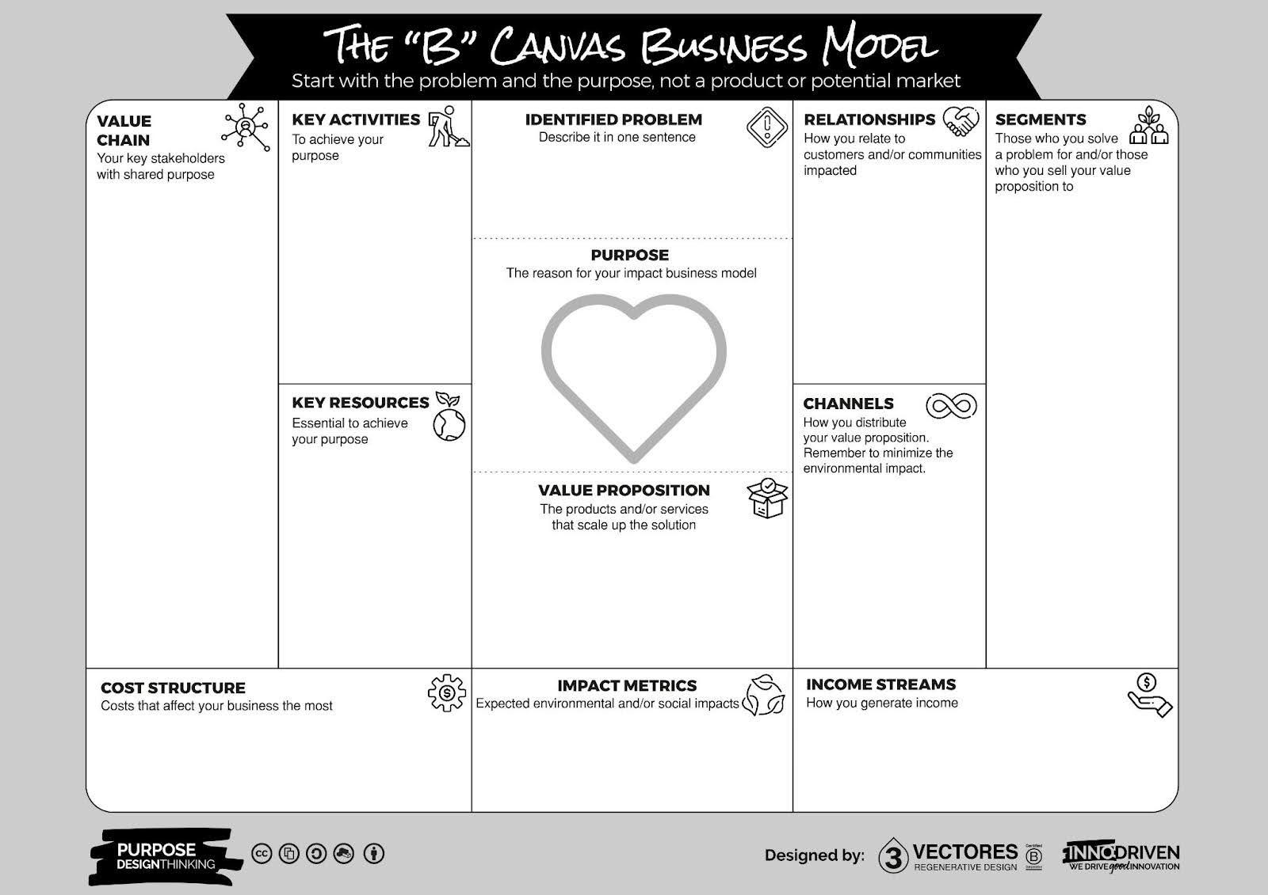

Fill in the following questions for your business

What product or service are you promoting in your business?
What needs does your product /service satisfy?
Do you think you made a good decision about the product you are promoting?

Assignment

Write at least 2 things that were meaningful from today’s lessons and how you plan to incorporate them into your business.

Understand Customer Segments

The Customer Segments Building Block defines the different groups of people or organizations an enterprise aims to reach and serve. As an entrepreneur, you need to make a conscious decision about which segments to serve and which segments to ignore. Once this decision is made, a business model can be carefully designed around a strong understanding of specific customer needs.

Some key decisions about the target segment:
- Where can I reach them?
- Where would they search for such a product?
- What price would work well?

- How much would they be willing to pay?
- How would they prefer to pay?
- What kind of message and images would be most appealing for them?
- How should I communicate with them?

Assignment

With this information fill in the Channels block on your business model canvas. Think through your business and answer the following questions
- Why should customers choose you? (Value Proposition)
- How will you reach your customers? (Channels)
- What are the points of contact with the customers? (Relationship)
- How do your target customers get informed? (Key Resources)
- How are products and services delivered to them? (Channels)
- How can we make our distribution channel more sustainable and circular? (IChannels)
- How do we best communicate the sustainable aspect of our product or service? (Impact Metrics)
- What are your prices like? (Revenue Streams)

Fatuma’s Case Study

Fatuma, a vibrant 26-year-old entrepreneur from Mombasa, has always dreamed of growing her eco-friendly coconut product business. She produces bowls, beauty products, and candles crafted from discarded coconut shells, a business that aligns with her passion for sustainability. Her products are gaining popularity on social media, especially among young people seeking environmentally conscious brands.
One day, Fatuma spots a “To Let” sign on a shop located in a bustling shopping area popular with tourists and locals. It’s the perfect location to take her business to the next level. Excited, she calls the landlord, Mr. Omari, to inquire about the space.

Module
6

Communicate & Connect

Entrepreneurship Skills for Blue Economy


Objectives

Module 6:
Communicate & Connect
- Learn the importance of effective communication and interpersonal relationships.
- Understand the importance of networking for your business.
- Learn how to make an effective sales pitch presentation.
- Practice a sales pitch for the business.

Communication Model
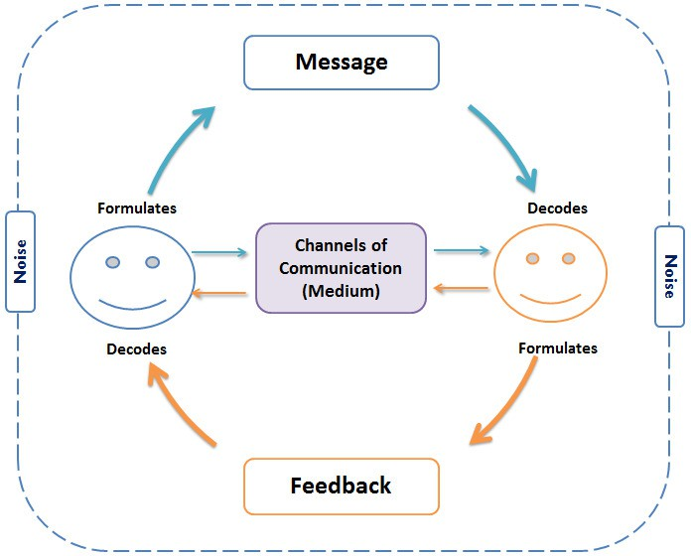

Katana’s Story

Katana is a hardworking fisherman. Each day, he wakes up early, wishes his young wife a good morning as she prepares to open their fish shop , and then heads out to his fishing boat. At the shore, he checks on his crew and records the day’s catch. He is often frustrated

with his crew in Kaya Bombo Beach Management Unit(BMU) because they don’t always keep the boat and nets clean.
Katana often takes his extra fish to his neighbors, Mr. and Mrs. Mwadime. They always give him good advice and offer help when needed. Today, Katana stops by the Mwadimes’ to drop off some fish. While there, Mr. Mwadime tells him that he just learned that the leaders of their fishing cooperative have been arrested for illegal fishing practices.
In the evening, as Katana enjoys his tea after a long day at sea, he starts to think of the people who make his life worth living.

Relationship Map



The bigger circles outside represent our weaker relationships – we typically have more of these so the area of the circle is bigger.

The smallest circle at the center represents our strongest relationship – this is a very small circle because we only have few such relationships. We can also call this the “inner circle”.
Family

Mr & Mrs Mwadime Beach Management Unit Cooperative

Knowledge Check

What are the components of effective communication?
Why are interpersonal interactions important?
What can you do with an interpersonal relationship map?

Activity

Write down at least two things that were meaningful to you, or that you plan to implement.

Hamisi’s Case Study

Hamisi wanted to start a beekeeping venture, but he did not know where to start. He remembered he had a friend- Naima who had experience working with mangrove conservation projects that supported apiculture. Hamisi approached Naima for help. Naima introduced Hamisi to a local organization that supported young people in entrepreneurship skills training.
The local organization enrolled Hamisi in the project training. Here Hamisi learned about sustainable entrepreneurship and he also met several people within his locality who were practicing apiculture. After interacting with his colleagues, Hamisi learned about a local store that bought honey from farmers, he approached the store owner who was willing to guide Hamisi further on the apiculture venture. Hamisi also learned how to ensure he got the best quality honey to fetch the best market price. The store owner also introduced him to a beehive supplier who had durable and good standard bee hives.
Hamisi now knows where he can buy beehives and all the farming gear he needs and have them set up. Hamisi established a network of organizations, businesses, and peers in his business of interest. He was now aware of all the requirements to start and grow his business, compliance requirements as well as sources of funding for his business.

Question
Using the Business Canvas list of activities carefully think about who you may need to efficiently run and manage your business.

Activity: Think about and list:
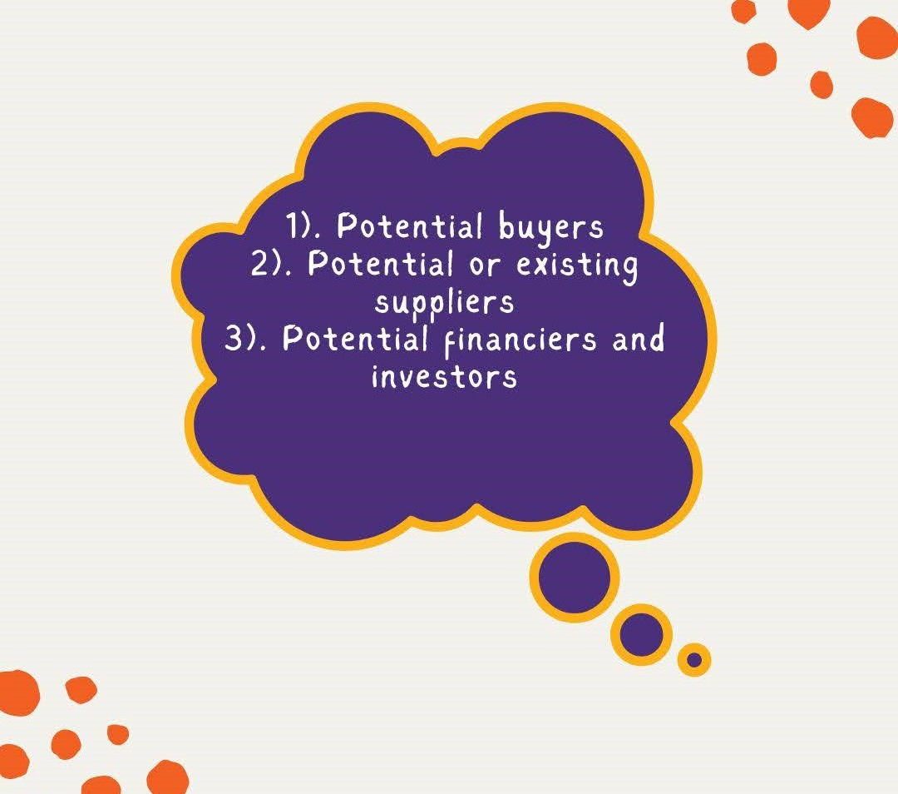

Workbook for Growth and Investment Training

Participant Name: Date:
- Introduction: About My Business
  - What does your business do?
Example: My business sells fresh and fried fish to families and restaurants in Mombasa.
Your Answer:

  - How long have you been in business?
Example: I have been in business for 3 years.
Your Answer:

  - Where is your business located?
Example: My business is located in Likoni Market, Mombasa.
Your Answer:

- The Problem I Am Solving
  - What problem do your customers face?
Example: Many families in Mombasa do not have easy access to fresh fish because fishermen sell mostly to wholesalers, leaving little for the local community.
Your Answer:

  - How are people solving this problem today?
Example: Families buy expensive frozen fish from supermarkets or wait for fishermen at the docks early in the morning.
Your Answer:

  - Why is your way better?
Example: I bring fresh fish to the market daily and fry fish on the spot for ready-to-eat meals, making it convenient for my customers.
Your Answer:

- My Solution
  - What is your product or service?
Example: I sell both fresh fish for cooking at home and fried fish ready to eat.
Your Answer:

  - What makes your product or service special?
Example: My fried fish is prepared with special spices, and my customers say it is tastier than others. I also deliver fresh fish to homes.
Your Answer:

  - Why is now the right time for your business?
Example: Mombasa’s population is growing, and more people want convenient access to affordable, fresh food without traveling far.
Your Answer:

- Who Are My Customers?
  - Who buys your product or service?
Example: My main customers are local families, food vendors, and small restaurants in Likoni.

Your Answer:

  - How big is your market?
Example: There are about 1,000 families in Likoni, and 50 restaurants in my area.
Your Answer:

  - What share of the market can you serve?
Example: I currently serve 200 families and 10 restaurants weekly.
Your Answer:

- Competitors and My Advantage
  - Who are your competitors?
Example: Other fish vendors in the market and fishermen who sell directly at the docks.
Your Answer:

  - What makes you different from competitors?
Example: I fry fish with unique spices, provide home deliveries, and ensure consistent quality.
Your Answer:

- My Business Model
  - How do you make money?
Example: I sell fish at a profit. Fried fish has a higher profit margin than fresh fish.
Your Answer:

  - How can you grow your business?
Example: I can start selling fish in new markets or add a variety of seafood like prawns and crabs.

Your Answer:

- My Achievements (Traction)
  - What have you achieved so far in your business?
Example: I sell 50kg of fresh fish and 30 fried fish meals daily. I have built a loyal customer base.

Your Answer:

- My Team
  - Who helps you in your business?
Example: My daughter helps with frying fish, and my nephew does deliveries.
Your Answer:

  - What skills do you or your team have?
Example: I know where to source the freshest fish at good prices, and my daughter has cooking skills that customers love.

Your Answer:

- My Finances
  - What were your sales last month?
Example: Last month, I sold items worth 50,000 KES.

Your Answer:

  - What are your expected sales next month? Example: I expect to sell 70,000 KES because I am introducing more delivery options.

Your Answer:

- My Investment Request
  - How much money do you need to grow your business? Example: I need 20,000 KES to buy a bigger stove and improve my delivery system.

Your Answer:

  - What will you use the money for?
Example: To buy a larger stove and packaging materials for deliveries.

Your Answer:

- Contact Details
  - How can customers or investors reach you?
Example: Phone: 0722 123 456 | Email: mama.karanga@ mombasa.com

Your Answer:








TechnoServe Fidel Odinga Road
Texas Building, 4th Floor, Nyali, Mombasa, Kenya www. technoserve.org

