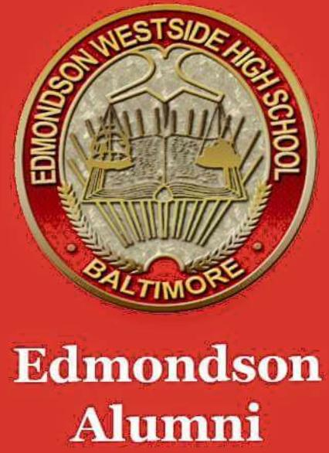

**EDMONDSON** **ALL** **ALUMNI ASSOCIATION (EAA) NEWSLETTER**

***Issue*** ***#1*** ***August 2018***

Welcome to the first edition of the EAA Newsletter – created to communicate important information from all class years, for all class years, by all class years. We welcome input from all members…

**Membership –** obtain EAA membership cards using the EAA online store [www.squareup.com/store/edmondsonalumni](http://www.squareup.com/store/edmondsonalumni)

EAA membership is $35 per fiscal year (July 1st through June 30th), identifies you as an active EWHS Alumni, and provides free access to all Fall and Winter boys and girls sports. Membership dues help to fund activities of the Association as well as restore administrative subscriptions. Membership proceeds also allows funds to be allocated to the scholarship fund and the athletic department.

**Point of Contacts (POCs) –** the EAA is currently in the process of obtaining Board Member information for all alumni years with active associations. As the “umbrella” for Alumni activities, communication with individual classes is crucial to our success. To assist us in this endeavor and keep us in the loop on class reunions and other activities email [edmondsonalumni@gmail.com](mailto:edmondsonalumni@gmail.com)

**EAA Meetings –** General Townhall meetings are held 2 times per year at the Edmondson High School – dates will be published via email and on Social media platforms. The Executive Board meets monthly at the Library or via conference call.

**Scholarships –** The EAA challenged all classes to donate towards our $5,000 goal for scholarships for the 2018 graduating class – few classes participated however $500 “book scholarships” has been awarded to five graduates, your help is needed to make this a success. We intend to issue the challenge earlier in the school year so that more awards can be made to the 2019 graduating class. To donate visit the online store [www.squareup.com/store/edmondsonalumni](http://www.squareup.com/store/edmondsonalumni) scroll to the bottom to contribute any amount.

**Fundraising –** The EAA will continue to raise funds from the sale of alumni apparel, memorabilia, EAA Events/Fundraisers and the sale of membership cards via the EAA online store. Also EAA has been working with a vendor to have yearbooks reproduced for sale – pre order at

[www.squareup.com/store/edmondsonalumni](http://www.squareup.com/store/edmondsonalumni).

The 4th Annual EAA “cook-out/cook-in” has been scheduled 1pm to 7pm at the Gentlemen Ten Lounge 2135 Edmondson Avenue Baltimore Md 21223 on September 8th. Tickets available online at [www.squareup.com/store/edmondsonalumni](http://www.squareup.com/store/edmondsonalumni)

**Volunteers-** The EAA is in need of Volunteers for committee members and school grounds cleanup (End of August) please email [edmonsonalumni@gmail.com](mailto:edmonsonalumni@gmail.com) put volunteer or committee in the subject line. EAA has also partnered up with Under Armour and Hearts of America to do renovation cosmetic work in 6 areas in the school, volunteers are needed September 12th -14th from 1 to 5pm, email [edmondsonalumni@gmail.com](mailto:edmondsonalumni@gmail.com) put we will in the subject line.

Stay tuned for EAA Newsletter Issue #2 - due in September 2018. Submit any questions, class information, etc. via the EAA email: [edmondsonalumni@gmail.com](mailto:edmondsonalumni@gmail.com). by August 20th for a September issue response.