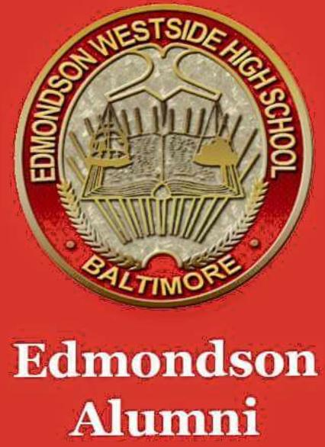

**EDMONDSON** **ALL** **ALUMNI ASSOCIATION (EAA) NEWSLETTER**

***Issue*** ***#2 September 2018***

Welcome to the Fall edition of the EAA Newsletter – created to communicate important information from all class years, for all class years, by all class years. We welcome input from all members…

**Sponsorships –** if we have your email address through membership, or you're a WBAL viewer, you should be aware of the pro bono renovations completed in the school by employees from Under Armor and Hearts Across America corporations – from cosmetic (painting, etc) to actual removal of the auditorium seats to replace flooring. Flooring was also updated in the cafeteria. Go to the WBAL website for pictures.

**Membership – EAA** membership continues to rise. If you do not have a membership card as yet, or you need to renew your membership go to the EAA website ([www.squareup.com/store/edmondsonalumni](http://www.squareup.com/store/edmondsonalumni)) to purchase one. EAA membership is $35 per fiscal year (July through June), identifies you as an EWHS Alumni, and provides free access to all Fall and Winter boys and girls sports. Compare paying $10 **per** **sporting** **event** throughout the year to one $35 yearly payment that gives you admission to all Fall and Winter games. In addition, membership dues help to fund activities of the Association.

**Point of Contacts (POCs) –** the EAA continues to seek Board Member information for all class years with active associations. As the “umbrella” for Alumni activities, communication with individual classes is crucial to our success. Please use the EAA website to assist us in this endeavor, and keep us in the loop on class reunions and other activities. We saw on FB this month that the class of 1963 and the class of 1968 celebrated 55 and 50 year reunions recently – email us at [edmondsonalumni@gmail.com](mailto:edmondsonalumni@gmail.com) in advance so that we can highlight your class activities.

**EAA Meetings –** General Membership meetings are held 2 times per year at the school or the Edmondson 1Village Public Library – dates and locations will be published on the EAA website. The Executive Board meets monthly at the school or the library, or via conference call.

**Scholarships –** EAA continues to challenge all classes to donate towards our $5,000 yearly goal for scholarships – this year for the 2019 graduating class. We hope to be able to award $500 book scholarships to at least 5 graduates (or more) but we need help from all classes. Check the website at [www.squareup.com/store/edmondsonalumni](http://www.squareup.com/store/edmondsonalumni) for more information and scroll to the bottom to contribute any amount.

**Fundraising –** the EAA will continue to raise funds from the sale of alumni tees and other paraphanalia – check out our tailgate table at Homecoming on October 5th . Membership cards will also be sold and are always available on the EAA website and at other EAA activities. We’re working with a vendor to have yearbooks reproduced for sale – pre order at [www.squareup.com/store/edmondsonalumni](http://www.squareup.com/store/edmondsonalumni).

Stay tuned for EAA Newsletter Issue #3- due in December 2018. Submit any questions, recent or upcoming class information, etc. via the EAA website [edmondsonalumni@gmail.com](mailto:edmondsonalumni@gmail.com). by November 30th for inclusion in the December issue.