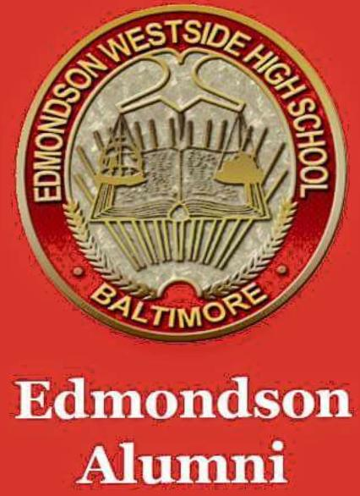

**EDMONDSON** **ALL** **ALUMNI ASSOCIATION (EAA) NEWSLETTER**

***Issue*** ***#2 January 9, 2019***

Welcome to the Fall edition of the EAA Newsletter – created to communicate important information from all class years, for all class years, by all class years. We welcome input from all members…

**Sponsorships –** if we have your email address through membership, or you're a WBAL viewer, you should be aware of the pro bono renovations completed in the school by employees from Under Armor and Hearts Across America corporations – from cosmetic (painting, etc) to actual removal of the auditorium seats to replace flooring. Flooring was also updated in the cafeteria. Go to the following link for article

<https://www.wbaltv.com/article/much-needed-help-coming-to-dozens-of-baltimore-city-schools/23120721>

**Membership – EAA** membership continues to rise. If you do not have a membership card as yet, or you need to renew your membership go to the EAA website ([www.squareup.com/store/edmondsonalumni](http://www.squareup.com/store/edmondsonalumni)) to purchase one. EAA membership is $35 per fiscal year (July through June), identifies you as an EWHS Alumni, and provides free access to all Fall and Winter boys and girls sports. Compare paying $10 **per** **sporting** **event** throughout the year to one $35 yearly payment that gives you admission to all Fall and Winter games. In addition, membership dues help to fund activities and administrative fess of the Association.

**Point of Contacts (POCs) –** the EAA continues to seek Board Member information for all class years with active associations. As the “umbrella” for Alumni activities, communication with individual classes is crucial to our success. Please use the EAA website to assist us in this endeavor, and keep us in the loop on class reunions and other activities. We saw on FB the class of 1963, the class of 1968, the class of 93, and the class of 98 celebrated 55, 50, 25, and 20 year reunions recently – email us at [edmondsonalumni@gmail.com](mailto:edmondsonalumni@gmail.com) in advance so that we can highlight your class activities.

**EAA Meetings –** General Membership meetings are held 2 times per year at the school or the Edmondson 1Village Public Library – dates and locations will be published on the EAA communications. The Executive Board meets monthly at the school or the library, or via conference call.

**Scholarships –** EAA continues to challenge all classes to donate towards our $5,000 yearly goal for scholarships – this year for the 2019 graduating class. We hope to be able to award $500 book scholarships to at least 5 graduates (or more) but we need help from all classes. Check the online store at [www.squareup.com/store/edmondsonalumni](http://www.squareup.com/store/edmondsonalumni) for more information and scroll to the bottom to contribute any amount.

**Fundraising –** the EAA will continue to raise funds from the sale of alumni tees and other apparel – our tailgate table at Homecoming on October 5th was stocked with membership cards and alumni apparel which are also available on the EAA online store and at other EAA activities. We’re currently working with a vendor to have yearbooks reproduced for sale – pre order at [www.squareup.com/store/edmondsonalumni](http://www.squareup.com/store/edmondsonalumni).

**Activities** - EAA is thinking about an all class black tie affair for 2019 – please use the EAA email address [edmondsonalumni@gmail.com](mailto:edmondsonalumni@gmail.com) to express your ideas. Leave us a voice message 410-657-8485

February 23rd will be the 2nd Annual all Alumni Basketball Event in partnership with Edmondson Legacy Experience. All Active Alumni members with proof of membership will $15 all others admission will be $20 this includes entry to the game from 12 to 3pm and the Alumni mixer social from 6 to 10pm. If you plan to compete please send an email to [edmondsonalumni@gmail.com](mailto:edmondsonalumni@gmail.com) with Alumni bball in the subject line list your name, class of, so we can create the teams.