**E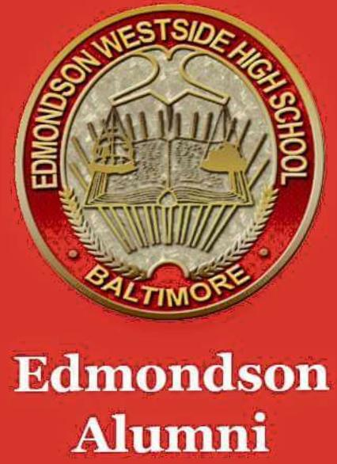AA**

**EDMONDSON** **ALUMNI ASSOCIATION (EAA) NEWSLETTER**

***Issue*** ***#4 June 2019***

Welcome to the fourth edition of the EAA Newsletter – created to communicate important information from all class years, for all class years, by all class years. We welcome input from all members…

**Membership –** obtain EAA membership cards using the EAA online store [www.squareup.com/store/edmondsonalumni](http://www.squareup.com/store/edmondsonalumni)

EAA membership is $35 per fiscal year (July 1st through June 30th), identifies you as an active EWHS Alumni, and provides free access to all Fall and Winter boys and girls sports. Most importantly, membership dues fund special activities of the Association including scholarships and support of the athletic department.

**Point of Contacts (POCs) –** the EAA is currently in the process of obtaining Board Member information for all class years with active associations. As the “umbrella” for Alumni activities, communication with individual classes is crucial to our success. To assist us in this endeavor and keep us in the loop on class reunions and other activities, email us at [edmondsonalumni@gmail.com](mailto:edmondsonalumni@gmail.com)

**EAA Meetings –** General Townhall meetings are held 2 times per year in the Edmondson High School library – dates will be published via email and on Social Media platforms. The Executive Board meets monthly at the Library or via conference call.

**Scholarships –** This year, with a donation from the class of '65, we are able to award $500 book scholarships to 2 graduating seniors at the May Senior Farewell - the class of ’68 has pledged to award 6. In order to provide more scholarships in 2020, the EAA challenges ALL CLASSES to donate towards our $5,000 goal. Donations from '65 and '68 are consistent each year, however to provide more $500 “book scholarships” contributions are needed from all class Associations. We will issue the challenge earlier in the Fall in order to reach our goal of assisting EWHS grads to attend college. To donate visit the online store [www.squareup.com/store/edmondsonalumni](http://www.squareup.com/store/edmondsonalumni) - scroll to the bottom to contribute any amount.

**Fundraising –** The EAA will continue to raise funds from the sale of alumni apparel, memorabilia, EAA Events/Fundraisers and the sale of membership cards via the EAA online store. In order to meet our goals and objectives, it is critical for alumni to support our efforts. We have recently contracted a vendor to have all class yearbooks reproduced for sale – pre order at [www.squareup.com/store/edmondsonalumni](http://www.squareup.com/store/edmondsonalumni).

The Annual EAA “cook-out/cook-in” has been tentatively scheduled for July 20th 2019 at the school 3-7pm. Check our website in the next few weeks for final info. Tickets will be available online at [www.squareup.com/store/edmondsonalumni](http://www.squareup.com/store/edmondsonalumni)

**Volunteers-** The EAA is in need of volunteers for committees and events - please email [edmonsonalumni@gmail.com](mailto:edmonsonalumni@gmail.com) put volunteer or committee in the subject line. EAA continues to send thanks to our corporate partners Under Armour and Hearts of America for the extensive renovation and cosmetic work in 6 areas of the school – Class Associations and individual entrepreneurs should contact EAA regarding contributions they wish to make – bottled water is always needed as water fountains contain elements (i.e. lead) that are not safe for student/staff consumption. In addition, restrooms need maintenance and upgrade. Contact us at [edmondsonalumni@gmail.com](mailto:edmondsonalumni@gmail.com).

**Alumni News –** HeartfeltCondolences were sent to the families of former EWHS auto mechanics teacher Charles A. Monroe, and former principal Delphine Lee. Condolences also go out to the Family of Bryan Schaffer and the Class of 93, to the Family of David Mackall Jr. and the Class of 09, also to the Family of Cody Bonner Class of 16.

ELE (Edmondson Legacy Experience) held their annual Red Carpet Gala on Saturday, May 4th that funds a $1000 scholarship to a graduating EWHS senior in memory of student Michael Mayfield. The gala is held at the school every year in May – check the alumni website starting in January for 2020 details.

Also check our social media for the video recording of EAA board members discussing the mission and goals of the Association on the “Radio On Fire’s Father and Son Show”.

**\*\*\***We congratulate EWHS graduate Derrick Tate for his recent NFL draft selection by the Atlanta Falcons – GO RED!!

**Special events -** The Class of '94 will celebrate their 25th Reunion on 10.12.19 – check the alumni social media for details and contact information. The Class of '70 has planned a Father's Day Oldies Cabaret for 6.16.19 at Millbrook Park – check the flier on our alumni social media for info. The Class of ‘04 will be hosting a fundraiser for their 15year reunion At Peace a Pizza 6-13-19 check flier on alumni social media for details

Stay tuned for EAA Newsletter Issue #5 - due in September 2019. Submit any questions, class information, etc. via the EAA email: [edmondsonalumni@gmail.com](mailto:edmondsonalumni@gmail.com). by August 20th for a September issue response.