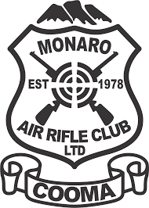

* Monaro Air Rifle Club provides a safe, relaxed and inclusive environment to participate in sports shooting.
* We specialise in 10m Air Rifle, with a 20 lane indoor range specifically for .177 calibre competition Target rifles.
* We are a category A club and hold both Club and Range approvals.
* Membership to our club meets the requirement for having a firearms license under the genuine reason of Target shooting.
* Membership with our club also includes your Association fees to NSW Smallbore & Air Rifle Association Inc which enables you to compete against other clubs in NSW as well as against all Target Australia Competitions.
* Our style of shooting is technical and takes practice and perseverance and is a lot harder than it looks.
* It also can be modified to be inclusive so that people from all ages and abilities can participate. Children must be over the age of 12 and be supervised by an adult.
* There will be opportunities to compete against others or just compete against yourself.
* The club does have a small number of club guns that can be borrowed by members who do not own their own rifles.
* Pellets can be purchased or provided at the club.
* Being an indoor range we can shoot in all weather conditions.

Membership Fees:
Includes both your club fees and your Association Fees and Insurance on the range.
They are yearly fees, from 1st January to the 31st December each Year.
Adult: $150.00
Concession: $130.00 Must be 60 years or over
Or hold Centerlink issued Pensioner Concession Card (PCC)
Centerlink issued Health Care Card (HCC)
Depart of Veterans Affairs Pensioner Concession Card
Fulltime Secondary or Tertiary student Card
Junior: $130.00 Must be under 21
Family: will be calculated per family.

Nightly Range Fees:

Members: $15.00 per night

Non members: $25.00 per night

