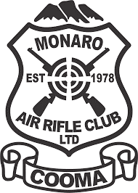
MEMBERSHIP APPLICATION
In Person, By mail to Po Box 772 Cooma NSW 2630 or
email form to marccooma@hotmail.com
Shooting Club Approval: 413431010
NEW ( ) RENEWAL ( ) Member Number_____________

NAME: ___________________________________________________________________
DATE OF BIRTH: ___________________________GENDER: _________________________
ADDRESS:_____________________________________________________________________________________________________________________________________________
POSTAL ADDRESS IF DIFFERENT; ________________________________________________
__________________________________________________________________________
PHONE; ___________________________________________________________________
EMAIL: ____________________________________________________________________

F/A LICENSE_______________________________________ P650
OTHER FORM OF ID IF NO F/A LICENSE__________________________________________
Do you wish for this club to be listed as your primary club for your Genuine Reason.

YES NO
Membership required
Adult $ 150.00 pa Family $ per application

Concession $ 130.00 pa Junior $ 130.00 pa
Concession card type & number_____________________________________________
Signature:_______________________________________________________________

If posting or emailing your application ( )Cheque * payable to Monaro Air Rifle Club
( )Card MC ( ) VC ( )Card Number_________________________________
EXP __/__ CV_______ Card Holder signature_____________________
( ) Bank T/F to BSB 032-720 A/C 153896 Monaro Air Rifle Club

