ANZAC DAY Combined
North Shore RSA
Dawn Parade & Service
FRIDAY, 25 April 2025
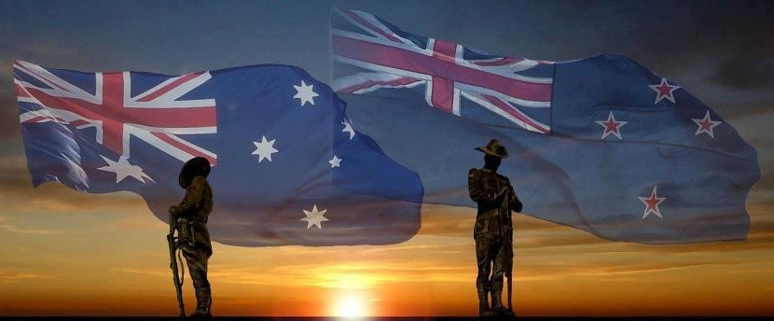

“Lest We Forget”
PARADE COMMANDER: LTCDR Sacha Belcourt NZCF
CENOTAPH GUARD: No. 6 (North Shore) Air Training Cadets

BANDS: Auckland Police Pipe Band
Salvation Army Band
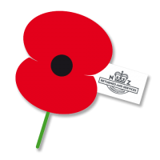
MASTER OF CEROMONIES: Chris Mullane, Veteran
Devonport RSA


THE MARCH
5.45am

Parade falls in at the corner of Anzac Road and Beachfront Lane—North Shore Cadet Units in attendance.
On the order of the Parade Commander, the Parade marches along Beach Front Lane to the War Memorial to the music of the Auckland Police Pipe Band.

ORDER OF SERVICE

INTRODUCTION
Chris Mullane, Veteran
Devonport RSA

CALL TO WORSHIP AND LEAD IN TO HYMN

Rev Martin Fey

“ABIDE WITH ME”
Emily Coffman, Emily & Elise Cuff, Carla Anderson,
Students from Long Bay College,
accompanied by the Salvation Army Band
(First line of each verse will be announced)
Abide with me; fast falls the even tide
The darkness deepens; Lord, with me abide.
When other helpers’ fail, and comforts flee
Help of the helpless, O abide with me.

I fear no foe; with Thee at hand to bless
Ills have no weight; and tears no bitterness.

Where is death’s sting; where grave Thy victory?
I triumph still; if Thou abide with me.

THE ANZAC DEDICATION
Recited by Logan Cudby, East Coast Bays RSA

At this hour, on this day, ANZAC received its baptism of fire and became one of the immortal names in history. We who are gathered here think of the comrades who went out with us to battle but did not return.
It is fitting that we should keep this dawn vigil together, in remembrance and gratitude. We feel them still near us in spirit. We wish to be worthy of their great sacrifice. Let us, therefore, once again dedicate ourselves to the service of the ideals for which they died. As the dawn is even now about to pierce the night, so let their memory inspire us to work for the coming of the new light into the dark places
of the world.
ADDRESS
Eliana Heard and Zhan Bowden, Students from Rangitoto College

PRAYERS AND PRAYER OF DEDICATION
Rev Martin Fey
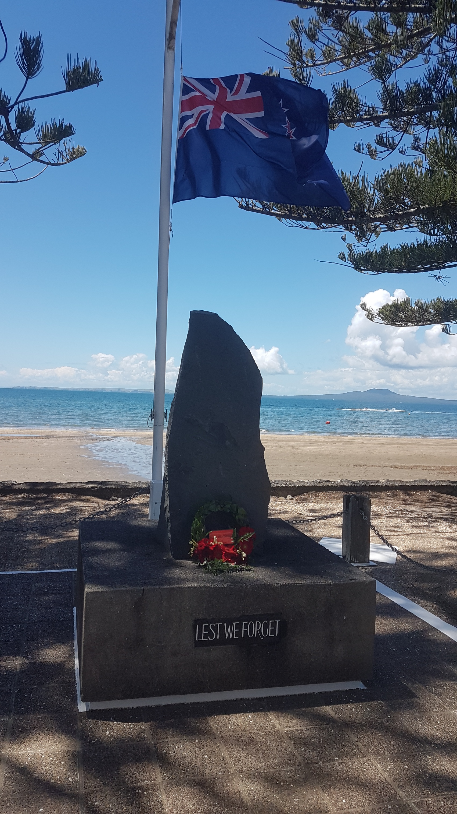

WREATH
Dutch Van Geuns, Vice President, Birkenhead RSA, to lay Wreath on
behalf of the Combined North Shore RSA’s

LAMENT
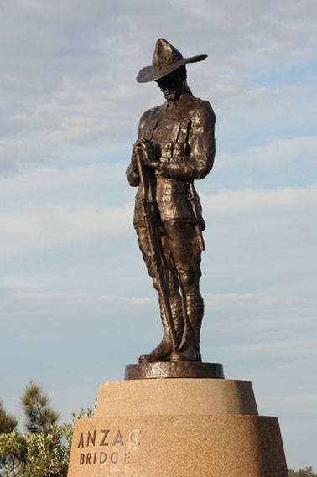
Pipe Major Simon Fraser

LAST POST
Bugler, Celine Wu, Age 10
(Flags Lowered)

ODE
Recited by, Reagan Shalley, Vanguard Military School and
CDR Muzz Kennett, RNZN, President, Devonport RSA

REVEILLE
Bugler, Dan Fordyce
(Flags Raised)

NATIONAL ANTHEMS
Emily Coffman, Emily & Elise Cuff, Carla Anderson,
Students from Long Bay College,
accompanied by the Salvation Army Band

AUSTRALIAN  Advance Australia Fair | NEW ZEALAND  God Defend New Zealand
Australians all let us rejoice,  For we are one and free;  We’ve golden soil and wealth for toil;  Our home is girt by sea;  Our land abounds in nature’s gifts  Of beauty rich and rare;  In history’s page, let every stage  Advance Australia Fair!  In joyful strains then let us sing,  "Advance Australia Fair!" | E Ihoa Atua,  O nga Iwi Matou ra  Ata whakarongona;  Me aroha noa.  Kia hua ko te pai;  Kia tau to atawhai;  Manaakitia mai  Aotearoa  God of Nations, At thy feet,  In the bonds of love we meet,  Hear our voices we entreat,  God defend our free land.  Guard Pacific’s triple star,  From the shafts of strife and war,  Make her praises heard afar,  God defend New Zealand.

BENEDICTION
Rev Martin Fey

CLOSURE AND DIRECTION FOR THE PARADE
TO MARCH OFF AND MARCH PAST
Chris Mullane, Veteran
Devonport RSA

east coast bays rsa centennial

Veterans, Current and Former Serving members, Service/Returned, those wearing Medals and RSA Members are Welcome on behalf of East Coast Bays RSA to return to the Bays Club for light refreshments, provided by ECB RSA and prepared by the Bays Club. Due to an increase of likely numbers Speakers Corner will also be open in support of the East Coast Bays RSA on Anzac Day.

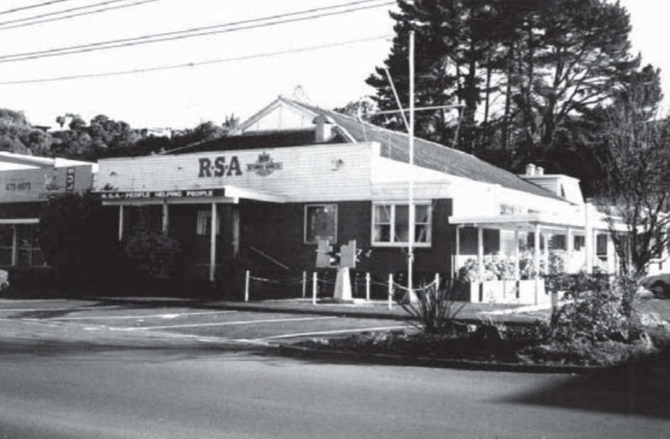

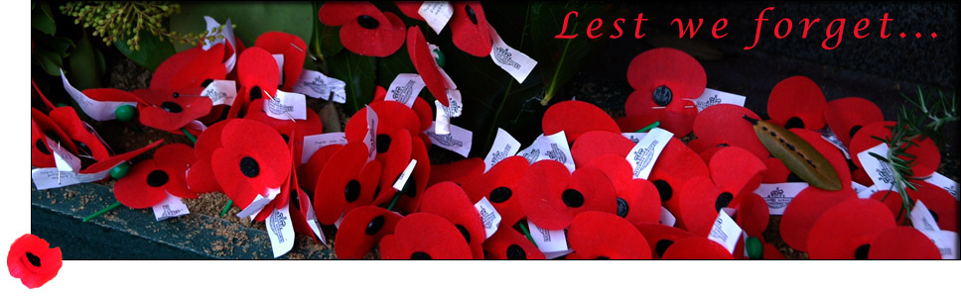

In Flanders fields the poppies blow
Between the crosses, row on row,
That mark our place; and in the sky
The larks, still bravely singing, fly
Scarce heard amid the guns below.
We are the Dead. Short days ago,
We lived, felt dawn, saw sunset glow,
Loved, and were loved, and now we lie
In Flanders fields.
Take up our quarrel with the foe
To you from failing hands we throw
The torch; be yours to hold it high.
If ye break faith with us who die
We shall not sleep, though poppies grow
In Flanders fields.
