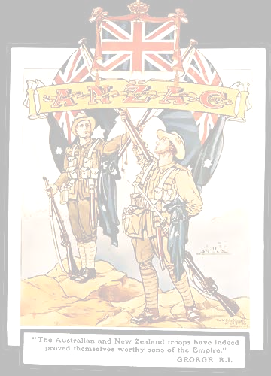

ANZAC

Memorial Parade and Service

BROWNS BAY

Friday, 25 April 2025
8.45 am

PARADE COMMANDER: LTCDR Sacha Belcourt NZCF
CENOTAPH GUARD: T.S. Bellona Navy Cadets

MASTER OF CEREMONIES: Alexis Poppelbaum
Hibiscus and Bays Local Board

BANDS: Auckland Police Pipe Band
Salvation Army Band



AN ANZAC TRIBUTE

ORDER OF SERVICE

INTRODUCTION
Alexis Poppelbaum

CALL TO WORSHIP AND LEAD IN TO HYMN
Sean Cloete

“ABIDE WITH ME”
Emily Coffman, Emily & Elise Cuff, Carla Anderson,
Students from Long Bay College,
accompanied by the Salvation Army Band

Abide with me; fast falls the even tide
The darkness deepens; Lord, with me abide.

When other helpers’ fail, and comforts flee
Help of the helpless, O abide with me.

I need Thy presence every passing hour,
What but Thy grace can foil the tempter’s power?

Who like Thyself my guide and stay can be?
Through cloud and sunshine, O abide with me.

Hold Thou Thy Cross before my closing eyes,
Shine through the gloom, and point me to the skies,
Heaven’s morning break, and earth’s vain shadows flee;

In life, in death, O Lord, abide with me.

ADDRESS
Rosita Misipati & Sione Naufahu, Students from Rangitoto College

SCRIPTURE LESSON
Sean Cloete

FOR THOSE IN PERIL ON THE SEA
Emily Coffman, Emily & Elise Cuff, Carla Anderson,
Students from Long Bay College,
accompanied by the Salvation Army Band

Eternal Father strong to save,  Whose arm hath bound the restless wave,  Who bidd’st the mighty ocean deep  Its own appointed limits keep;  O hear us when we cry to Thee  For those in Peril on the sea.  O Holy spirit who did’st brood  Upon the waters dark and rude,  And bid their angry tumult cease,  And give, for wild confusion, peace;  O hear us when we cry to Thee  For those in Peril on the sea.  O Trinity of love and power,  Our brethren shield in danger’s hour  From rock and tempest, fire and foe  Protect them wheresoe’er they go;  Thus evermore shall rise to Thee  Glad hymns of praise from land and sea. | 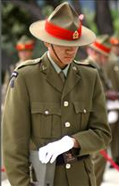  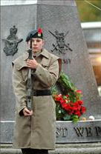

THE ANZAC PRAYER
Sean Cloete

LORD’S PRAYER
Sean Cloete

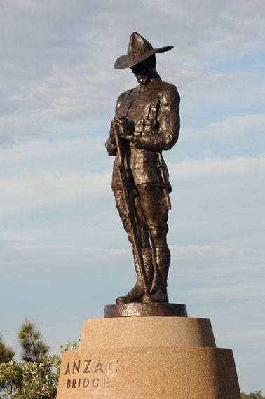

LAMENT
Pipe Major Simon Fraser

LAST POST
Dan Fordyce, Bugler
(Flag Lowered)

ODE
Recited by, Reagan Shalley, Vanguard Military School and
John Wright, East Coast Bays RSA

“E kore rātou e kaumātuatia
Pēnei i a tātou kua mahue nei
E kore hoki rātou e ngoikore
Ahakoa pēhea i ngā āhuatanga o te wā
I te hekenga atu o te rā
Tae noa ki te aranga mai i te ata
Ka maumahara tonu tātou ki a rātou
Ka maumahara tonu tātou ki a rātou.”
“They shall grow not old,
as we that are left grow old;
Age shall not weary them,
nor the years condemn;
At the going down of the sun,
and in the morning.
We will remember them.”

All – We will remember them

THE REVEILLE
Bugler, Dan Fordyce
(Flag raised)

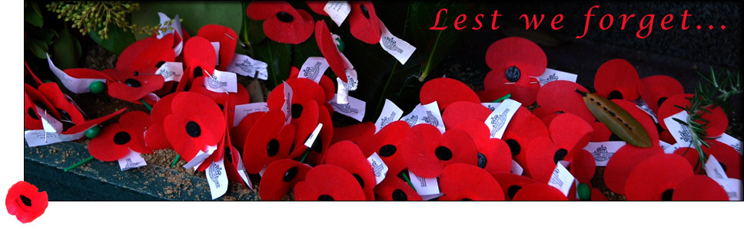

NATIONAL ANTHEMS
Emily Coffman, Emily & Elise Cuff, Carla Anderson,
Students from Long Bay College,
accompanied by the Salvation Army Band

AUSTRALIAN  Advance Australia Fair | NEW ZEALAND  God Defend New Zealand
Australians all let us rejoice,  For we are one and free.  We’ve golden soil and wealth for toil;  Our home is girt by sea;  Our land abounds in nature’s gifts  Of beauty rich and rare;  In history’s page, let every stage  Advance Australia Fair!  In joyful strains then let us sing,  "Advance Australia Fair!" | E Ihoa Atua,  O nga Iwi Matou ra  Ata whakarongona;  Me aroha noa.  Kia hua ko te pai;  Kia tau to atawhai;  Manaakitia mai  Aotearoa  God of Nations, At thy feet,  In the bonds of love we meet,  Hear our voices we entreat,  God defend our free land.  Guard Pacific’s triple star,  From the shafts of strife and war,  Make her praises heard afar,  God defend New Zealand.

BENEDICTION
Sean Cloete

LAYING OF OFFICIAL WREATHS & TRIBUTES

The order of Wreath Laying will be directed by the Master of Ceremonies

CLOSURE AND DIRECTION FOR THE PARADE
TO MARCH OFF AND MARCH PAST
Alexis Poppelbaum

east coast bays rsa centennial

Veterans, Current and Former Serving members, Service/Returned, those wearing Medals and RSA Members are Welcome on behalf of East Coast Bays RSA to return to the Bays Club for light refreshments provided by ECB RSA and prepared by The Bays Club. Due to an increase of likely numbers Speakers Corner will also be open in support of the ECB RSA on Anzac Day.
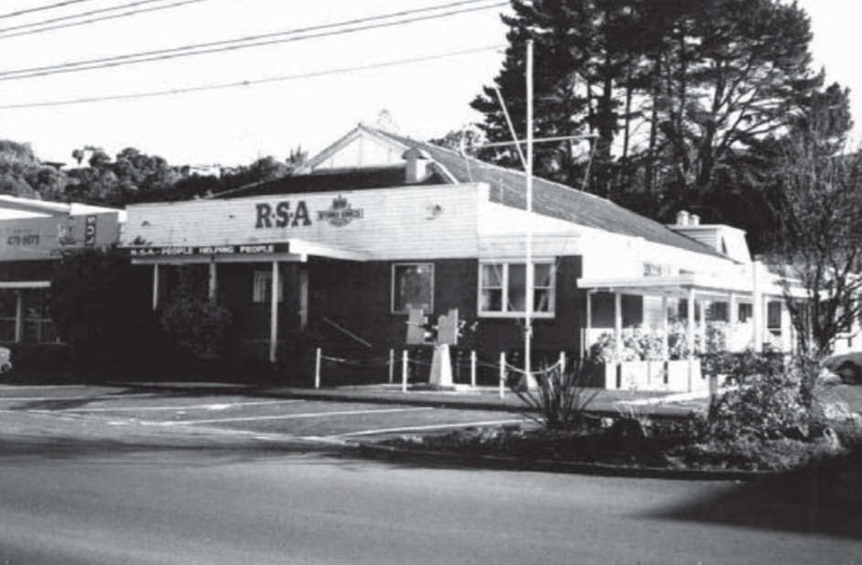

In Flanders fields the poppies blow
Between the crosses, row on row,
That mark our place; and in the sky
The larks, still bravely singing, fly
Scarce heard amid the guns below.
We are the Dead. Short days ago,
We lived, felt dawn, saw sunset glow,
Loved, and were loved, and now we lie
In Flanders fields.
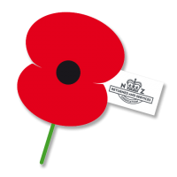
Take up our quarrel with the foe
To you from failing hands we throw
The torch; be yours to hold it high.
If ye break faith with us who die
We shall not sleep, though poppies grow
In Flanders fields.

