Combined
North Shore RSA
Dawn Parade & Service
SUNDAY, 25 April 2021
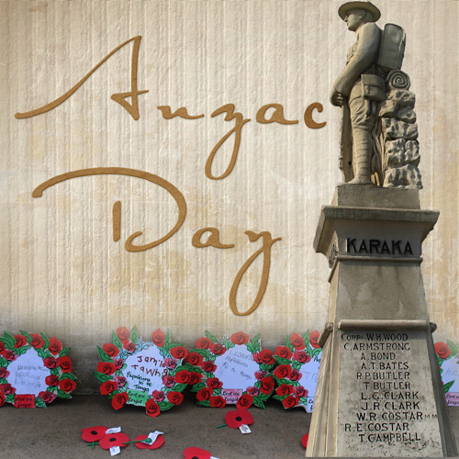

PARADE COMMANDER: Major Peter Gilliland NZCF
CENOTAPH GUARD: North Shore Army Cadets

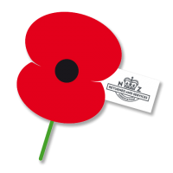
BANDS: Auckland Police Pipe Band

Salvation Army Band
THE MARCH
5.45am

Parade falls in at the corner of Anzac Road and Beachfront Lane—North Shore Cadet Units in attendance.
On the order of the Parade Commander, the Parade marches along Beach Front Lane to the War Memorial to the music of the Auckland Police Pipe Band.

DAWN SERVICE

INTRODUCTION
Lt Col Christopher Mullane, Devonport RSA

CALL TO WORSHIP AND LEAD IN TO HYMN
Reverand Dr Tokerau Joesph

ABIDE WITH ME
(Michael Read-Percival and Lexie Fisher, Students from Long Bay College, accompanied by the Salvation Army Band
First line of each verse will be announced.)
Abide with me; fast falls the even tide
The darkness deepens; Lord, with me abide.
When other helpers’ fail, and comforts flee
Help of the helpless, O abide with me.

I fear no foe; with Thee at hand to bless
Ills have no weight; and tears no bitterness.
Where is death’s sting; where grave Thy victory?
I triumph still; if Thou abide with me.
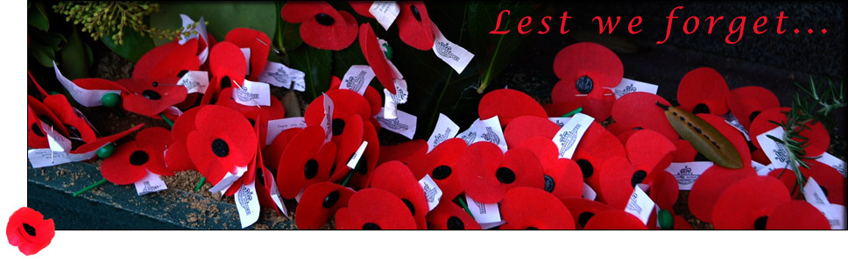
THE ANZAC DEDICATION
Recited by Howard Mace, President, Devonport RSA

At this hour, on this day, ANZAC received its baptism of fire and became one of the immortal names in history. We who are gathered here think of the comrades who went out with us to battle but did not return.
It is fitting that we should keep this dawn vigil together, in remembrance and gratitude. We feel them still near us in spirit. We wish to be worthy of their great sacrifice. Let us, therefore, once again dedicate ourselves to the service of the ideals for which they died. As the dawn is even now about to pierce the night, so let their memory inspire us to work for the coming of the new light into the dark places
of the world.
ADDRESS
Lt Col Christopher Mullane, Devonport RSA
Kieran Munro and Kelly Cha from Rangitoto College

PRAYERS AND PRAYER OF DEDICATION
Reverand Dr Tokerau Joesph

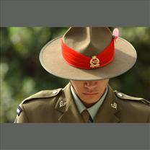

WREATH
George Coffin, Vice President, Birkenhead RSA, to lay wreath on
behalf of the Combined North Shore RSA’S

NATIONAL ANTHEMS
(Michael Read-Percival and Lexie Fisher, Students from Long Bay College, accompanied by the Salvation Army Band)

AUSTRALIAN  Advance Australia Fair | NEW ZEALAND  God Defend New Zealand
Australians all let us rejoice,  For we are young and free;  We’ve golden soil and wealth for toil;  Our home is girt by sea;  Our land abounds in nature’s gifts  Of beauty rich and rare;  In history’s page, let every stage  Advance Australia Fair!  In joyful strains then let us sing,  "Advance Australia Fair!" | E Ihoa Atua,  O nga Iwi Matou ra  Ata whakarongona;  Me aroha noa.  Kia hua ko te pai;  Kia tau to atawhai;  Manaakitia mai  Aotearoa  God of Nations, At thy feet,  In the bonds of love we meet,  Hear our voices we entreat,  God defend our free land.  Guard Pacific’s triple star,  From the shafts of strife and war,  Make her praises heard afar,  God defend New Zealand.

LAMENT
Pipe Major

LAST POST
Will Fordyce, Bugler

ODE
Recited by, Amethyst Neru, Long Bay College and Mike Jack, Vice President, Birkenhead RSA

REVEILLE
Will Fordyce, Bugler

BENEDICTION
Reverand Dr Tokerau Joesph

CLOSURE AND DIRECTION FOR THE PARADE
TO MARCH OFF AND MARCH PAST
Lt Col Christopher Mullane, Devonport RSA

