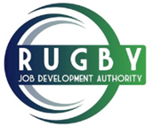
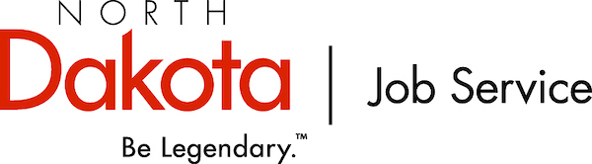

2019 Rugby Community Job Fair
You’re invited
Date: August 6th, 2019
Location:
Rugby Armory Auditorium
115 South Main Ave
Rugby, ND 58368
Time:
4:00 – 7:30 PM

Tap here to add a caption
Join Job Service North Dakota, the Rugby Job Development Authority, and the Rugby Chamber of Commerce for the Rugby Community Job Fair.
To reserve your table, please register soon. After you register, your company’s name and positions you hope to fill will be listed both on a job posting advertising the hiring event and on the Job Service North Dakota website (www.jobsnd.com). To get help with log in information, please contact Cindy Bitz (cbitz@nd.gov), 701-857-7546.
The advanced (local) advertising could result in increased applications prior to the hiring event, as well as better attendance at the job fair.
If you have questions about the hiring event or billing, please contact Liz Heisey (rugbyjda@gondtc.com), 701-776-7655.

P.S. If you are not the person that this email should go to, please email me the correct information.
Registration Form
Company Name: _____________________________ Phone:_____________________
Contact Person Name & Email: _________________________________________________
Address: __________________________ City, State, Zip: __________________________
Positions Recruiting: ________________________________________________________
_______________________________________________________________________
Registration form and fee must be received by July 26th, 2019. (First come basis and no refunds after this date)
Registration Fee: $25.00 (Check Only!) Checks payable to: Rugby JDA. NO CREDIT CARDS ACCEPTED!
Submit to: Rugby JDA
126 2nd Ave SW
Rugby, ND 58368

Your registration fee includes a 4 x 6 table and two chairs. Table cloths are not available, employers are encouraged to bring their own. There will be limited electrical access available and No Public Access to WIFI.

Set up time opens at 3:00 pm on August 6th, 2019.

