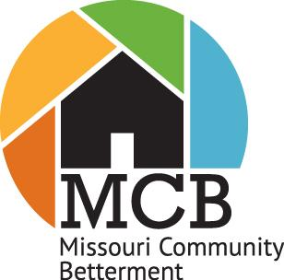

Missouri Community Betterment
Awards Program
Community Entry Form

Please complete and return this form postmarked by June 30. Submission of the form will indicate that you intend to participate in the judging and awards. List up to five projects that you plan to feature in your Project Report Submission and present to the judges during their visit (youth group projects should be submitted on the separate youth group entry form). Return the form to: Missouri Community Betterment, 8921 Camco Drive, Plato, MO 65552 or via email at: decamcoinc@yahoo.com

Name of Community/Neighborhood | Population (MCB Staff will enter this information using MERIC)
Name of Community Betterment Organization | Phone
Name of Adult Chairperson | Cell phone
Address | Zip Code
City | E-Mail Address

The following projects will appear in your Project Report and will be the primary focus of the judges. Please choose one of the twelve categories for your project to be entered for judging:.
a. People Category: Best Youth-led Project; Most Community Involvement; Best Use of Volunteers
b. Planning Category: Best Planning Process; Most Engaged Community
c. Resource Category: Best Project on a Budget; Most Creative Fundraising Effort, Best Use of Community Assets
d. Quality of Life Category: Most Heartfelt Project; Most Unique Community Activity; Community Event: Good Neighbor Day, (week of September 28)
PROJECT JUDGING CATEGORY
1.
2.
3.
4
5.

Please attach a sheet to this form with the name, address, phone and email address for your mayor, Chamber of Commerce or other community betterment members that wish to receive Missouri Community Betterment information

For MCB office use only: Date received _________ By ___________

